






Work cooperatively in a general administration environment
D1.HGE.CL7.13
D1.HGA.CL6.02
Trainer Guide

Work cooperatively in a general administration environment

D1.HGE.CL7.13
D1.HGA.CL6.02

Trainer Guide




Project Base
William Angliss Institute of TAFE
555 La Trobe Street
Melbourne 3000 Victoria
Telephone: | (03) 9606 2111
Facsimile: | (03) 9670 1330
Acknowledgements
Project Director: | Wayne Crosbie
Chief Writer: | Alan Hickman
Subject Writer: | Nick Hyland
Project Manager: | Alan Maguire
Editor: | Jim Irwin
DTP/Production: | Daniel Chee, Mai Vu, Kaly Quach

The Association of Southeast Asian Nations (ASEAN) was established on 8 August 1967. The Member States of the Association are Brunei Darussalam, Cambodia, Indonesia, Lao PDR, Malaysia, Myanmar, Philippines, Singapore, Thailand and Viet Nam.
The ASEAN Secretariat is based in Jakarta, Indonesia.
General Information on ASEAN appears online at the ASEAN Website: www.asean.org.
All text is produced by William Angliss Institute of TAFE for the ASEAN Project on “Toolbox Development for Front Office, Food and Beverage Services and Food Production Divisions”.
This publication is supported by the Australian Government’s aid program through the ASEAN-Australia Development Cooperation Program Phase II (AADCP II).
Copyright: Association of Southeast Asian Nations (ASEAN) 2013.
All rights reserved.
Disclaimer
Every effort has been made to ensure that this publication is free from errors or omissions. However, you should conduct your own enquiries and seek professional advice before relying on any fact, statement or matter contained in this book. The ASEAN Secretariat and William Angliss Institute of TAFE are not responsible for any injury, loss or damage as a result of material included or omitted from this course. Information in this module is current at the time of publication. Time of publication is indicated in the date stamp at the bottom of each page.
Some images appearing in this resource have been purchased from stock photography suppliers Shutterstock and iStockphoto and other third party copyright owners and as such are non-transferable and non-exclusive. Clip arts, font images and illustrations used are from the Microsoft Office Clip Art and Media Library. Some images have been provided by and are the property of William Angliss Institute.
Additional images have been sourced from Flickr and SXC and are used under Creative Commons licence: http://creativecommons.org/licenses/by/2.0/deed.en
File name: TG_Work_cooperatively_in_GA_environ_refined.docx





Table of Contents
Competency Based Training (CBT) and assessment – An introduction for trainers 1
Competency standard 11
Notes and PowerPoint slides 23
Recommended training equipment 181
Instructions for Trainers for using PowerPoint – Presenter View 183
Appendix – ASEAN acronyms 185

Competency Based Training (CBT) and assessment – An introduction for trainers

Competency
Competency refers to the ability to perform particular tasks and duties to the standard of performance expected in the workplace.
Competency requires the application of specified knowledge, skills and attitudes relevant to effective participation, consistently over time and in the workplace environment.
The essential skills and knowledge are either identified separately or combined.
Knowledge identifies what a person needs to know to perform the work in an informed and effective manner.
Skills describe the application of knowledge to situations where understanding is converted into a workplace outcome.
Attitude describes the founding reasons behind the need for certain knowledge or why skills are performed in a specified manner.
Competency covers all aspects of workplace performance and involves:
- Performing individual tasks
- Managing a range of different tasks
- Responding to contingencies or breakdowns
- Dealing with the responsibilities of the workplace
- Working with others.

Unit of Competency
Like with any training qualification or program, a range of subject topics are identified that focus on the ability in a certain work area, responsibility or function.
Each manual focuses on a specific unit of competency that applies in the hospitality workplace.
In this manual a unit of competency is identified as a ‘unit’.
Each unit of competency identifies a discrete workplace requirement and includes:
- Knowledge and skills that underpin competency
- Language, literacy and numeracy
- Occupational safety and health requirements.
Each unit of competency must be adhered to in training and assessment to ensure consistency of outcomes.

Element of Competency
An element of competency describes the essential outcomes within a unit of competency.
The elements of competency are the basic building blocks of the unit of competency. They describe in terms of outcomes the significant functions and tasks that make up the competency.
In this manual elements of competency are identified as an ‘element’.

Performance criteria
Performance criteria indicate the standard of performance that is required to demonstrate achievement within an element of competency. The standards reflect identified industry skill needs.
Performance criteria will be made up of certain specified skills, knowledge and attitudes.

Learning
For the purpose of this manual learning incorporates two key activities:
- Training
- Assessment.
Both of these activities will be discussed in detail in this introduction.
Today training and assessment can be delivered in a variety of ways. It may be provided to participants:
- On-the-job – in the workplace
- Off-the-job – at an educational institution or dedicated training environment
- As a combination of these two options.
No longer is it necessary for learners to be absent from the workplace for long periods of time in order to obtain recognised and accredited qualifications.

Learning Approaches
This manual will identify two avenues to facilitate learning:
Competency Based Training (CBT)
This is the strategy of developing a participant’s competency.
Educational institutions utilise a range of training strategies to ensure that participants are able to gain the knowledge and skills required for successful:
- Completion of the training program or qualification
- Implementation in the workplace.
The strategies selected should be chosen based on suitability and the learning styles of participants.

Competency Based Assessment (CBA)
This is the strategy of assessing competency of a participant.
Educational institutions utilise a range of assessment strategies to ensure that participants are assessed in a manner that demonstrates validity, fairness, reliability, flexibility and fairness of assessment processes.

Flexibility in Learning
It is important to note that flexibility in training and assessment strategies is required to meet the needs of participants who may have learning difficulties. The strategies used will vary, taking into account the needs of individual participants with learning difficulties. However they will be applied in a manner which does not discriminate against the participant or the participant body as a whole.
Catering for Participant Diversity
Participants have diverse backgrounds, needs and interests. When planning training and assessment activities to cater for individual differences, trainers and assessors should:
- Consider individuals’ experiences, learning styles and interests
- Develop questions and activities that are aimed at different levels of ability
- Modify the expectations for some participants
- Provide opportunities for a variety of forms of participation, such as individual, pair and small group activities
- Assess participants based on individual progress and outcomes.
The diversity among participants also provides a good reason for building up a learning community in which participants support each other’s learning.
Participant Centred Learning
This involves taking into account structuring training and assessment that:
- Builds on strengths – Training environments need to demonstrate the many positive features of local participants (such as the attribution of academic success to effort, and the social nature of achievement motivation) and of their trainers (such as a strong emphasis on subject disciplines and moral responsibility). These strengths and uniqueness of local participants and trainers should be acknowledged and treasured
- Acknowledges prior knowledge and experience – The learning activities should be planned with participants’ prior knowledge and experience in mind
- Understands learning objectives – Each learning activity should have clear learning objectives and participants should be informed of them at the outset. Trainers should also be clear about the purpose of assignments and explain their significance to participants
- Teaches for understanding – The pedagogies chosen should aim at enabling participants to act and think flexibly with what they know
- Teaches for independent learning – Generic skills and reflection should be nurtured through learning activities in appropriate contexts of the curriculum. Participants should be encouraged to take responsibility for their own learning
- Enhances motivation – Learning is most effective when participants are motivated. Various strategies should be used to arouse the interest of participants
- Makes effective use of resources – A variety of teaching resources can be employed as tools for learning
- Maximises engagement – In conducting learning activities, it is important for the minds of participants to be actively engaged
- Aligns assessment with learning and teaching – Feedback and assessment should be an integral part of learning and teaching
- Caters for learner diversity – Trainers should be aware that participants have different characteristics and strengths and try to nurture these rather than impose a standard set of expectations.
Active Learning
The goal of nurturing independent learning in participants does not imply that they always have to work in isolation or solely in a classroom. On the contrary, the construction of knowledge in tourism and hospitality studies can often best be carried out in collaboration with others in the field. Sharing experiences, insights and views on issues of common concern, and working together to collect information through conducting investigative studies in the field (active learning) can contribute a lot to their eventual success.
Active learning has an important part to play in fostering a sense of community in the class. First, to operate successfully, a learning community requires an ethos of acceptance and a sense of trust among participants, and between them and their trainers. Trainers can help to foster acceptance and trust through encouragement and personal example, and by allowing participants to take risks as they explore and articulate their views, however immature these may appear to be. Participants also come to realise that their classmates (and their trainers) are partners in learning and solving.
Trainers can also encourage cooperative learning by designing appropriate group learning tasks, which include, for example, collecting background information, conducting small-scale surveys, or producing media presentations on certain issues and themes. Participants need to be reminded that, while they should work towards successful completion of the field tasks, developing positive peer relationships in the process is an important objective of all group work.

Competency Based Training (CBT)
Principle of Competency Based Training
Competency based training is aimed at developing the knowledge, skills and attitudes of participants, through a variety of training tools.
Training Strategies
The aims of this curriculum are to enable participants to:
- Undertake a variety of subject courses that are relevant to industry in the current environment
- Learn current industry skills, information and trends relevant to industry
- Learn through a range of practical and theoretical approaches
- Be able to identify, explore and solve issues in a productive manner
- Be able to become confident, equipped and flexible managers of the future
- Be ‘job ready’ and a valuable employee in the industry upon graduation of any qualification level.
To ensure participants are able to gain the knowledge and skills required to meet competency in each unit of competency in the qualification, a range of training delivery modes are used.
Types of Training
In choosing learning and teaching strategies, trainers should take into account the practical, complex and multi-disciplinary nature of the subject area, as well as their participant’s prior knowledge, learning styles and abilities.
Training outcomes can be attained by utilising one or more delivery methods:
Lecture/Tutorial
This is a common method of training involving transfer of information from the trainer to the participants. It is an effective approach to introduce new concepts or information to the learners and also to build upon the existing knowledge. The listener is expected to reflect on the subject and seek clarifications on the doubts.
Demonstration
Demonstration is a very effective training method that involves a trainer showing a participant how to perform a task or activity. Through a visual demonstration, trainers may also explain reasoning behind certain actions or provide supplementary information to help facilitate understanding.
Group Discussions
Brainstorming in which all the members in a group express their ideas, views and opinions on a given topic. It is a free flow and exchange of knowledge among the participants and the trainer. The discussion is carried out by the group on the basis of their own experience, perceptions and values. This will facilitate acquiring new knowledge. When everybody is expected to participate in the group discussion, even the introverted persons will also get stimulated and try to articulate their feelings.
The ideas that emerge in the discussions should be noted down and presentations are to be made by the groups. Sometimes consensus needs to be arrived at on a given topic. Group discussions are to be held under the moderation of a leader guided by the trainer. Group discussion technique triggers thinking process, encourages interactions and enhances communication skills.
Role Play
This is a common and very effective method of bringing into the classroom real life situations, which may not otherwise be possible. Participants are made to enact a particular role so as to give a real feel of the roles they may be called upon to play. This enables participants to understand the behaviour of others as well as their own emotions and feelings. The instructor must brief the role players on what is expected of them. The role player may either be given a ready-made script, which they can memorise and enact, or they may be required to develop their own scripts around a given situation. This technique is extremely useful in understanding creative selling techniques and human relations. It can be entertaining and energising and it helps the reserved and less literate to express their feelings.

Simulation Games
When trainees need to become aware of something that they have not been conscious of, simulations can be a useful mechanism. Simulation games are a method based on "here and now" experience shared by all the participants. The games focus on the participation of the trainees and their willingness to share their ideas with others. A "near real life" situation is created providing an opportunity to which they apply themselves by adopting certain behaviour. They then experience the impact of their behaviour on the situation. It is carried out to generate responses and reactions based on the real feelings of the participants, which are subsequently analysed by the trainer.
While use of simulation games can result in very effective learning, it needs considerable trainer competence to analyse the situations.
Individual /Group Exercises
Exercises are often introduced to find out how much the participant has assimilated. This method involves imparting instructions to participants on a particular subject through use of written exercises. In the group exercises, the entire class is divided into small groups, and members are asked to collaborate to arrive at a consensus or solution to a problem.
Case Study
This is a training method that enables the trainer and the participant to experience a real life situation. It may be on account of events in the past or situations in the present, in which there may be one or more problems to be solved and decisions to be taken. The basic objective of a case study is to help participants diagnose, analyse and/or solve a particular problem and to make them internalise the critical inputs delivered in the training. Questions are generally given at the end of the case study to direct the participants and to stimulate their thinking towards possible solutions. Studies may be presented in written or verbal form.
Field Visit
This involves a carefully planned visit or tour to a place of learning or interest. The idea is to give first-hand knowledge by personal observation of field situations, and to relate theory with practice. The emphasis is on observing, exploring, asking questions and understanding. The trainer should remember to brief the participants about what they should observe and about the customs and norms that need to be respected.
Group Presentation
The participants are asked to work in groups and produce the results and findings of their group work to the members of another sub-group. By this method participants get a good picture of each other's views and perceptions on the topic and they are able to compare them with their own point of view. The pooling and sharing of findings enriches the discussion and learning process.
Practice Sessions
This method is of paramount importance for skills training. Participants are provided with an opportunity to practice in a controlled situation what they have learnt. It could be real life or through a make-believe situation.

Games
This is a group process and includes those methods that involve usually fun-based activity, aimed at conveying feelings and experiences, which are everyday in nature, and applying them within the game being played. A game has set rules and regulations, and may or may not include a competitive element. After the game is played, it is essential that the participants be debriefed and their lessons and experiences consolidated by the trainer.
Research
Trainers may require learners to undertake research activities, including online research, to gather information or further understanding about a specific subject area.

Competency Based Assessment (CBA)
Principle of Competency Based Assessment
Competency based assessment is aimed at compiling a list of evidence that shows that a person is competent in a particular unit of competency.
Competencies are gained through a multitude of ways including:
- Training and development programs
- Formal education
- Life experience
- Apprenticeships
- On-the-job experience
- Self-help programs.
All of these together contribute to job competence in a person. Ultimately, assessors and participants work together, through the ‘collection of evidence’ in determining overall competence.
This evidence can be collected:
- Using different formats
- Using different people
- Collected over a period of time.
The assessor, who is ideally someone with considerable experience in the area being assessed, reviews the evidence and verifies the person as being competent or not.
Flexibility in Assessment
Whilst allocated assessment tools have been identified for this subject, all attempts are made to determine competency and suitable alternate assessment tools may be used, according to the requirements of the participant.
The assessment needs to be equitable for all participants, taking into account their cultural and linguistic needs.
Competency must be proven regardless of:
- Language
- Delivery Method
- Assessment Method.
Assessment Objectives
The assessment tools used for subjects are designed to determine competency against the ‘elements of competency’ and their associated ‘performance criteria’.
The assessment tools are used to identify sufficient:
- Knowledge, including underpinning knowledge
- Skills
- Attitudes
Assessment tools are activities that trainees are required to undertake to prove participant competency in this subject.
All assessments must be completed satisfactorily for participants to obtain competence in this subject. There are no exceptions to this requirement, however, it is possible that in some cases several assessment items may be combined and assessed together.
Types of Assessment
Allocated Assessment Tools
There are a number of assessment tools that are used to determine competency in this subject:
- Work projects
- Written questions
- Oral questions
- Third Party Report
- Observation Checklist.
Instructions on how assessors should conduct these assessment methods are explained in the Assessment Manuals.
Alternative Assessment Tools
Whilst this subject has identified assessment tools, as indicated above, this does not restrict the assessor from using different assessment methods to measure the competency of a participant.
Evidence is simply proof that the assessor gathers to show participants can actually do what they are required to do.
Whilst there is a distinct requirement for participants to demonstrate competency, there are many and diverse sources of evidence available to the assessor.
Ongoing performance at work, as verified by a supervisor or physical evidence, can count towards assessment. Additionally, the assessor can talk to customers or work colleagues to gather evidence about performance.
A range of assessment methods to assess competency include:
- Practical demonstrations
- Practical demonstrations in simulated work conditions
- Problem solving
- Portfolios of evidence
- Critical incident reports
- Journals
- Oral presentations
- Interviews
- Videos
- Visuals: slides, audio tapes
- Case studies
- Log books
- Projects
- Role plays
- Group projects
- Group discussions
- Examinations.
Recognition of Prior Learning
Recognition of Prior Learning is the process that gives current industry professionals who do not have a formal qualification, the opportunity to benchmark their extensive skills and experience against the standards set out in each unit of competency/subject.
Also known as a Skills Recognition Audit (SRA), this process is a learning and assessment pathway which encompasses:
- Recognition of Current Competencies (RCC)
- Skills auditing
- Gap analysis and training
- Credit transfer.
Assessing competency
As mentioned, assessment is the process of identifying a participant’s current knowledge, skills and attitudes sets against all elements of competency within a unit of competency. Traditionally in education, grades or marks were given to participants, dependent on how many questions the participant successfully answered in an assessment tool.
Competency based assessment does not award grades, but simply identifies if the participant has the knowledge, skills and attitudes to undertake the required task to the specified standard.
Therefore, when assessing competency, an assessor has two possible results that can be awarded:
- Pass Competent (PC)
- Not Yet Competent (NYC)
- Pass Competent (PC).
If the participant is able to successfully answer or demonstrate what is required, to the expected standards of the performance criteria, they will be deemed as ‘Pass Competent’ (PC).
The assessor will award a ‘Pass Competent’ (PC) if they feel the participant has the necessary knowledge, skills and attitudes in all assessment tasks for a unit.
Not Yet Competent’ (NYC)
If the participant is unable to answer or demonstrate competency to the desired standard, they will be deemed to be ‘Not Yet Competent’ (NYC).
This does not mean the participant will need to complete all the assessment tasks again. The focus will be on the specific assessment tasks that were not performed to the expected standards.
The participant may be required to:
a) Undertake further training or instruction
b) Undertake the assessment task again until they are deemed to be ‘Pass Competent’.

Competency standard
UNIT TITLE: WORK COOPERATIVELY IN A GENERAL ADMINISTRATION ENVIRONMENT |  | NOMINAL HOURS: 35
UNIT NUMBER: D1.HGE.CL7.13 D1.HGA.CL6.02
UNIT DESCRIPTOR: This unit deals with the skills and knowledge required to work cooperatively in a general administration environment in a range of settings within the labour divisions of the hotel industries
ELEMENTS AND PERFORMANCE CRITERIA | UNIT VARIABLE AND ASSESSMENT GUIDE
Element 1: Develop effective team relationships  1.1 Develop and maintain relationships with team members and promote benefits of cooperative work consistent with organisational goals and objectives  1.2 Undertake responsibilities and assignments in a positive manner to promote effective relationships within the work group  1.3 Conduct courteous and appropriate communication with others in a manner which reflects sensitivity to individual social and cultural differences in accordance with organisational requirements  1.4 Use appropriate communication techniques to relay information in a clear and concise manner  1.5 Use language and tone appropriate to a particular audience, purpose and situation, taking into account the relevant factors involved  1.6 Recognise and discuss issues that may lead to, or involve conflict with team members, or refer to appropriate persons  1.7 Complete routine workplace documentation accurately in a timely manner  Element 2: Participate in team assignments  2.1 Identify and meet individual responsibilities within the workgroup in accordance with organisational requirements  2.2 Assist team members to ensure efficient and safe completion of assignment instructions and work tasks in accordance with legislative and organisational requirements  2.3 Communicate relevant information to team members to efficiently complete tasks in accordance with assignment goals and objectives  2.4 Provide appropriate assistance to colleagues or seek as required to achieve work tasks within designated timeframes  2.5 Recognise and accommodate cultural differences within the team  Element 3: Contribute to team development  3.1 Meet both internal customer and external customer needs and expectations in accordance with organisation standards, policies and procedures and within acceptable time frames  3.2 Give encouragement and support to other team members to identify and organise professional development opportunities  3.3 Seek formal feedback and informal feedback on individual and team performance regularly from colleagues and supervisors to identify and implement improvements to products, services, processes or outcomes  3.4 Maintain personal work standards in a manner that supports the workgroup and organisational requirements  3.5 Make positive contributions to the planning process to improve work practices  3.6 Use non-discriminatory attitudes and language when interacting with customers, staff and management, consistently | Unit Variables  The Unit Variables provide advice to interpret the scope and context of this unit of competence, allowing for differences between enterprises and workplaces. It relates to the unit as a whole and facilitates holistic assessment  This unit applies to working cooperatively in a general administration environment within the labour divisions of the hotel and travel industries and may include:  1. Front Office  2. Housekeeping  3. Food and Beverage Service  4. Food Production.  Team members may include:  - Specific groups of employees assigned to complete designated tasks, or to work together  - The organisation as a whole  - Individual branches  - Individual work sections.  Organisational goals and objectives may include:  - Reporting deadlines  - Budgetary targets  - Team participation  - Team and individual learning goals  - Professional development.  Responsibility may include:  - Obeying lawful orders  - Confidentiality and privacy requirements  - Safety and care with respect to occupational safety and health requirements  - Terms and conditions of own employment  - Responsibility of providing a safe environment, free from discrimination and sexual harassment.  Appropriate communication may be related to:  - Using active listening  - Using both open and closed questions  - Speaking clearly and concisely  - Using appropriate language and tone of voice  - Being attentive  - Maintaining eye contact in face-to face interactions  - Using appropriate non-verbal communication in face-to-face interactions, e.g. Body language, attention and personal presentation.  Social and cultural differences may be expressed in:  - Language  - Traditional practices and observations  - Beliefs, values, practices  - Food, diet  - Dress  - Religious and spiritual observances  - Social conventions  - Cultural stereotypes  - Conventions of gender/sexuality.  Organisational requirements may relate to:  - Legal and organisational policy and procedures, including personnel practices and guidelines  - Organisational goals, objectives, plans, systems and processes  - Legislation relevant to the operation, incident and/or response  - Employer and employee rights and responsibilities  - Business and performance plans  - Policies and procedures relating to own role, responsibility and delegation  - Quality and continuous improvement processes and standards  - Client service standards  - Defined resource parameters.  Language and tone may be related to:  - Using simple, concise language that can be easily understood by the audience  - Using appropriate tone, i.e. not patronising, not too loud, not too soft, not yelling, not angry.  Conflict may include:  - Group conflict  - Conflict with individuals  - Conflict with co-workers.  Appropriate persons may include:  - Supervisors, managers  - Colleagues  - Human resource personnel  - Members of the public  - Clients.  Workplace documentation may include:  - Letters  - Memos  - Faxes  - Emails  - Invoices and purchase orders  - Policies and procedures.  Assignment instructions may relate to:  - Instructions from client, or supervisor, or management  - Assignment objectives and timeframes  - Work tasks and procedures  - Resource and equipment requirements  - Reporting and documentation requirements  - Personal protective clothing and equipment requirements.  Legislative and organisational requirements must relate to:  - Relevant legislation which affects organisational operation such as:  - Occupational safety and health  - Equal employment opportunity  - Industrial relations  - Anti-discrimination and diversity  - Licensing arrangements  - Trade practices  - Privacy requirements  - Confidentiality.  - Environmental issues  - Quality assurance and certification requirements  - Relevant industry codes of practice  - Award and enterprise agreements.  Communicate relevant information may include:  - Clarifying the organisation's preferred task completion methods  - Encouraging team members  - Potential hazards or changing occupational safety and health (OSH) requirements  - Acknowledging satisfactory performance  - Acknowledging unsatisfactory performance.  Assistance may involve:  - Providing back-up support  - Explaining, clarifying  - Problem solving  - Providing encouragement  - Providing feedback to another team member  - Undertaking extra tasks, if necessary.  Cultural differences may include:  - Forms of address  - Levels of formality, or informality  - Non-verbal behaviour  - Work ethics  - Personal grooming  - Family obligations  - Recognised holidays  - Special needs  - Preferences for personal interactions.  Internal customer may include:  - Colleagues working in another department  - Team members  - Supervisor or managers.  External customer may include:  - Suppliers  - People who buy the goods and services the enterprise sells.  Organisation standards, policies and procedures may include:  - Complaints procedures  - Organisational standard report forms  - Job descriptions  - Code of ethics  - Quality systems, standards and guidelines.  Professional development opportunities may include:  - Coaching, mentoring and/or supervision  - Formal and/or informal learning programs  - Internal and/or external training provision  - Work experience and exchange opportunities  - Personal study  - Career planning and development  - Performance appraisals  - Workplace skills assessment  - Quality assurance assessments and recommendations.  Formal feedback may include:  - 360-degree assessment  - Customer satisfaction surveys/forms  - Team evaluations  - Performance reviews/appraisals  - Workplace assessment.  Informal feedback may include:  - Critical incident reviews  - Impromptu questioning of customers to obtain view of products and/or service provided  - Chance discussions with customers  - Coaching and mentoring  - Seeking the opinions of others  - Comments from supervisors, colleagues or clients  - Personal, reflective behaviour strategies.  Non-discriminatory attitudes and language may include:  - Language in relation to race and ethnicity  - Not making assumptions about physical or intellectual abilities  - The use of non-discriminatory language in relation to the portrayal of people with disabilities  - Using non-sexist and gender inclusive language.  Assessment Guide  The following skills and knowledge must be assessed as part of this unit:  - Ability to apply the principles of effective communication skills  - Ability to use active listening, feedback techniques and team building techniques to build and maintain interpersonal relationships within a designated work group or team  - Ability to identify the need(s) and concerns of others  - Knowledge of and ability to process a complaint or feedback in accordance with the enterprise’s policies and procedures in regard to resolving complaints and conflict  - Ability to recommend appropriate action arising from a complaint or problem  - Ability to communicate effectively with a range of people relevant to position and role  - Ability to respond appropriately to both face-to-face and written requests.  Linkages To Other Units  - Manage and resolve conflict situations  - Perform clerical procedures  - Provide professional support to business colleagues  - Work in a socially diverse environment.  Critical Aspects of Assessment  Evidence of the following is essential:  - Demonstrated ability to apply active listening techniques  - Demonstrated ability to use effective communication skills to build and maintain interpersonal relationships within a designated work group or team  - Demonstrated ability to apply the principles of good teamwork to assist self and others to complete assignments within designated timeframes  - Demonstrated ability to interpret and comply with a range of legislative and procedural requirements relevant to security operations  - Demonstrated ability to actively seek and interpret feedback on quality of work performance and identify opportunities for professional development to develop and improve future career options  - Demonstrated ability to communicate in a clear, concise and accurate manner which reflects sensitivity to individual social and cultural differences.  Context of Assessment  This unit may be assessed on or off the job  - Assessment should include practical demonstration of working cooperatively in a general administration environment either in the workplace or through a simulation activity, supported by a range of methods to assess underpinning knowledge  - Assessment must relate to the individual’s work area or area of responsibility  - Assessment must include project or work activities that allow the candidate to respond to multiple and varying team situations relevant to work area, job role and area of responsibility.  Resource Implications  Training and assessment to include access to a real or simulated workplace; and access to workplace standards, procedures, policies, guidelines, tools and equipment.  Assessment Methods  The following methods may be used to assess competency for this unit:  - Case studies  - Observation of practical candidate performance  - Oral and written questions  - Portfolio evidence  - Problem solving  - Role plays  - Third party reports completed by a supervisor  - Project and assignment work.  Key Competencies in this Unit  Level 1 = competence to undertake tasks effectively  Level 2 = competence to manage tasks  Level 3 = competence to use concepts for evaluating  Key Competencies Level Examples  Collecting, organising and analysing information 0 Obtain feedback on individual and team work performance  Communicating ideas and information 2 Use positive communication techniques to build interpersonal relationships  Planning and organising activities 2 Identify the most appropriate way to respond to feedback  Working with others and in teams 2 Respond to internal and external customer requests  Using mathematical ideas and techniques 0  Solving problems 2 Apply conflict resolution and communication skills to resolve conflict and/or misunderstandings  Using technology 0

Notes and PowerPoint slides
Slide

Slide No | Trainer Notes
 | Trainer welcomes trainees and informs them that they will be learning how to work cooperatively in a general administration environment.

Slide
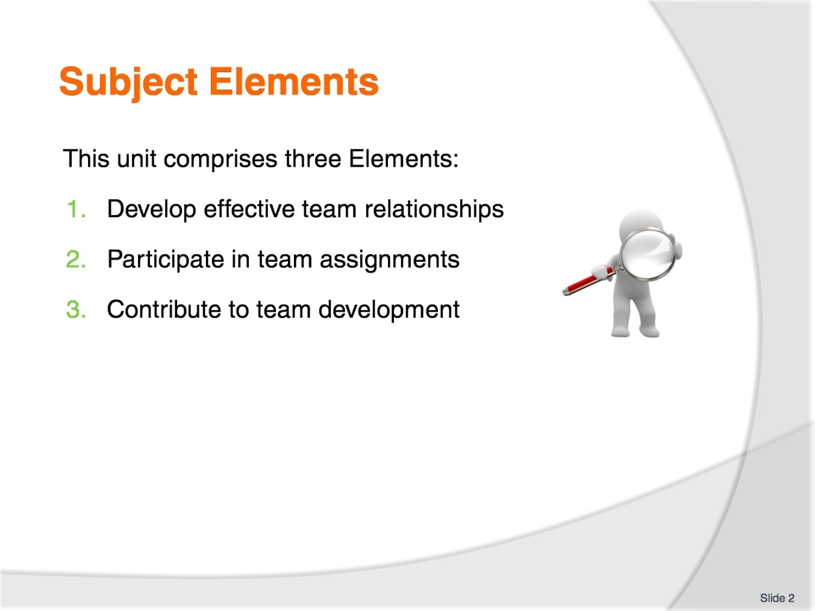
Slide No | Trainer Notes
Trainer advises this Unit comprises three Elements, as listed on the slide explaining:
Each Element comprises a number of Performance Criteria which will be identified throughout the class and explained in detail
Trainees can obtain more detail from their Trainee Manual
At times the course presents advice and information about various protocols but where their workplace requirements differ to what is presented, the workplace practices and standards, as well as policies and procedures must be observed.

Slide
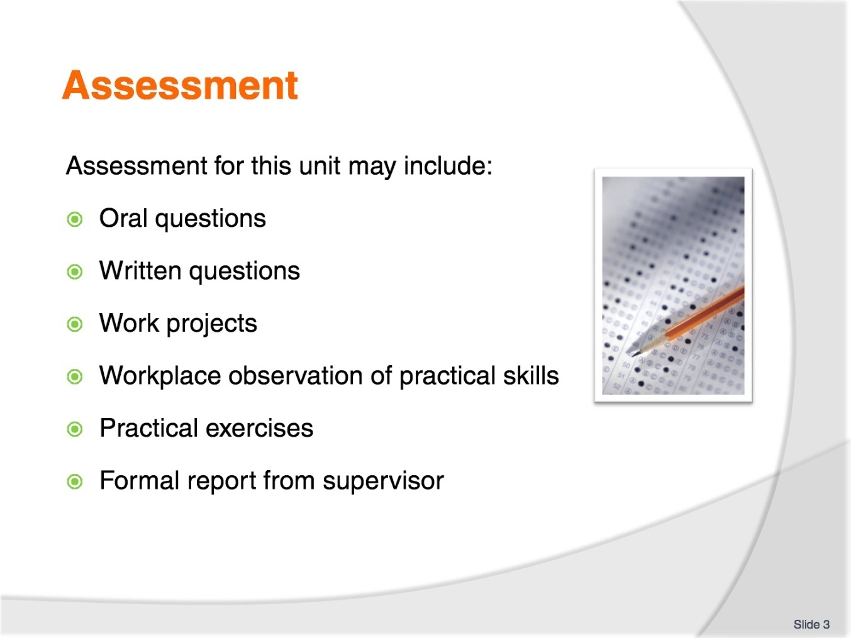
Slide No | Trainer Notes
Trainer advises that assessment for this Unit may take several forms all of which are aimed at verifying they have achieved competency for the Unit as required.
Trainer indicates the methods of assessment that will be applied to them for this Unit.

Slide
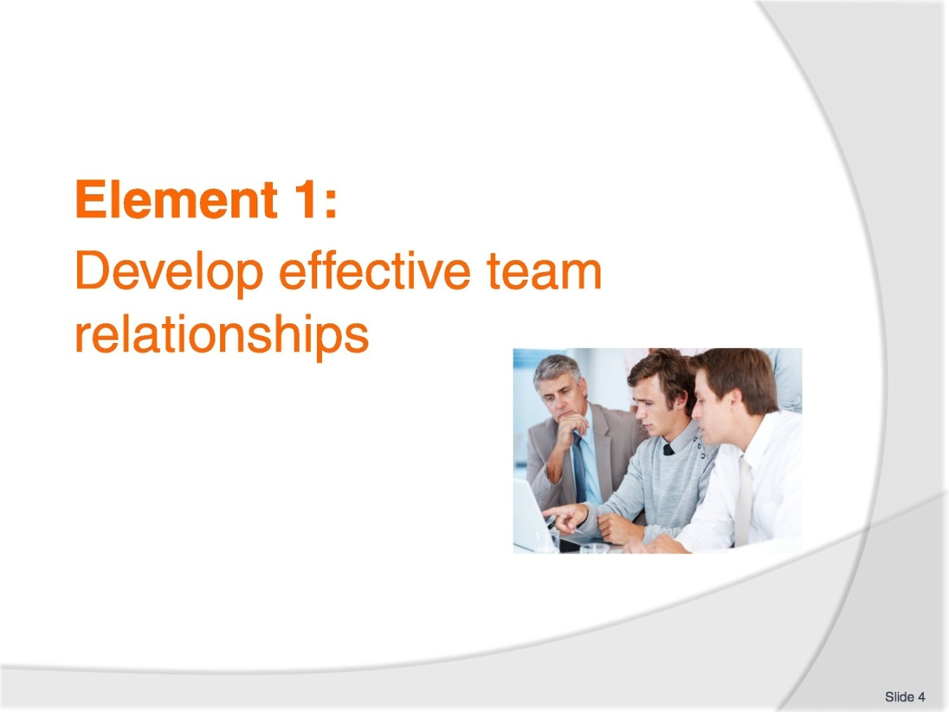
Slide No | Trainer Notes
Introduce topic.
Class Activity – General Discussion
Ask general questions:
What is a team?
What is the purpose of a team?
What types of teams exist?
What are characteristics of teams?

Slide
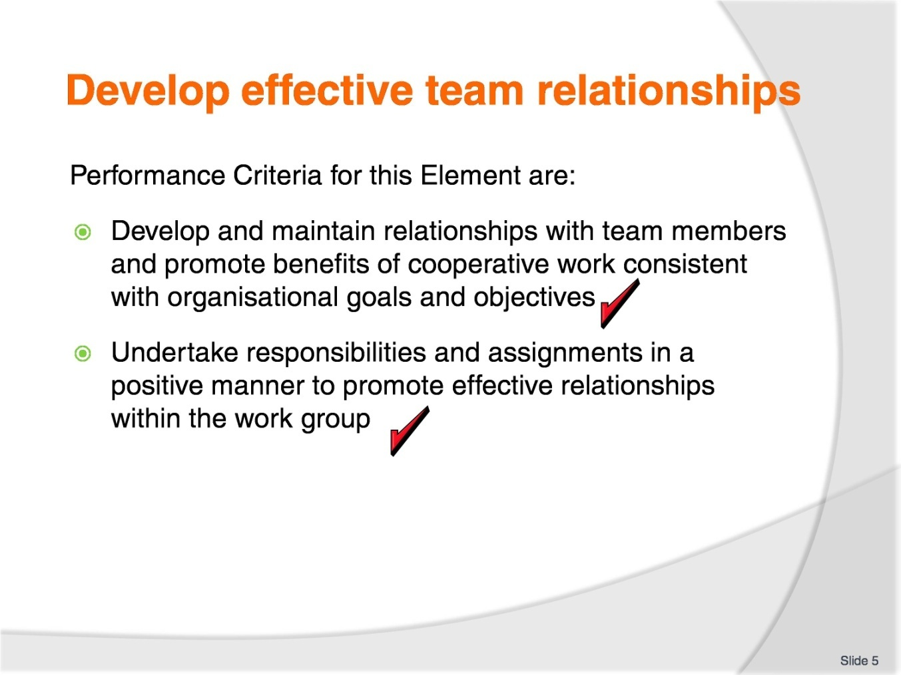
Slide No | Trainer Notes
 | Trainer identifies the Performance Criteria for this Element, as listed on the slide.

Slide
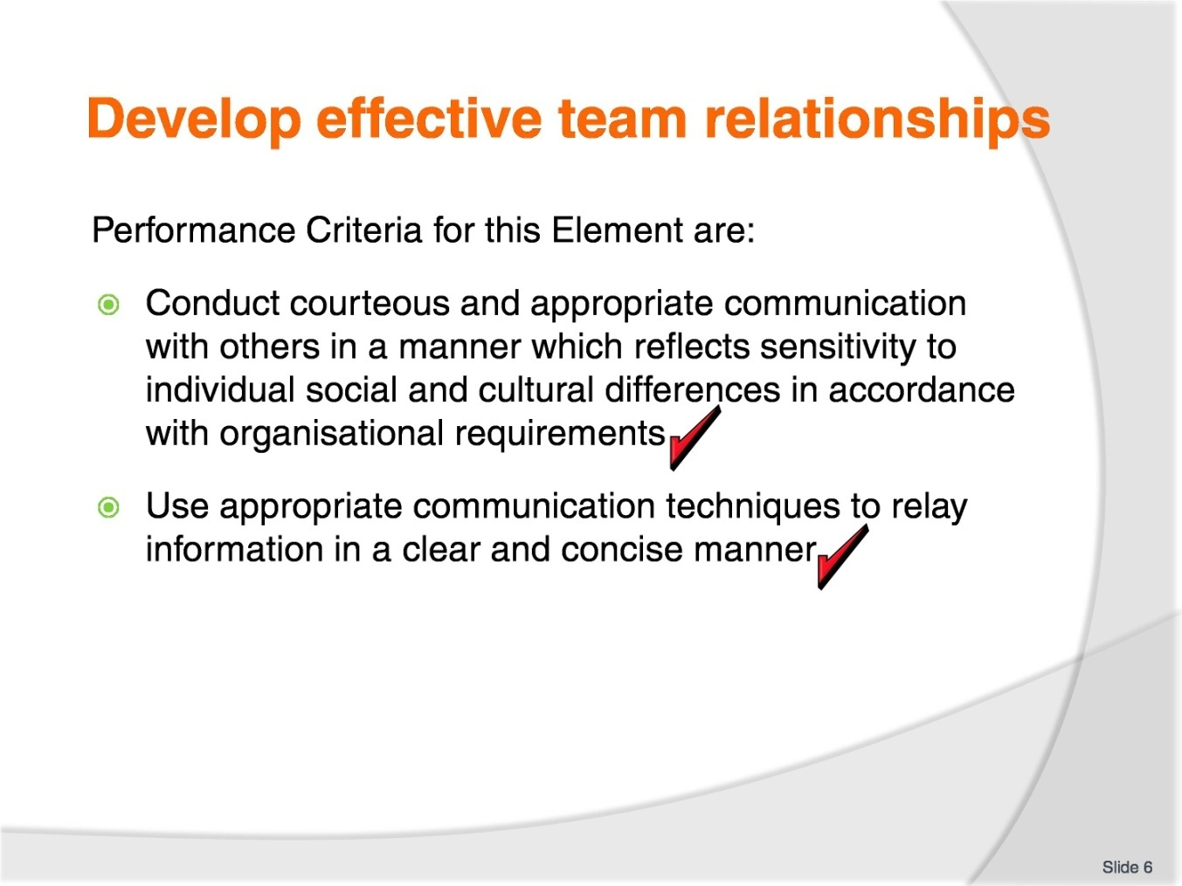
Slide No | Trainer Notes
 | Trainer identifies the Performance Criteria for this Element, as listed on the slide.

Slide
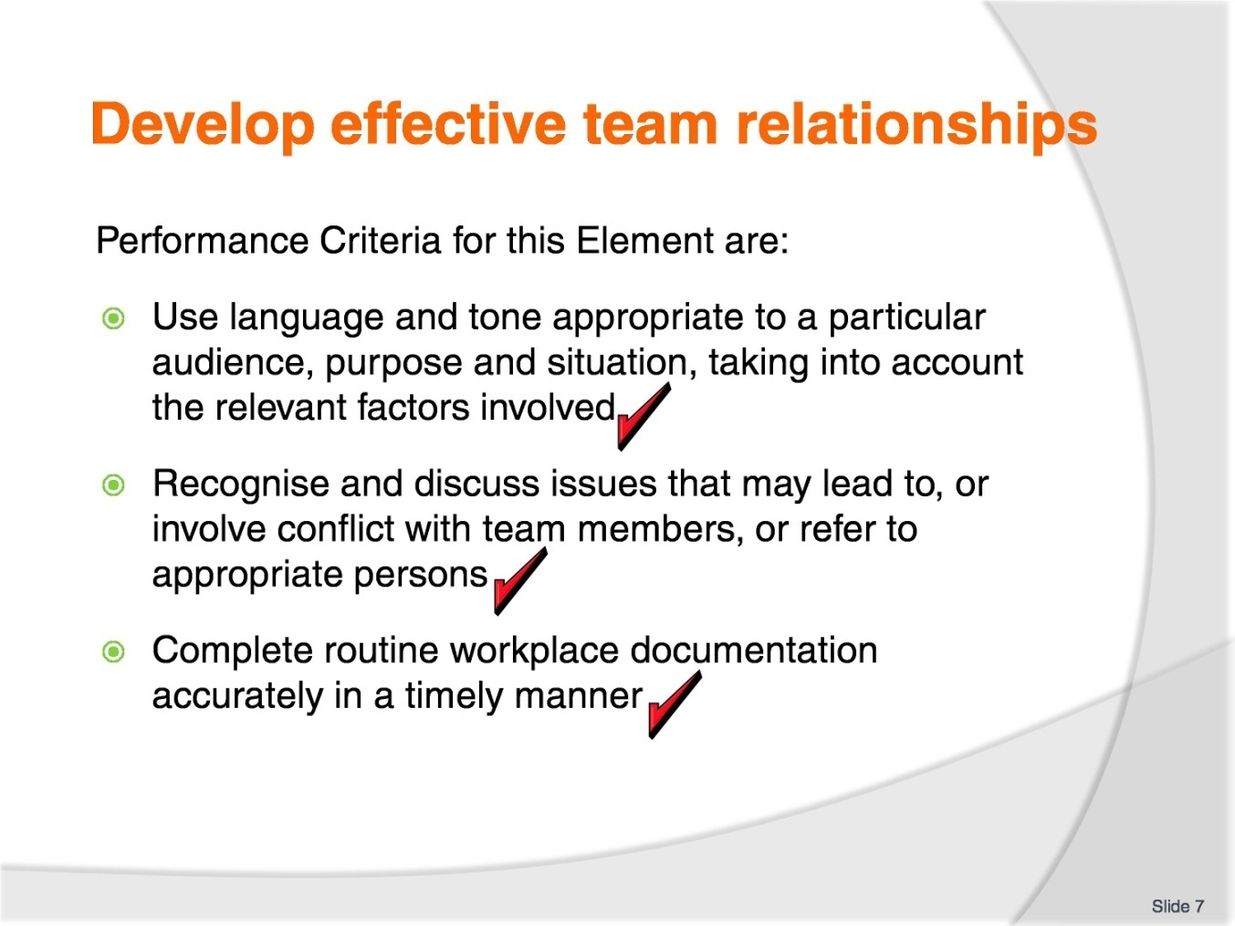
Slide No | Trainer Notes
 | Trainer identifies the Performance Criteria for this Element, as listed on the slide.

Slide
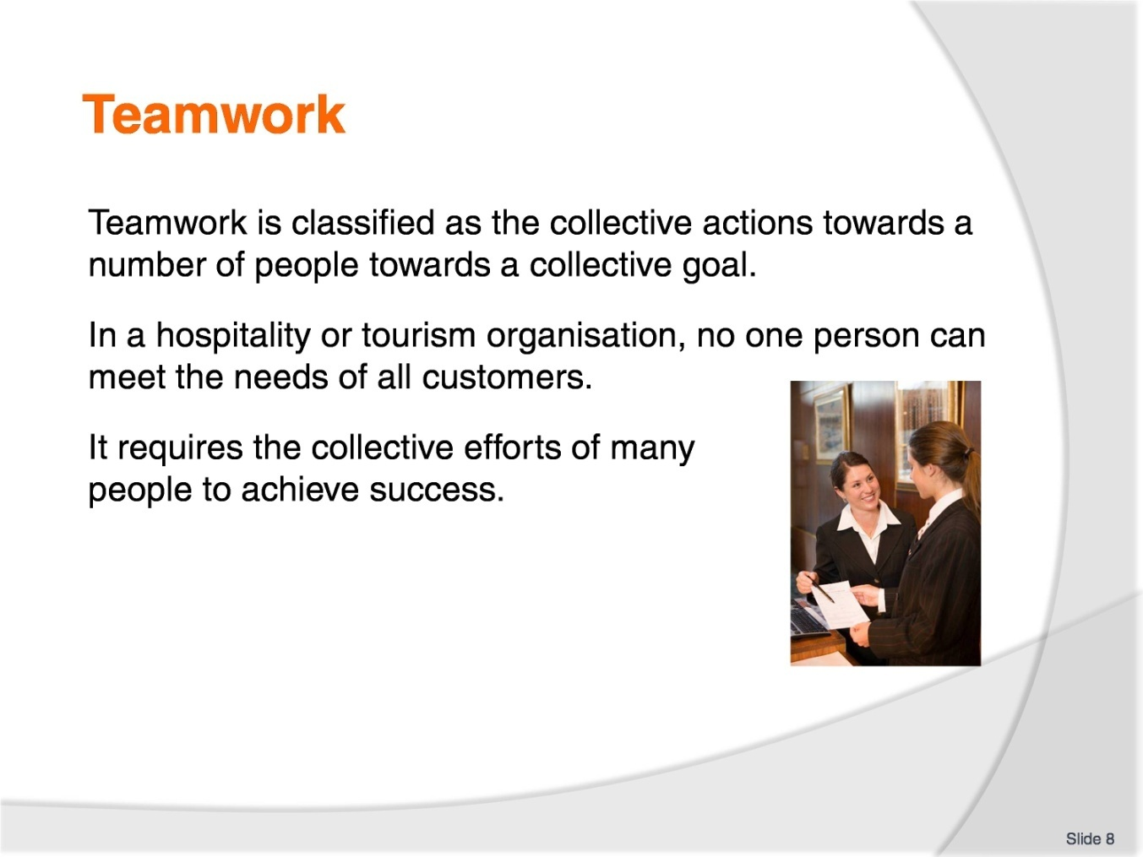
Slide No | Trainer Notes
Discuss the concept of a team.
Class Activity – Questions
What is teamwork and how is it developed?

Slide
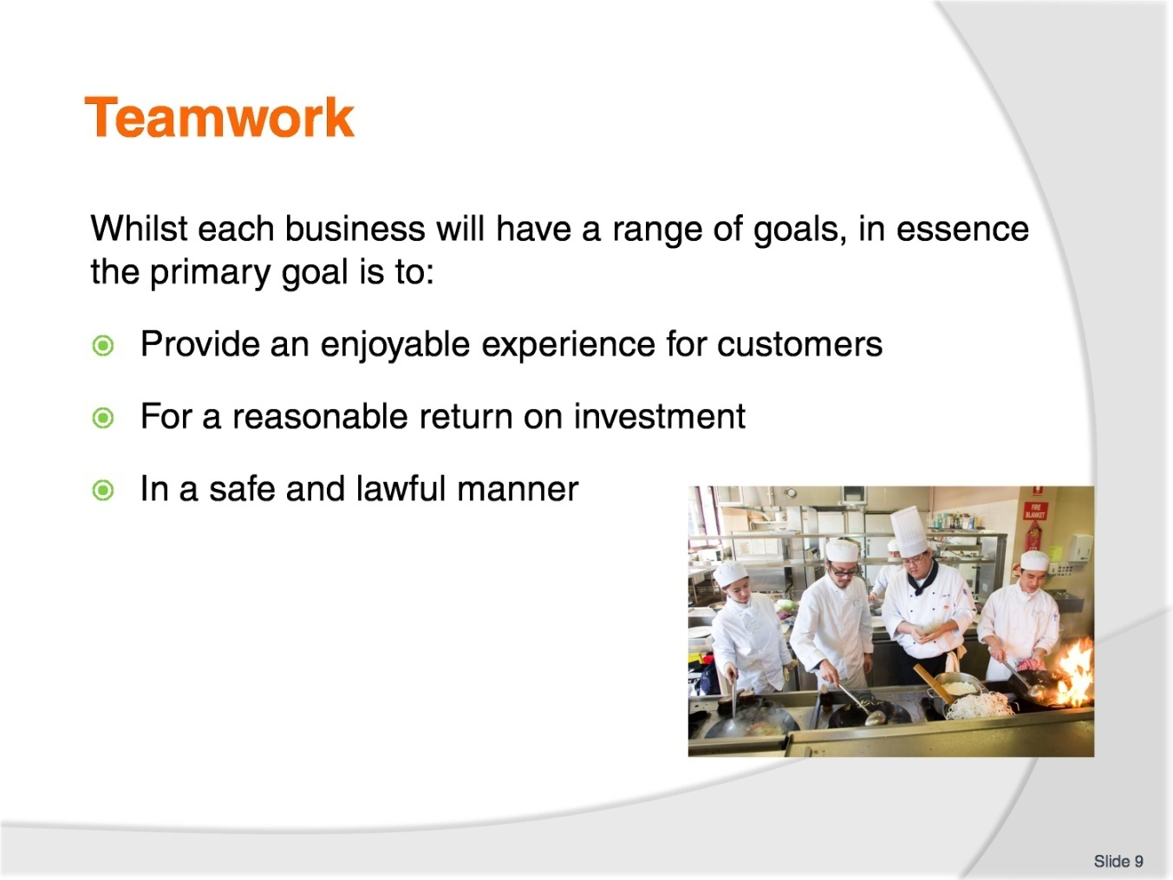
Slide No | Trainer Notes
 | Discuss the above points.

Slide
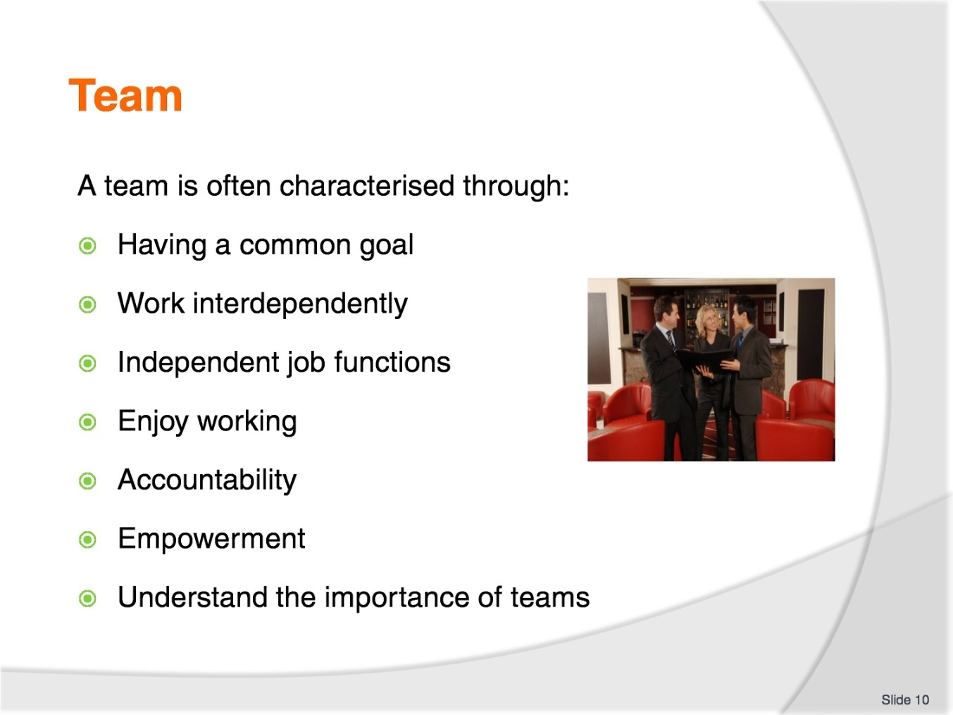
Slide No | Trainer Notes
A team is often characterised through:
Having a common goal – it is important all staff not only identify the goal, but why it is important
Work interdependently with each other – the actions of one person impacts other staff
Independent job functions – whilst staff are working together, they perform different roles and have different activities. Staff must understand how their actions contribute to the greater good of the team
Enjoy working together – this may be hard with different personalities, however in most cases people enjoy working together. Get staff involved in activities where they can find out more about each other
Accountability - staff will not only have their own responsibilities, but will also have collective responsibilities
Empowerment – staff have their own power to act and make decisions
Understand the importance of teams.

Slide
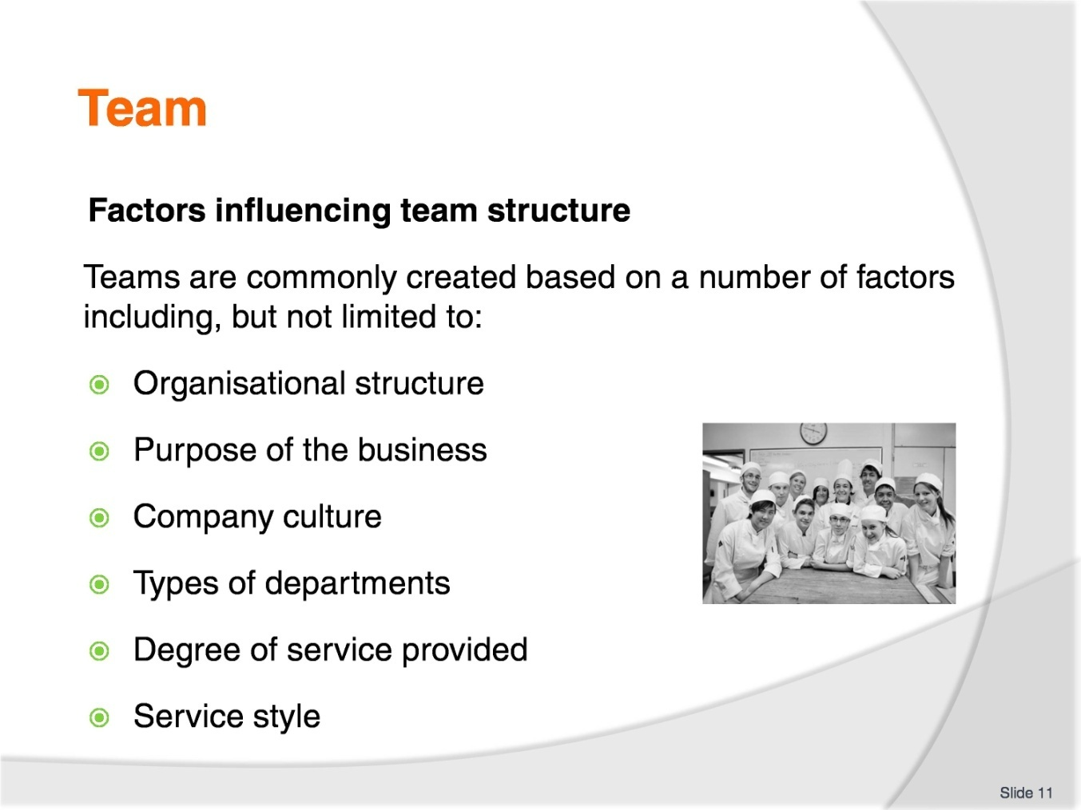
Slide No | Trainer Notes
Discuss impacts of team structure
Trainer to show or explain organisational structures for different styles of hospitality businesses.

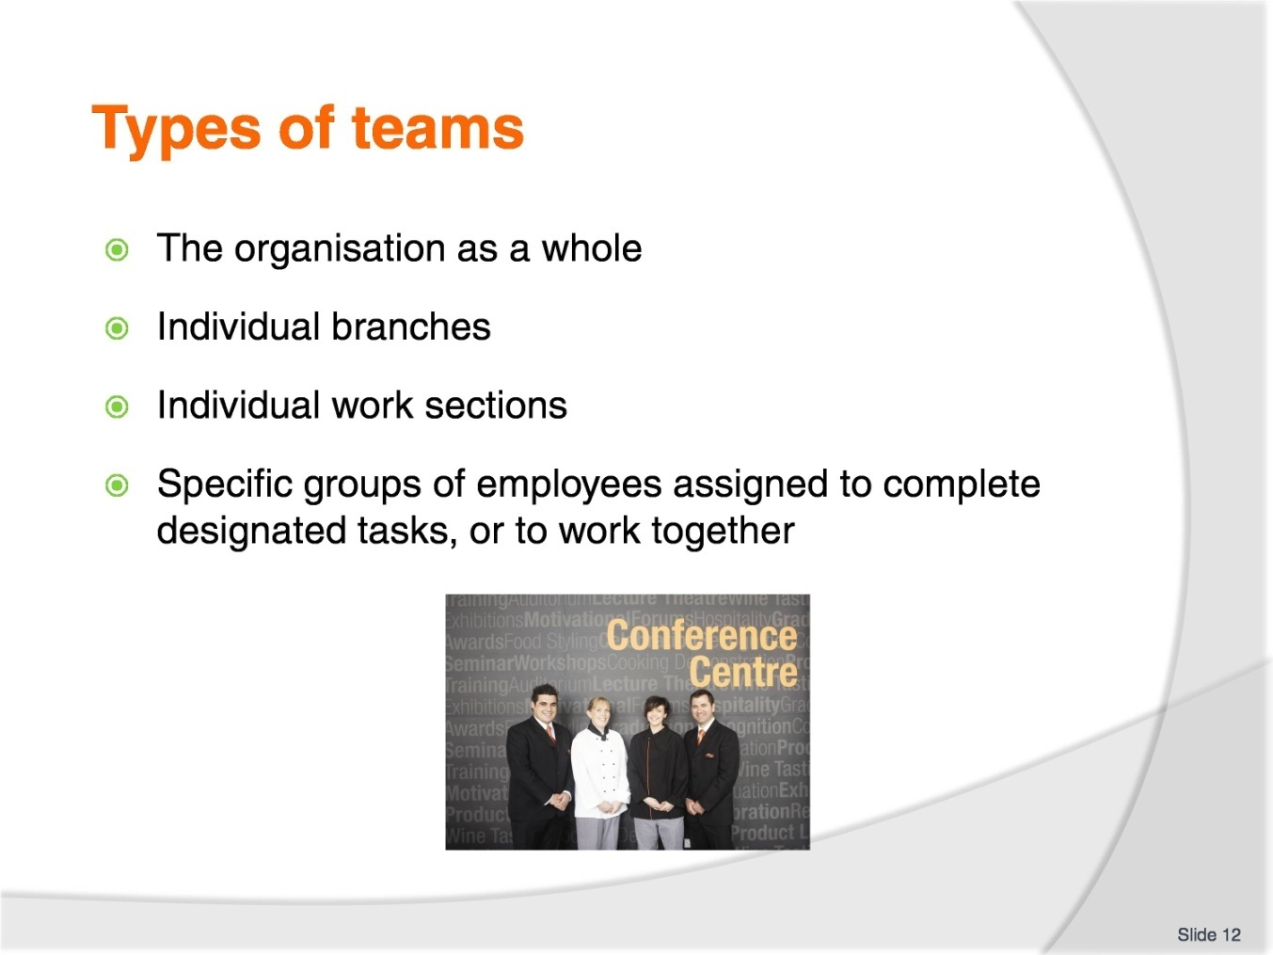
Slide No | Trainer Notes
Discussion
Discuss the different types of teams and how they are formed.

Slide
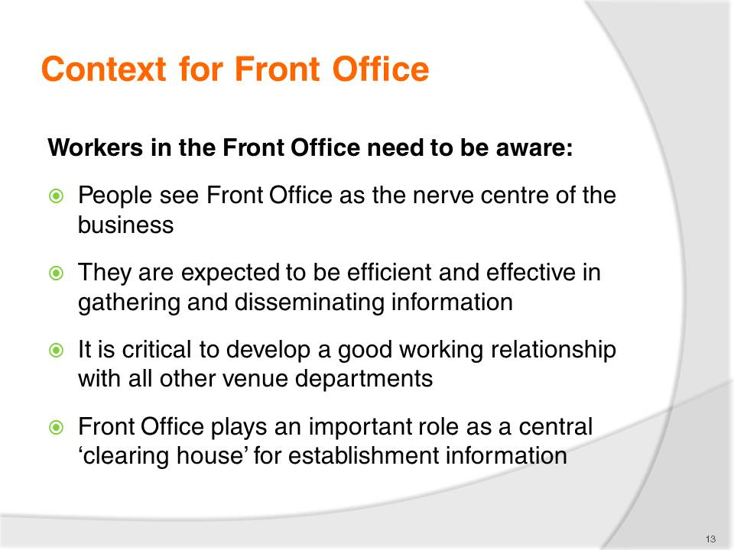
Slide No | Trainer Notes
Discussion
Discuss role of Front Office as a ‘clearing house’ for information.

Slide
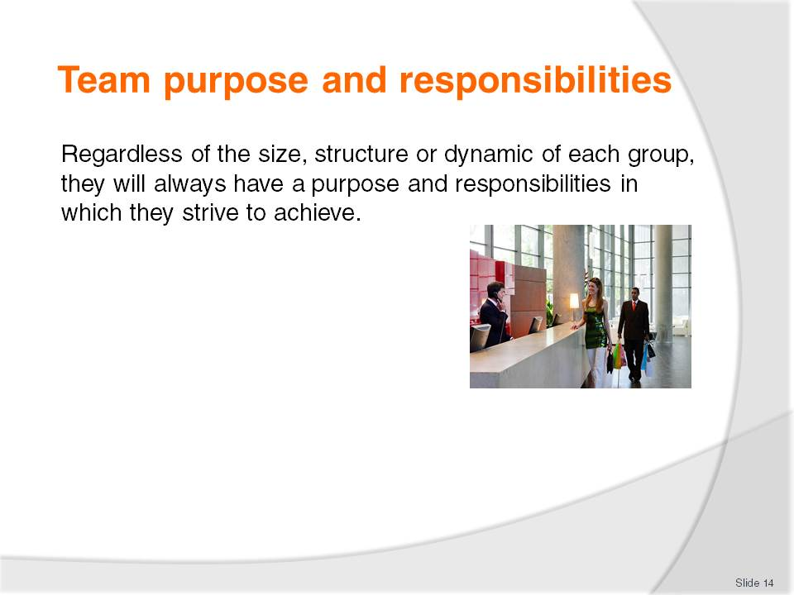
Slide No | Trainer Notes
Discussion
What are possible purposes and responsibilities each team will have?

Slide
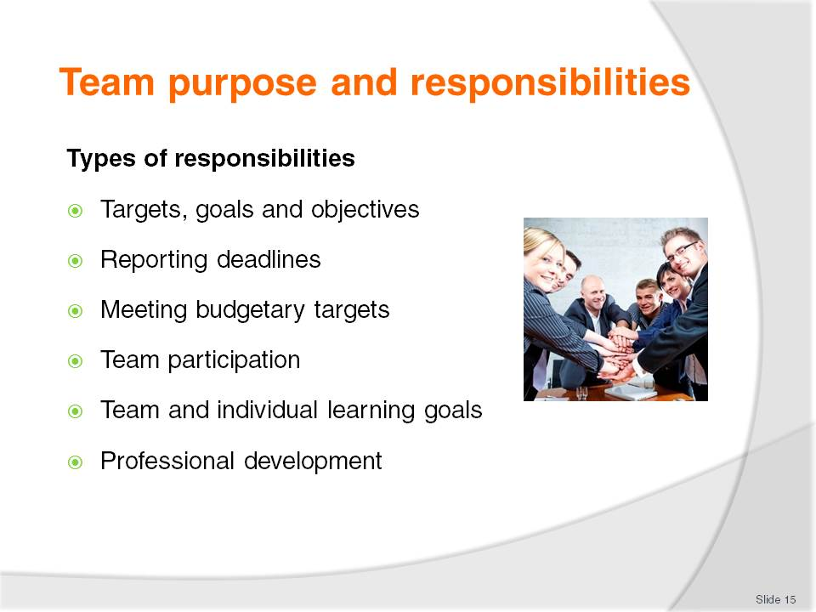
Slide No | Trainer Notes
Discussion
Discuss the importance of these responsibilities?
What other ones may exist?

Slide
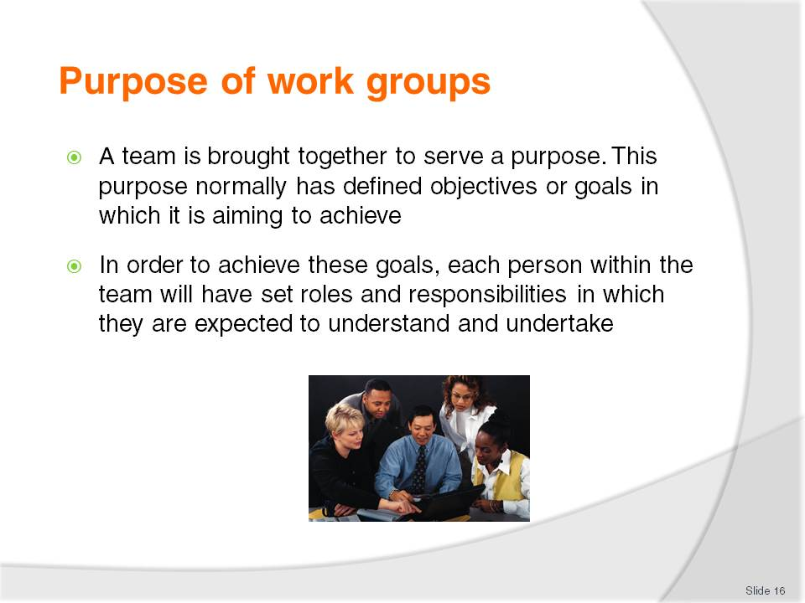
Slide No | Trainer Notes
Discussion
What roles and responsibilities does each team member have towards meeting overall team goals?
How are these defined?
What are the advantages and disadvantages of having work groups?

Slide
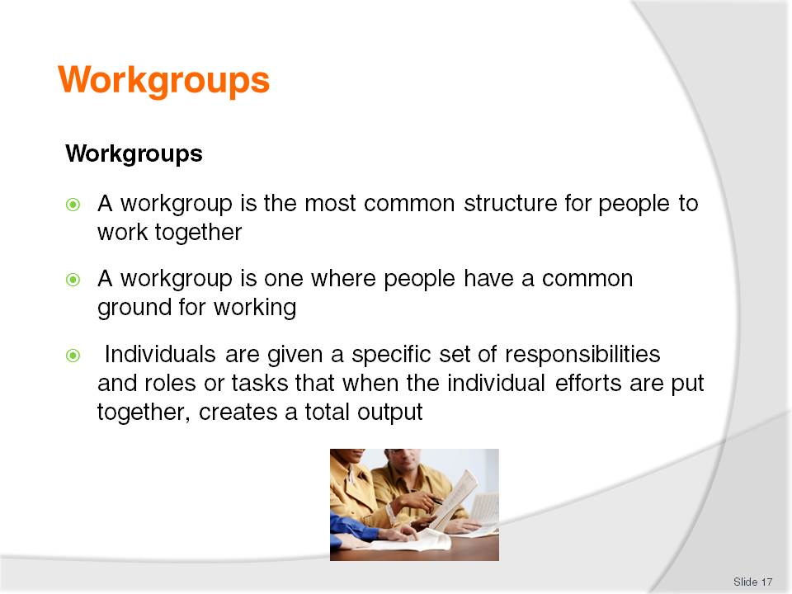
Slide No | Trainer Notes
Discussion
How are group members made aware of the responsibilities and assignments?

Slide
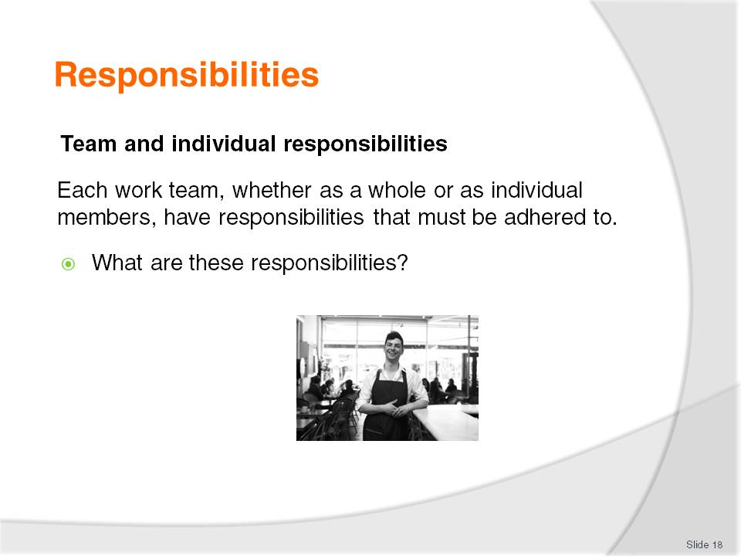
Slide No | Trainer Notes
Discussion
What are these responsibilities?

Slide
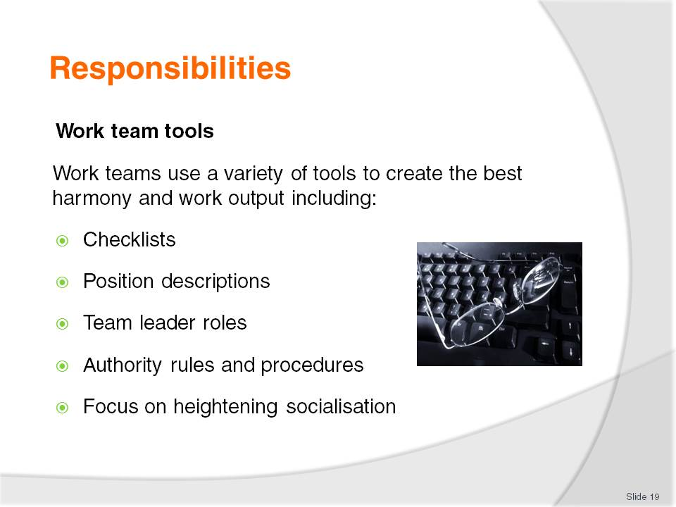
Slide No | Trainer Notes
Discussion & Review of documents
Discuss these tools
Trainer to provide examples of each for the audience to review.

Slide
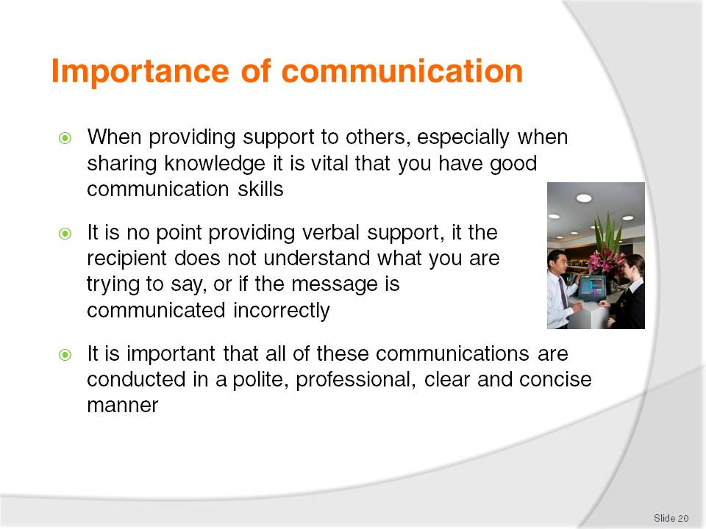
Slide No | Trainer Notes
Class Activity – Questions
How can you provide polite, professional, clear and concise information?

Slide
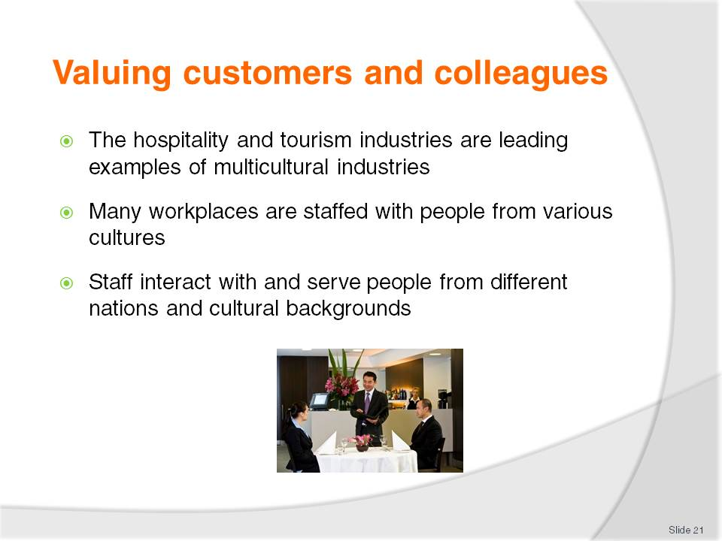
Slide No | Trainer Notes
Class Activity – General Discussion
Trainer leads a general class discussion how diverse a hospitality environment is
Staff - What diversity exists in your business in regards to staff? What countries do they come from? What different cultures exist?
Customers - What diversity exists in your business in regards to customers? What countries do they come from? What different cultures exist? What languages do they speak?

Slide
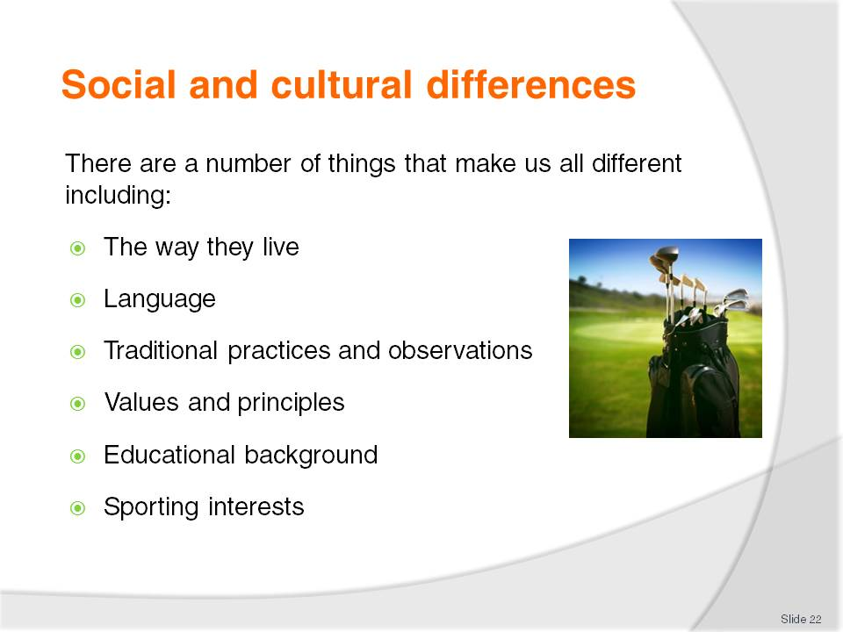
Slide No | Trainer Notes
Class Activity – General Discussion & Exercise (incorporates this and next slide)
Discuss the diversity of the audience in relation to these points. Write the answers down on the board.
You will find a great amount of diversity just amongst this group. Imagine the expanse of diversity given all the staff and customers in a typical hospitality business.
Given the list you have developed, what can a hospitality business do to help cater to these cultural differences?

Slide
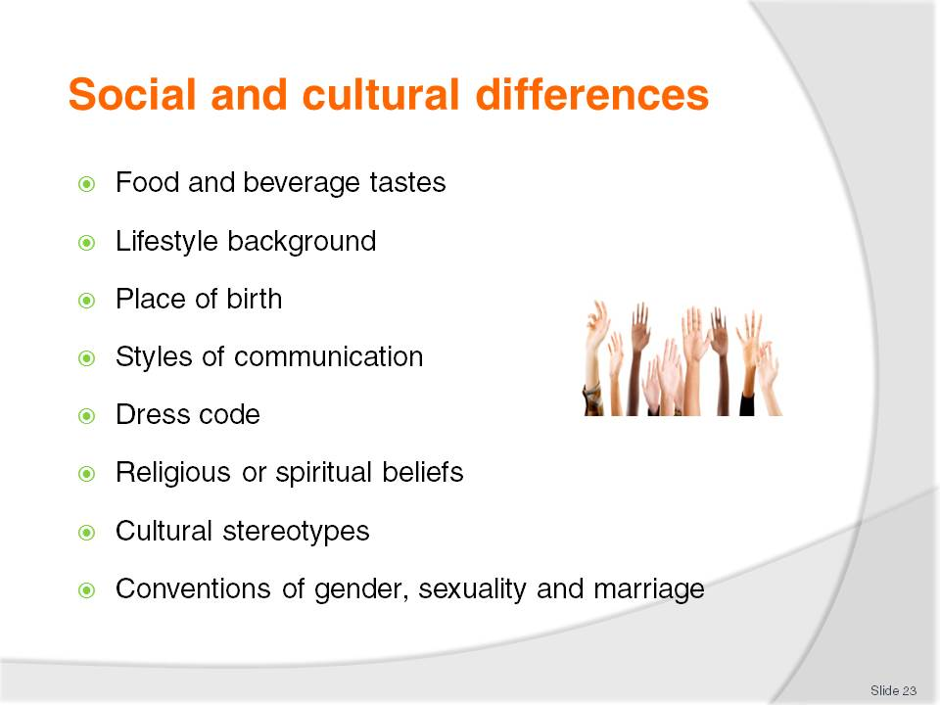
Slide No | Trainer Notes
Class Activity – General Discussion & Exercise (incorporates this and past slide)
Discuss the diversity of the audience in relation to these points. Write the answers down on the board.
You will find a great amount of diversity just amongst this group. Imagine the expanse of diversity given all the staff and customers in a typical hospitality business.
Given the list you have developed, what can a hospitality business do to help cater to these cultural differences?

Slide
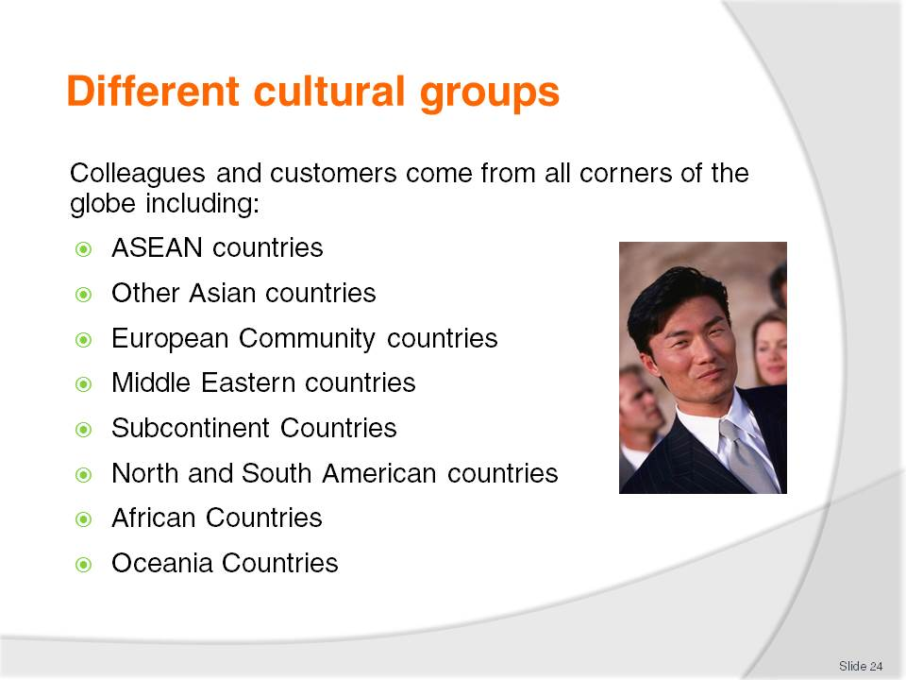
Slide No | Trainer Notes
Class Activity – List and discuss
Identify different countries located within the geographical areas listed in this slide
For each country identify some cultural characteristics and needs
Identify how a hospitality business can cater to these needs.

Slide
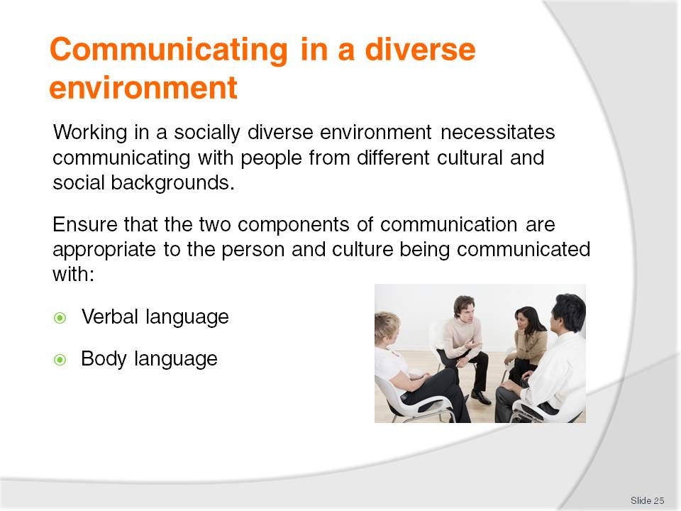
Slide No | Trainer Notes
Class Activity – Discussion
How do you use verbal language to communicate?
How do you use body language to communicate?

Slide
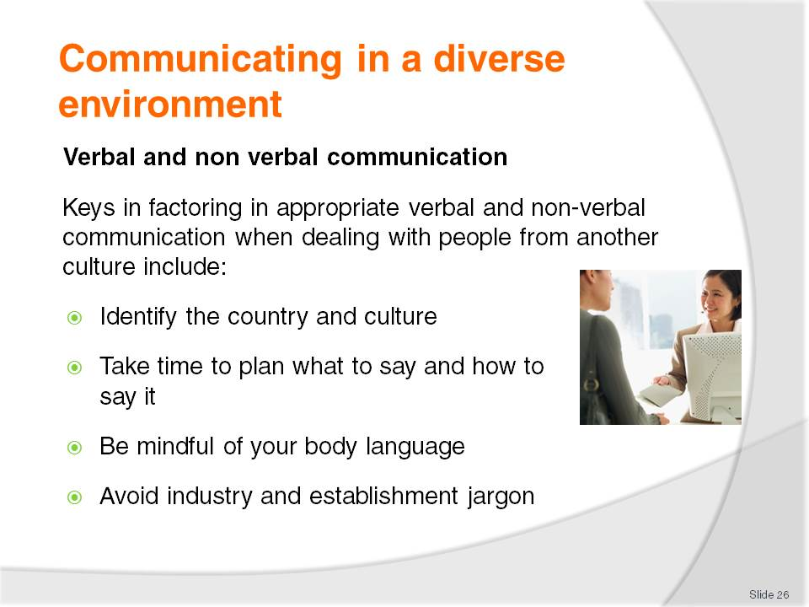
Slide No | Trainer Notes
Class Activity – Discussion
Provide examples for each point in this slide and how they can easily cause communication problems
Provide examples of how these can be applied correctly for effective communication.

Slide
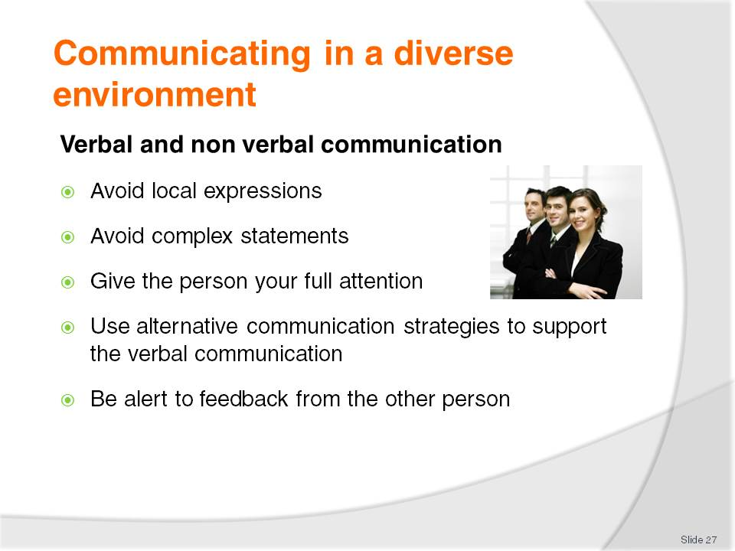
Slide No | Trainer Notes
Class Activity – Discussion
Provide examples for each point in this slide and how they can easily cause communication problems
Provide examples of how these can be applied correctly for effective communication.

Slide
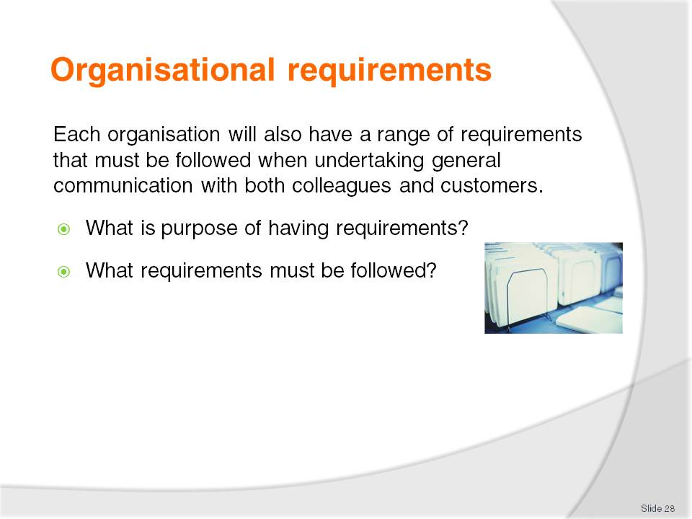
Slide No | Trainer Notes
Class Activity – Discussion
Discuss the questions in the slide.

Slide
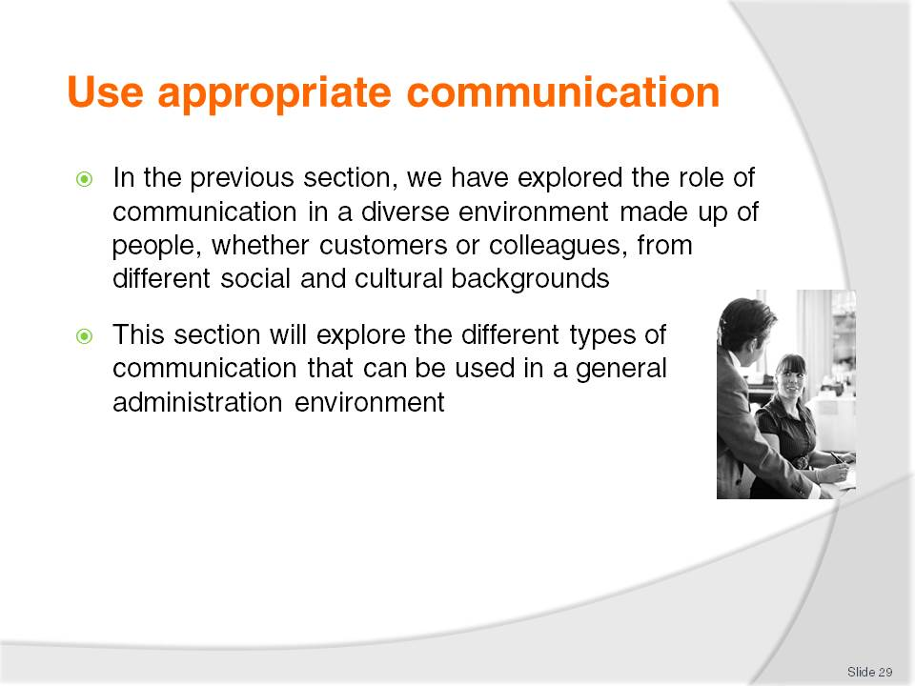
Slide No | Trainer Notes
Class Activity – Discussion
How do we communicate?
What are the different types of communication?
What are some tips to remember to make communication clear and concise?

Slide
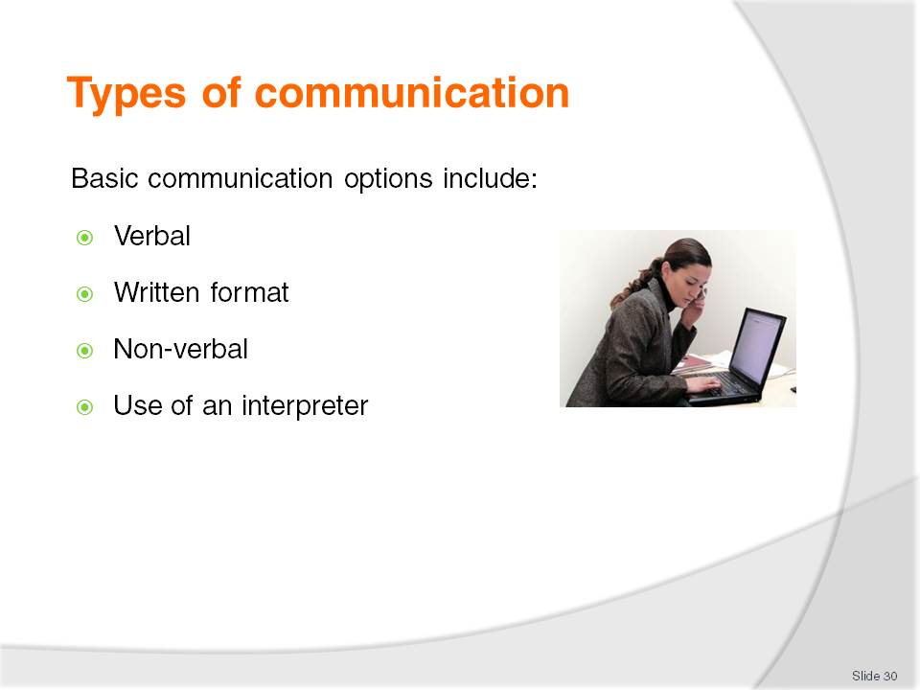
Slide No | Trainer Notes
There are a variety of communications mediums used in the industry. Some may be specific to a particular establishment or industry sector, and others are quite general across all industry types and venues.
The basic communication options include:
Verbal –including face-to-face communication and talking on the phone. This also embraces the use of languages other than English and the use of Indigenous languages
Written format – which includes electronic mail and hard copy communications such as letters, signs, labels, posters and advertising and warning material
Non-verbal – facial expressions, gestures, sign language
Use of an interpreter to interpret verbal and printed language.

Slide
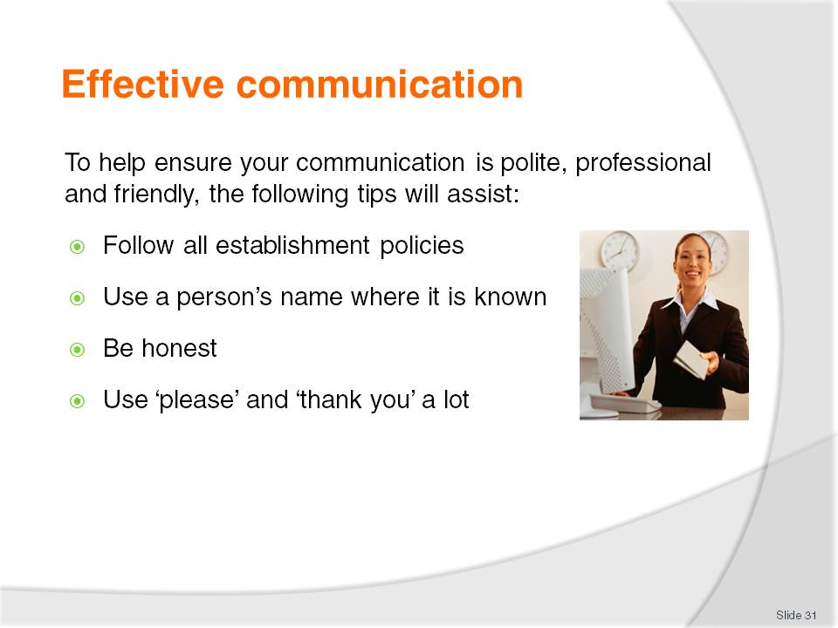
Slide No | Trainer Notes
To help ensure communication is polite, professional and friendly, the following tips will assist:
Follow all establishment policies regarding communication with customers and colleagues. These may exist for greeting customers, interacting with staff and answering the phone
Use a person’s name where it is known
Be honest – but be sensitive, tactful, caring and respectful
Use ‘please’ and ‘thank you’ a lot.

Slide
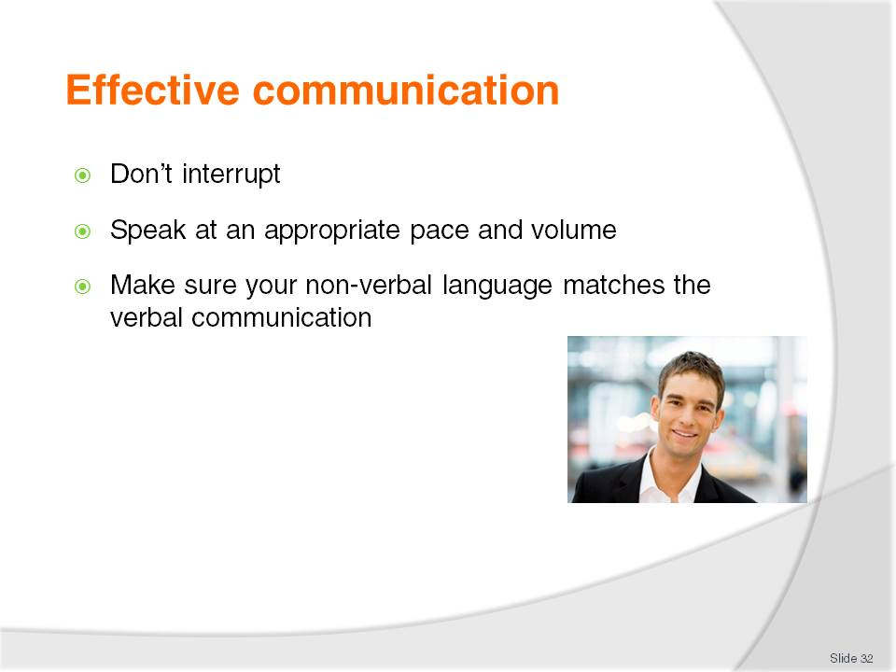
Slide No | Trainer Notes
To help ensure communication is polite, professional and friendly, the following tips will assist:
Don’t interrupt
Speak at an appropriate pace and volume – don’t’ yell, don’t whisper
Make sure your non-verbal language matches the verbal communication you are sending. This commonly means smiling when it is appropriate to do so, and displaying a serious demeanour when something serious is being discussed.

Slide
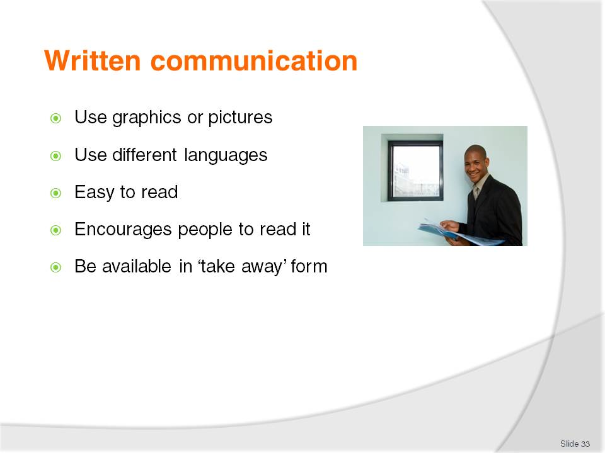
Slide No | Trainer Notes
This means that in some instances, written communication may need to:
Use graphics or pictures to help clarify meaning
Be produced in a language other than English
Be printed in a font that is easy to read and in a print size that encourages people to read it
Be available in ‘take away’ form so that people can take a copy with them to read later and or in more detail.
Class Activity – General Discussion & Review
Discuss ways written communication can be improved in a hotel
Audience to collect and discuss examples different businesses do to enhance their message through written documentation.

Slide
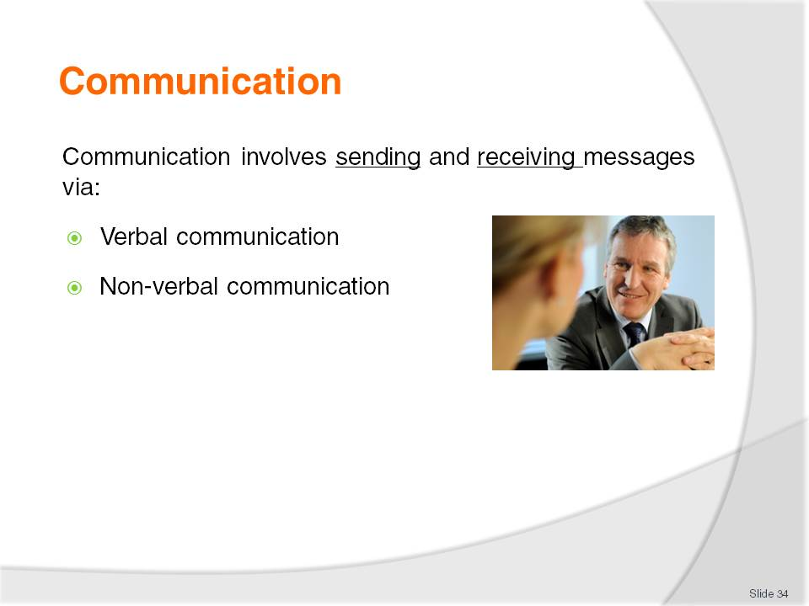
Slide No | Trainer Notes
Class Activity – General Discussion
What is the difference between verbal and non-verbal communication?
Which one is more effective and why?

Slide
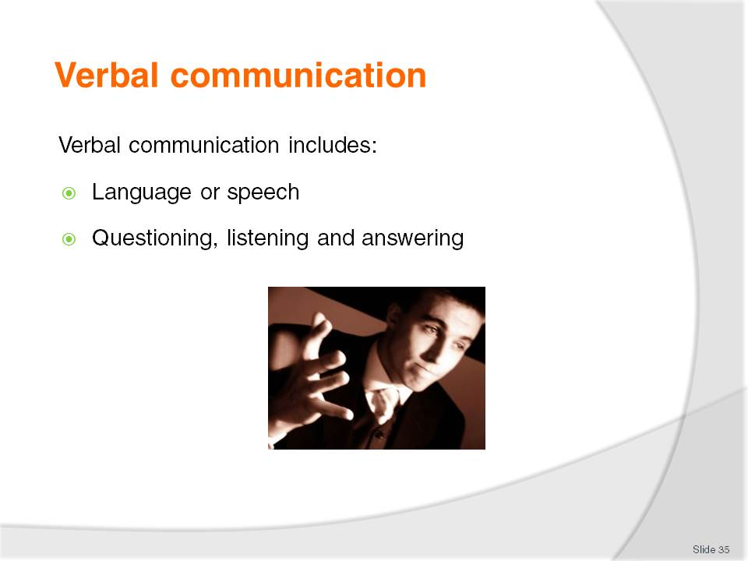
Slide No | Trainer Notes
 | Discuss the above points.

Slide
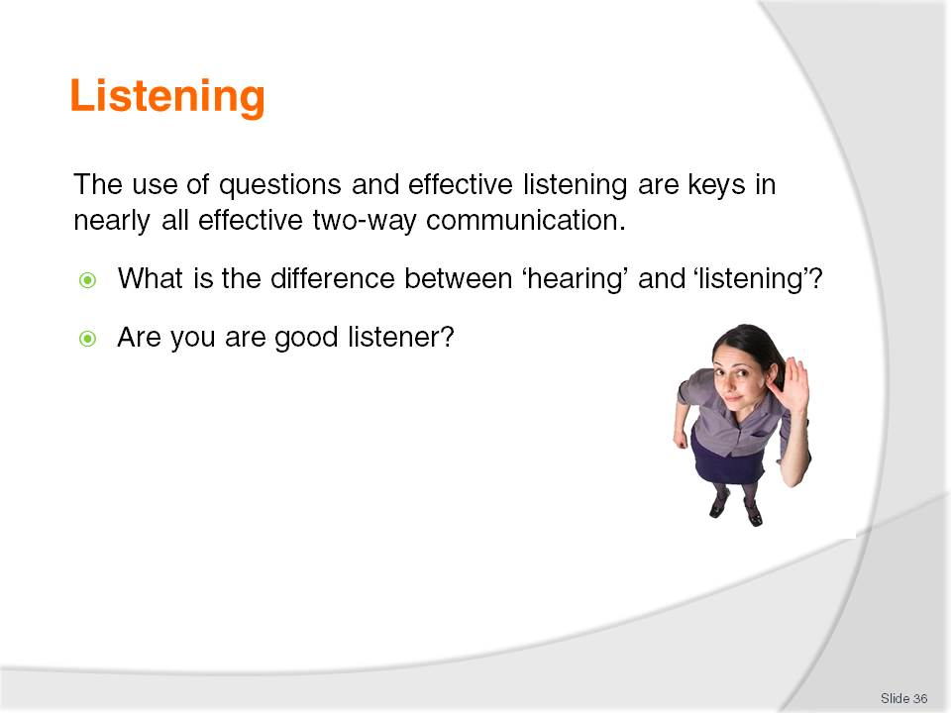
Slide No | Trainer Notes
Discuss points.
If someone is a good listener, what makes them a good listener?

Slide
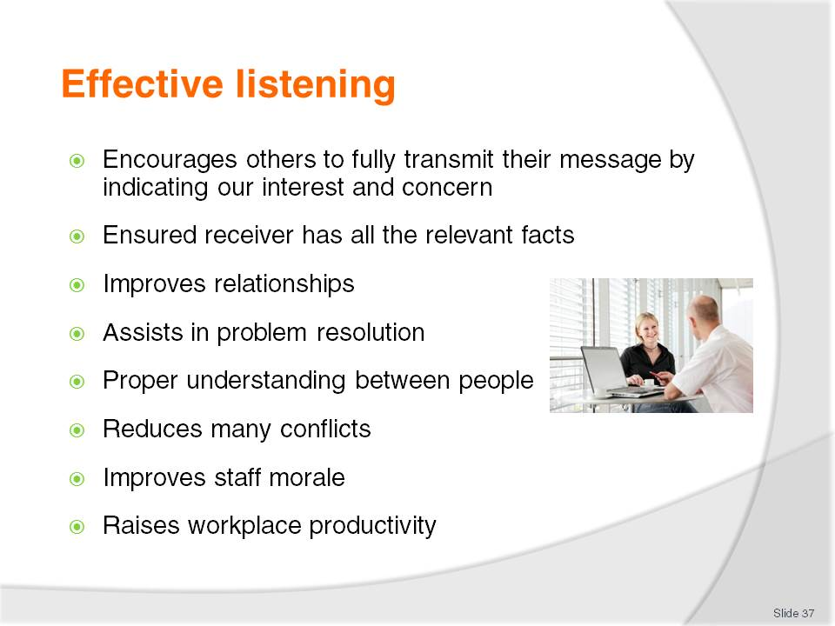
Slide No | Trainer Notes
 | Discuss points.

Slide
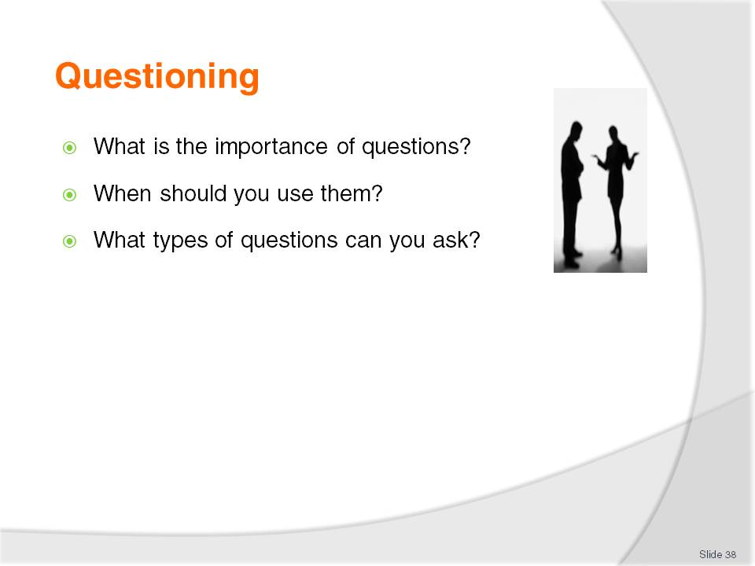
Slide No | Trainer Notes
 | Discuss the questions on this slide.

Slide
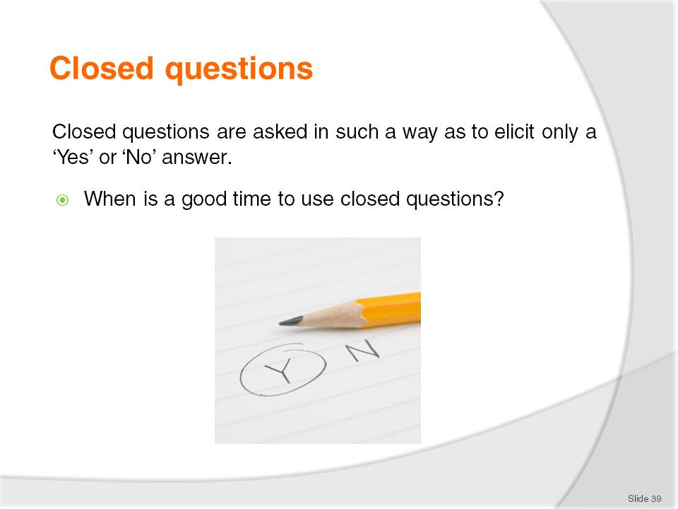
Slide No | Trainer Notes
Class Activity – General Discussion
Get the audience to identify times and to develop a list of suitable closed questions they could ask to a variety of scenarios.

Slide
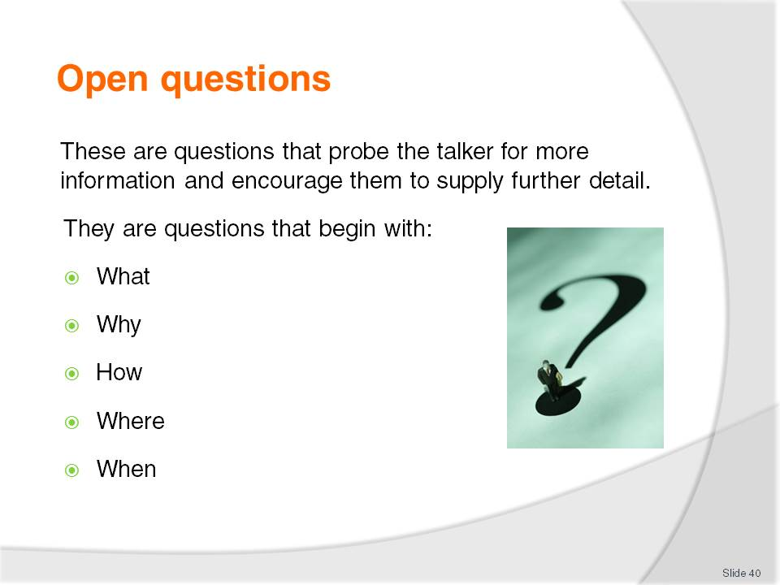
Slide No | Trainer Notes
Class Activity – General Discussion
Get the audience to develop a list of suitable open questions they could ask to a variety of scenarios.
In teams get audience to continue a conversation just using open questions, with the aim of not actually answering a question. This will make audience members to think about possible questions they could ask.

Slide
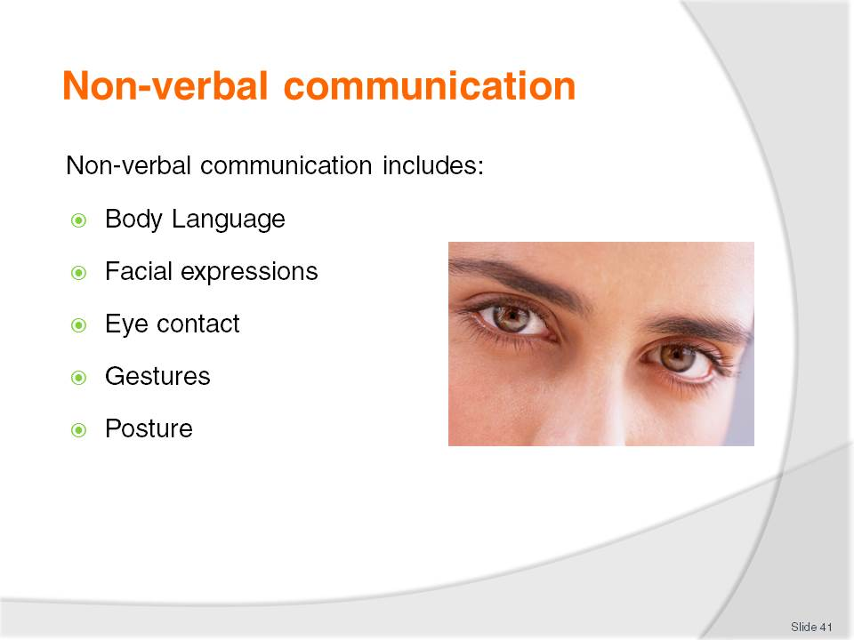
Slide No | Trainer Notes
Discuss each point identifying how these can be used to relay a message.
Class Activity – Activity
Get the audience to demonstrate a range of different communications using each of the points mentioned in this slide to depict a range of emotions.

Slide
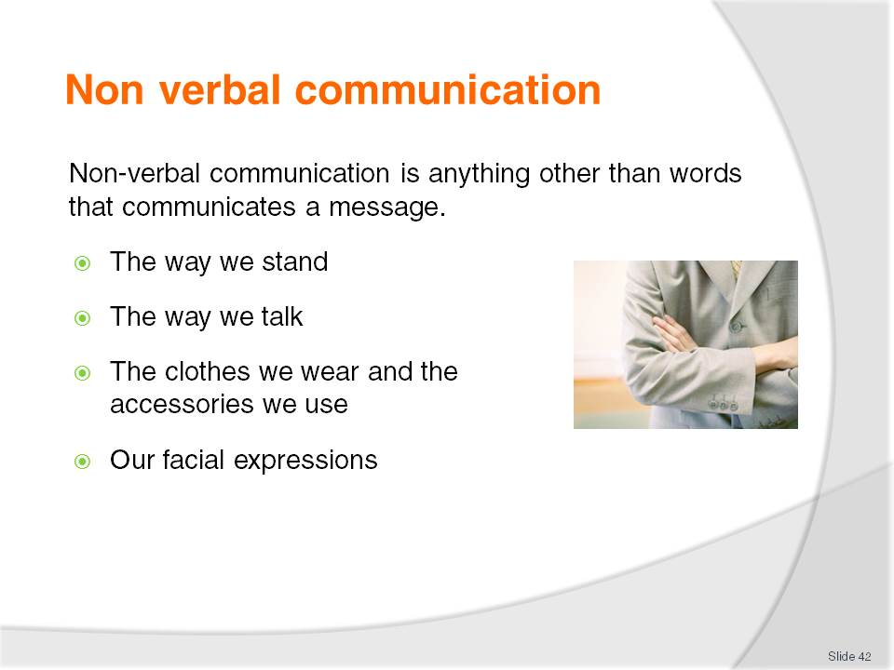
Slide No | Trainer Notes
Discuss point.
Class Activity – General Discussion
For each of the points identify different ways you can use this non-verbal communication to give different messages.

Slide
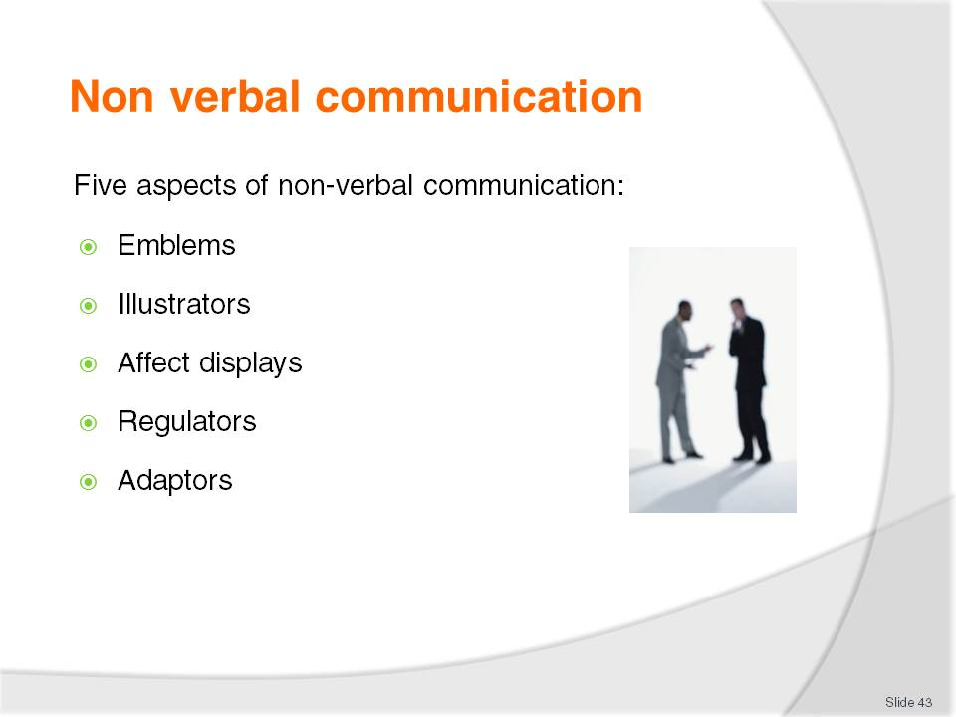
Slide No | Trainer Notes
Major aspects of non-verbal communication
Five distinct aspects of non-verbal communication have been identified.
Emblems
These are the explicit type of gestures/body language that are used with complete intention, and whose meanings are generally accepted and understood.
Examples are:
Cupping the hand to the ear to indicate ‘I can’t hear you’
Holding the forefinger vertically in front of the lips to indicate ‘Shhh, be quiet’.
Illustrators
These are mannerisms that are unique to individuals.
They are what people do when talking. They are used to reinforce the verbal message they are sending.
They are usually related to the use of the hands, but they also include things that mark a person’s speech, such as the way one person may end a sentence, pauses in their speech, and emphasises words.
While these mannerisms are individualistic, the people are usually not aware that they do them until they see themselves on video-tape or hear themselves on audio-tape.

Affect displays
These are the ways in which our facial expressions or our body movements reveal
our emotions.
In everyday life, people tend not to monitor or intentionally control their affect displays. Their true emotions are allowed to show.
In certain workplace situations however, staff may be required to display emotions that are contrary to their real feelings.
This is the case where staff primarily have customer-contact that requires them to smile all the time and present themselves as happy and nice when they may even feel the opposite.
Regulators
Everyone expresses themselves using regulators.
They are behaviours such as:
Nods
Stance
The direction and the duration of someone’s gaze
Vocal pitch
Raised eyebrows
The position/inclination of the head.
These behaviours regulate the verbal message, for instance, making it stronger or gentler, more authoritative or friendlier, casual or more formal. Just like illustrators, regulators are hardly noticed by the person speaking, but they are certainly noticed by others.
Adaptors
These are unconscious behaviours that are mainly nervous in nature.
People are generally unaware of making them.
Examples are:
Doodling during meetings
Itching your nose in a meeting
Picking your nails in a meeting
Scratching.

Slide
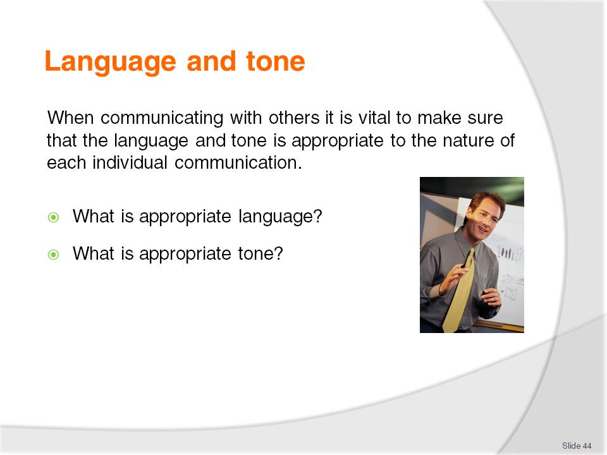
Slide No | Trainer Notes
This highlights that many communications need to be undertaken taking into account the context in which each communication occurs.
This means there is a need to modify most communications to suit the individual set of circumstances that apply, and to take into account the individual with whom the communication is taking place.

Slide
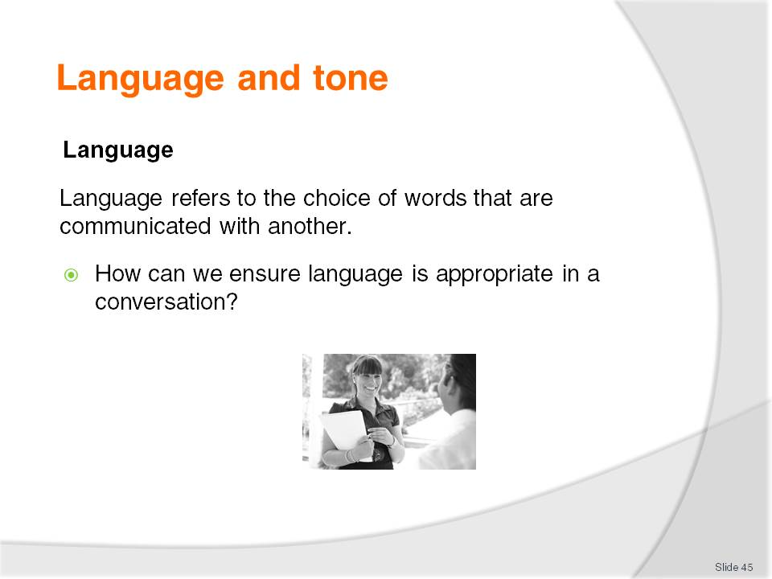
Slide No | Trainer Notes
 | Discuss the question in the slide.

Slide
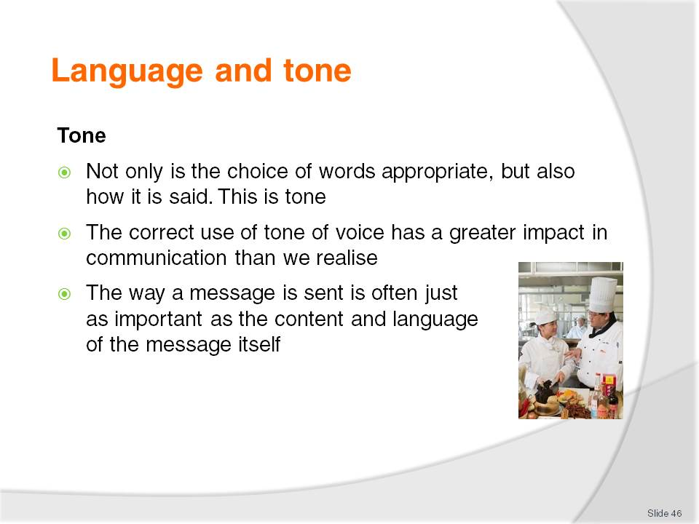
Slide No | Trainer Notes
Discussion
How can you change tone?

Slide
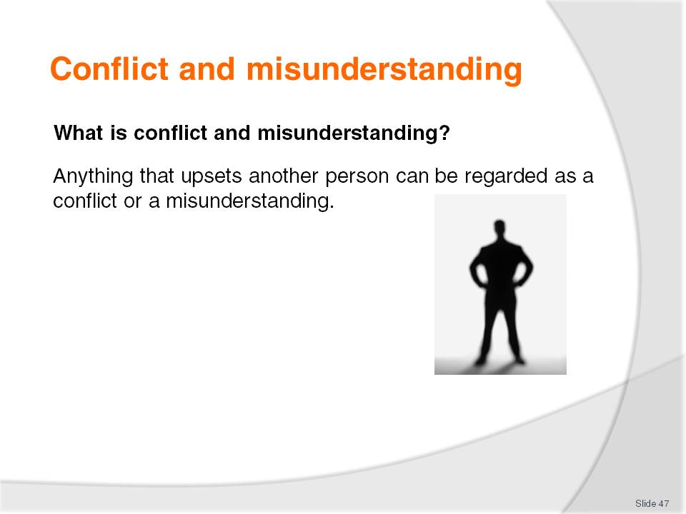
Slide No | Trainer Notes
Class Activity – Discussion
What are common conflicts you have in your private life?
What causes them?
How can they be solved?

Slide
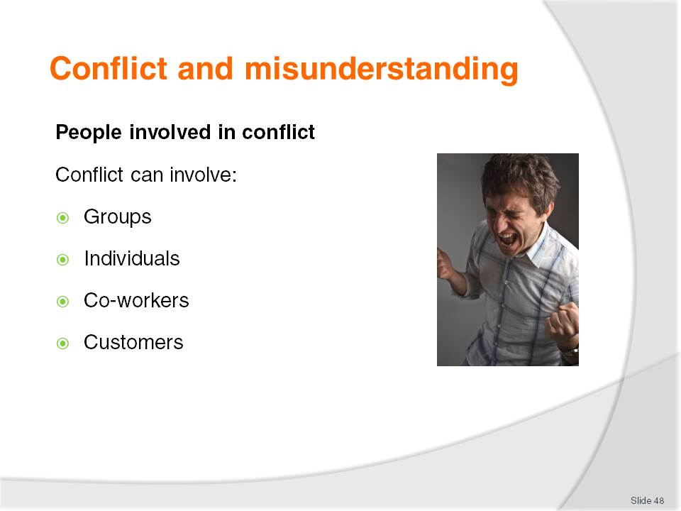
Slide No | Trainer Notes
Class Activity – Discussion
What are common conflicts that affect these different people?

Slide
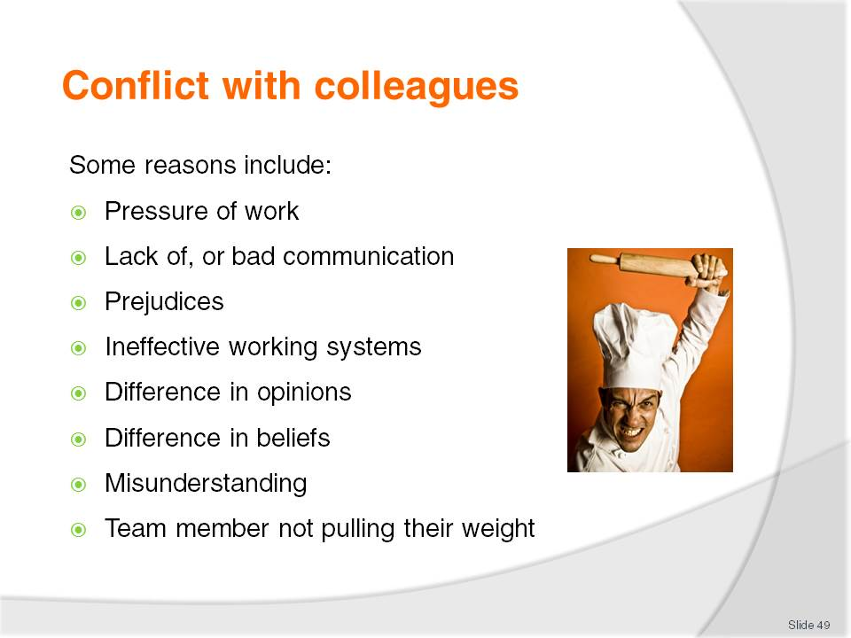
Slide No | Trainer Notes
Class Activity – General Discussion
Provide some examples for each point in this slide including suggestions for reducing the conflict.

Slide
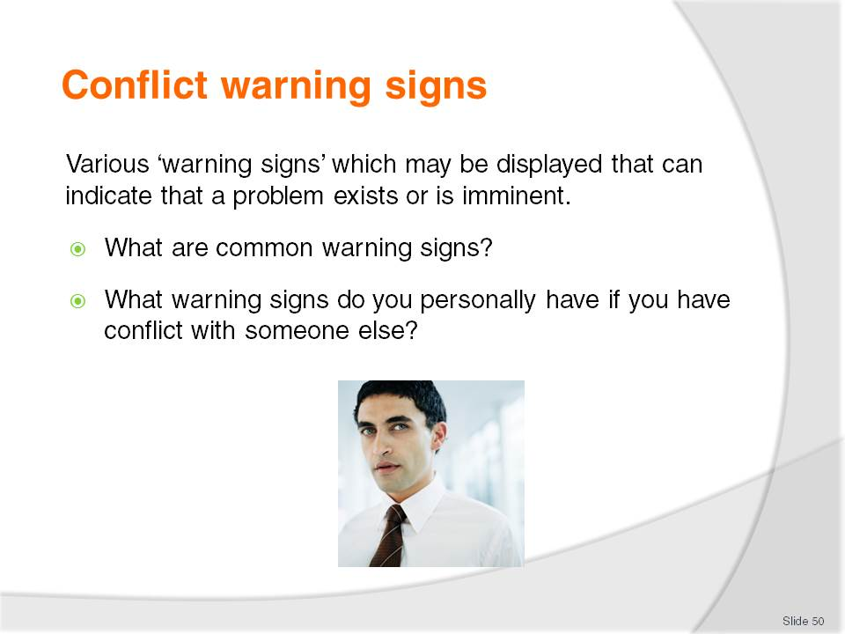
Slide No | Trainer Notes
Class Activity – General Discussion
Discuss the questions in the slide.

Slide
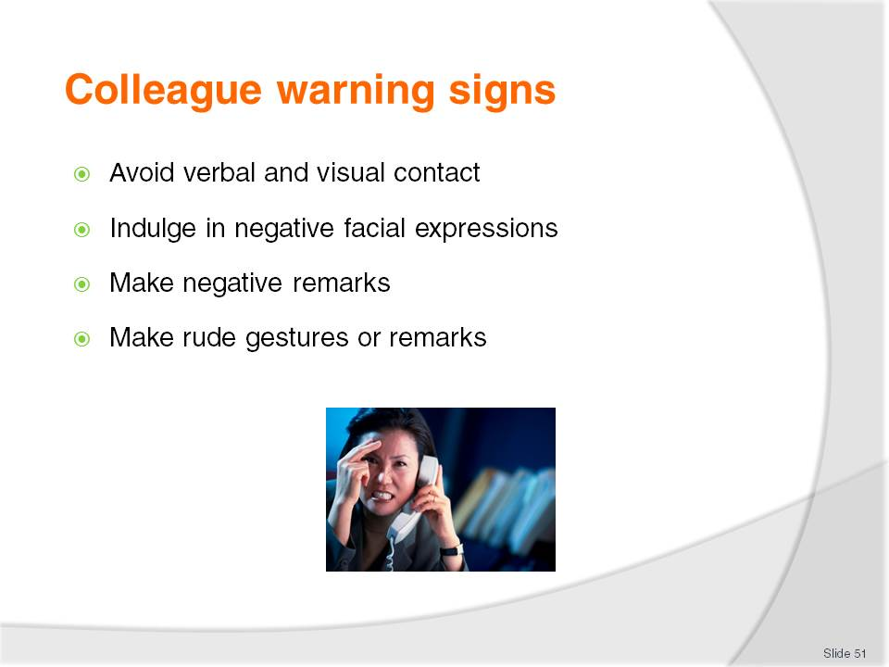
Slide No | Trainer Notes
Trainer presents possible warning signs:
Avoid verbal and visual contact – taking breaks in physically different areas, avoiding walking down the same corridor, asking for shifts that help avoid the chance of contact, sitting so that the other person is not in the direct line of sight
Indulge in negative facial expressions – the person may sneer your way, roll their eyes and shake their head slowly from side-to-side, or purse their lips
Make negative remarks – this can spill over into areas that are outside the initial cause of the conflict. For example, a staff member may be annoyed that you didn’t help doing the cleaning up after a function. Their perception was that you are a slacker, you are lazy and not a team player
The truth is that the boss told you to go home because you had been at work for twelve hours that day, and were required back early the following day. The negative remarks will not stop at your perceived laziness, but will usually involve unrelated areas such as your attitude, your relationships with others, your personal habits, and so on
Make rude gestures or remarks – these can be offensive remarks (perhaps of a sexual nature) or finger and forearm gestures designed to convey a specific message.

Slide
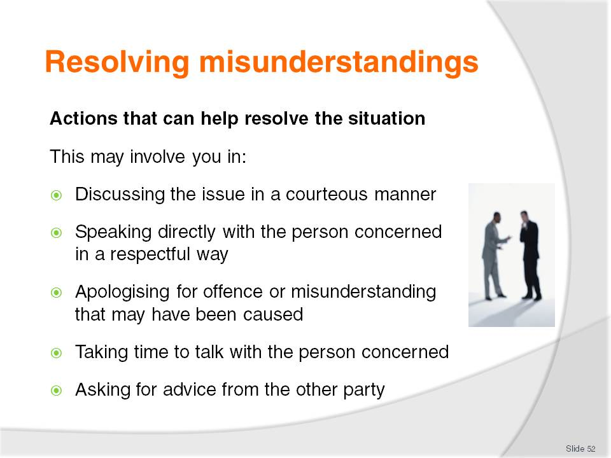
Slide No | Trainer Notes
Class Activity – Discussion
Discuss points.

Slide
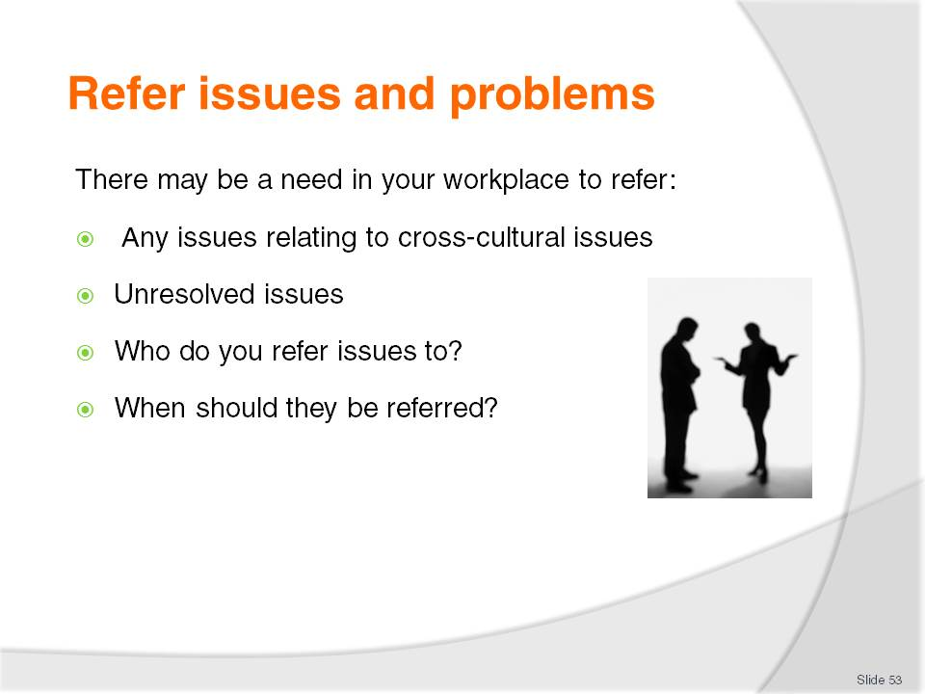
Slide No | Trainer Notes
Class Activity – Discussion
Discuss questions in the slide.

Slide
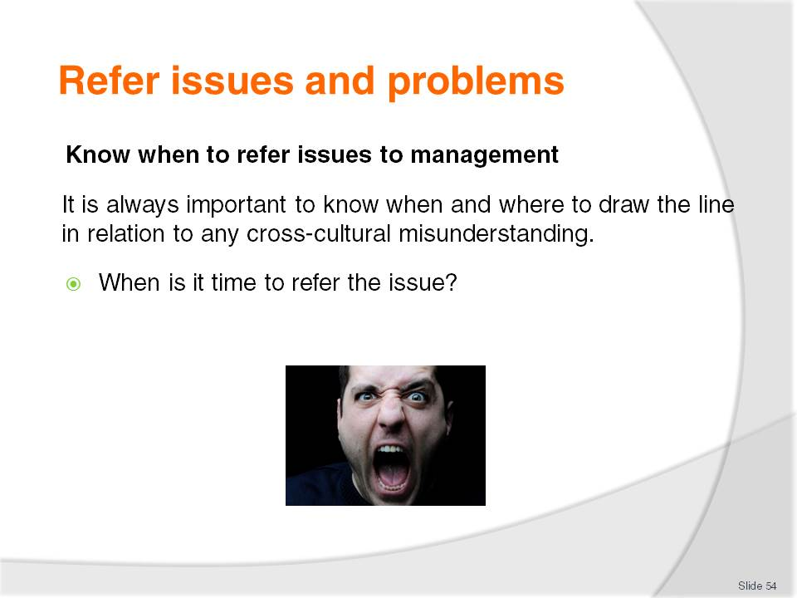
Slide No | Trainer Notes
Class Activity – Discussion
What is ‘your line’ when it is time to stop handling a situation and to refer it to someone else?

Slide
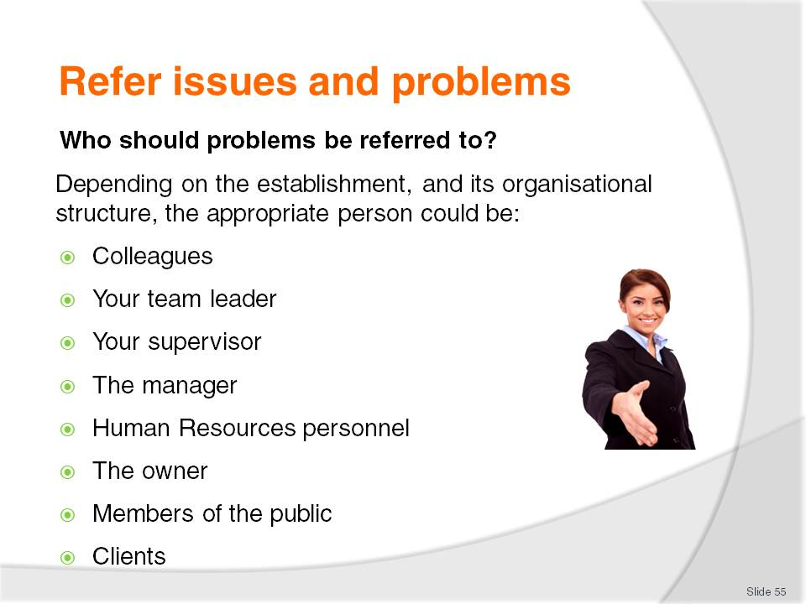
Slide No | Trainer Notes
Class Activity – Discussion
What is the protocol of referring issues?
Is the team leader or supervisor the first contact point or can you go higher?
When do you do higher?

Slide
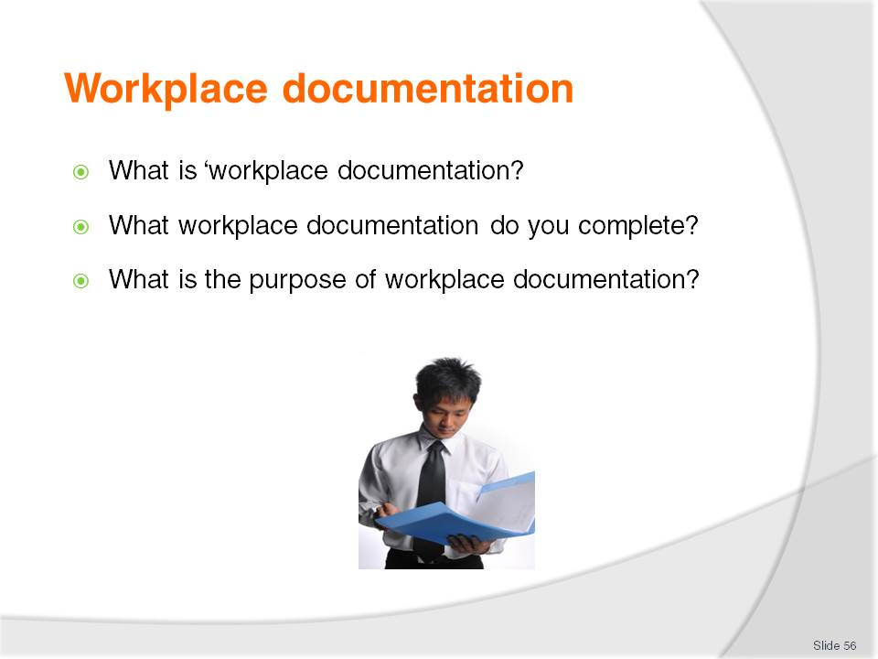
Slide No | Trainer Notes
Discuss and answer the questions.
Class Activity – General Discussion
Get the audience to list and where possible collect and discuss different types of documentation used in different departments of a hospitality business.

Slide
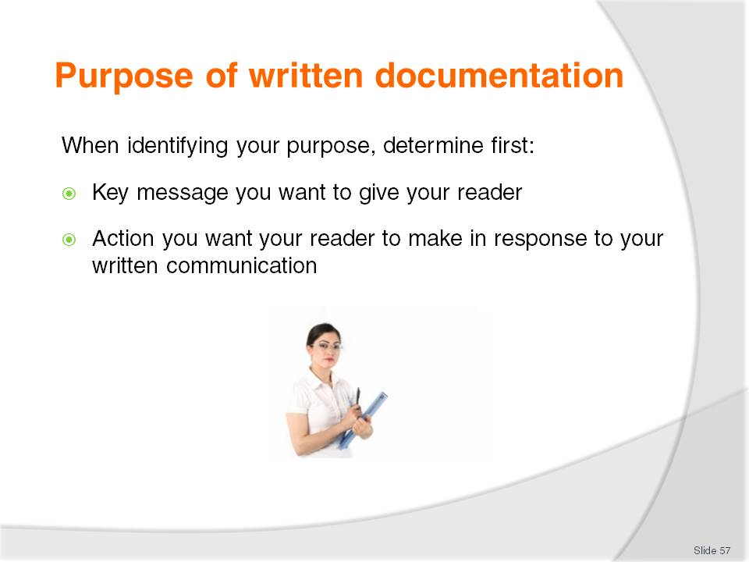
Slide No | Trainer Notes
 | Discuss points.

Slide
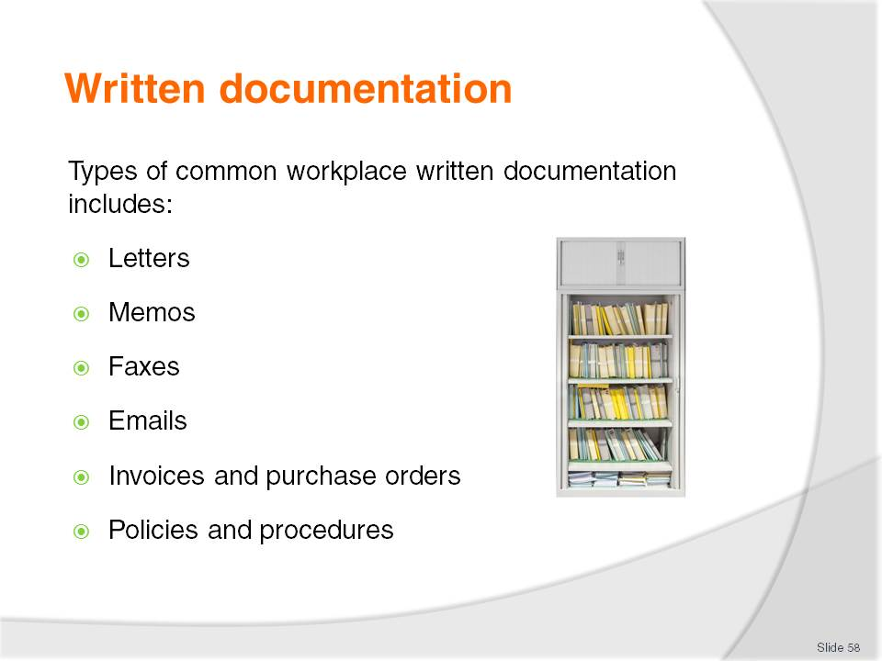
Slide No | Trainer Notes
Class Activity – General Discussion
When you do use each type of written documentation?
Which is more popular and why?

Slide
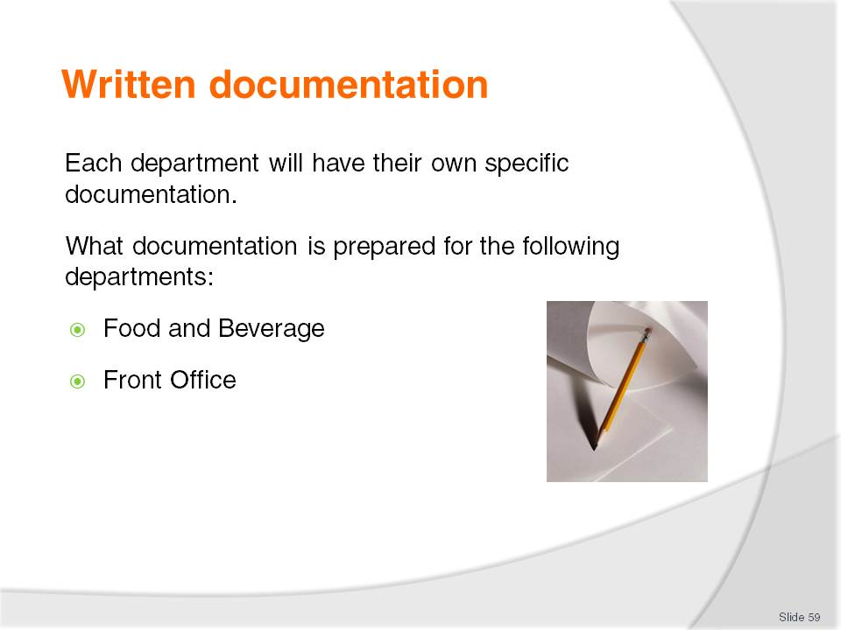
Slide No | Trainer Notes
 | Answer questions in the slide.

Slide
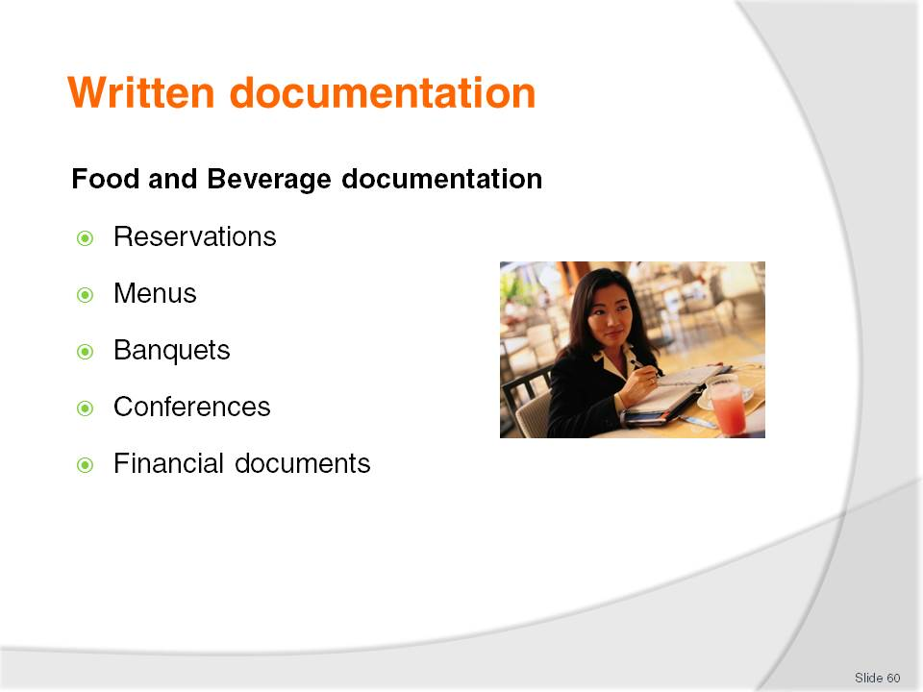
Slide No | Trainer Notes
Reservations – including booking information, special requests, receipts and confirmation to customers
Menus – including specials of the day, menus for specific groups, drink lists and menus in different languages
Banquets – menus, schedule of events, invitations, enquiry letters, invoices, name cards
Conferences – schedule of events, enquiry letters, confirmation letters, secretarial services
Financial documents – daily checklists, sales sheets, register dockets, reconciliation sheets, breakage sheets, ‘comp’ (complimentary) sheets, forecasts and budgets.
Class Activity – Review documentation
Trainer to distribute different types of written documentation used in the F&B Department.

Slide
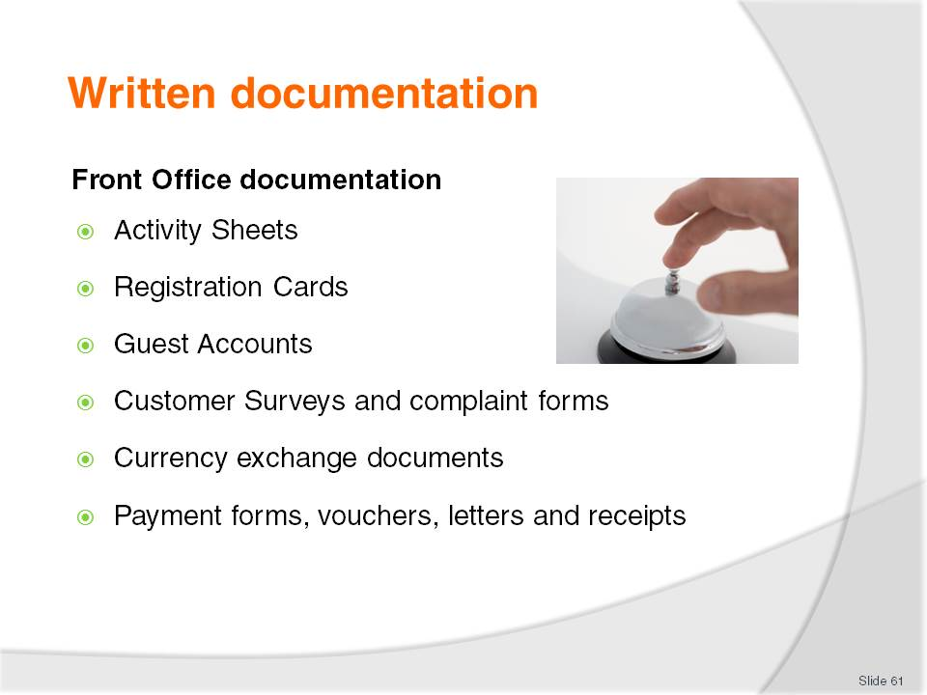
Slide No | Trainer Notes
Front Office
Activity Sheets – arrivals and departure sheets and VIP Lists
Registration Cards – for completion and signature by customers
Guest Accounts
Customer Surveys and complaint forms
Currency exchange documents
Payment forms, vouchers, letters and receipts.
Class Activity – Review documentation
Trainer to distribute different types of written documentation used in the Front Office department.

Slide
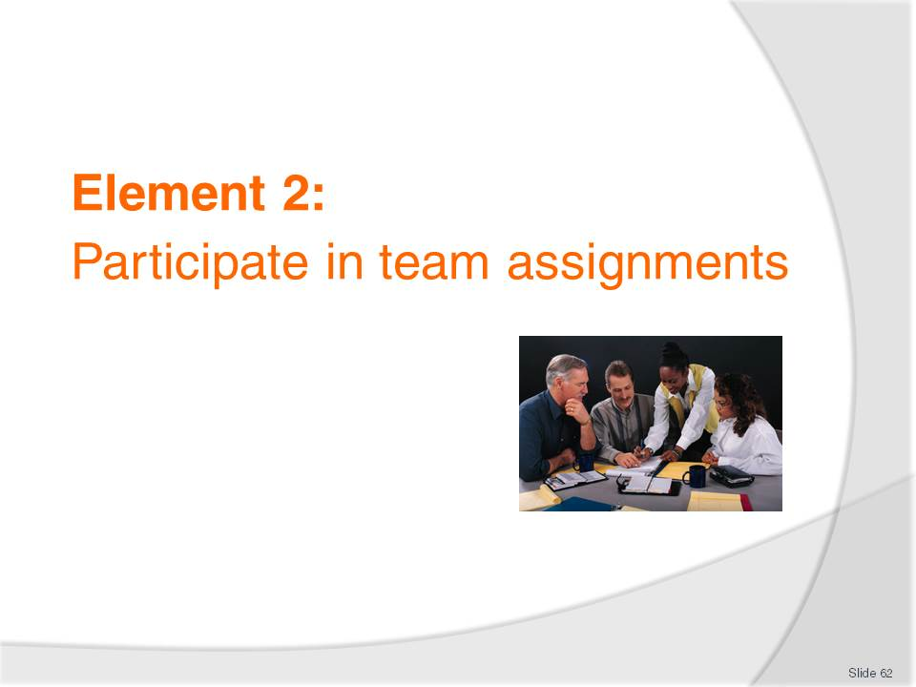
Slide No | Trainer Notes
Introduce topic.
Class Activity – General Discussion
Ask general questions:
How are team roles decided?
How are individual roles and responsibilities decided?
How can a team work effectively and efficiently together?

Slide
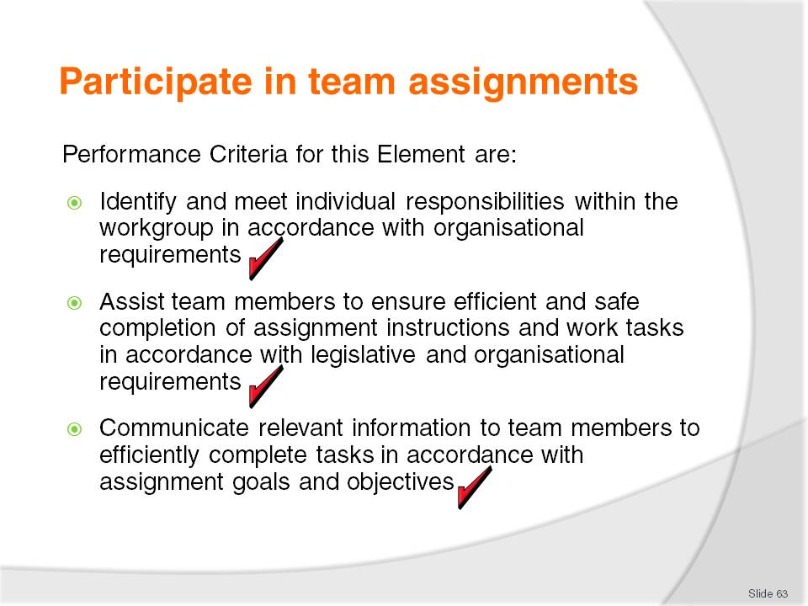
Slide No | Trainer Notes
 | Trainer identifies the Performance Criteria for this Element, as listed on the slide.

Slide
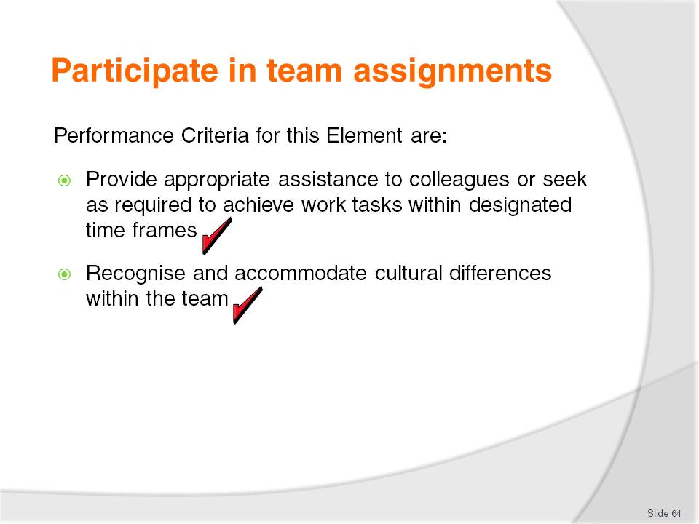
Slide No | Trainer Notes
 | Trainer identifies the Performance Criteria for this Element, as listed on the slide.

Slide
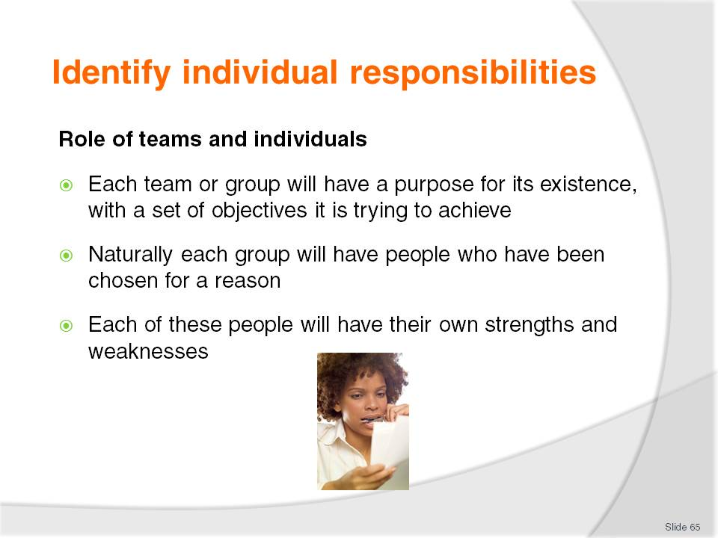
Slide No | Trainer Notes
Discussion
How team members are normally selected?
What is the benefit of having people with different strengths and weaknesses?
Group Activity
Group to undertake a ‘get to know each other’ game. This is designed to identify strengths of people in a group, which they may not have previously known
Get each member to write three things about themselves which they are good at and place in a hat
Trainer to pull out and read
Group must try to identify the person.

Slide
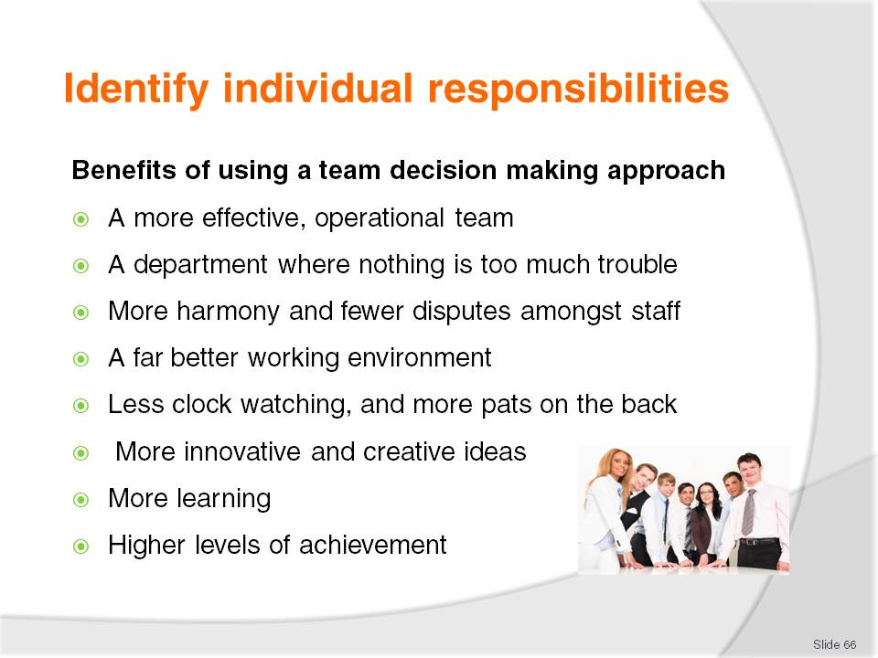
Slide No | Trainer Notes
Discussion about the benefits of group decision making
A more effective, operational team
A department where nothing is too much trouble – whether or not it is a customer or management who makes the request
More harmony and fewer disputes amongst staff
A far better working environment where you will be inclined to take less time off, and where you will actually look forward to going to work
Less clock watching, and more pats on the back – from management and patrons
More innovative and creative ideas – a situation will emerge where you are encouraged to try out new(but nonetheless intelligent ideas and concepts
More learning – not just about the establishment and the industry, but also about co-workers, group dynamics and interpersonal relationships
Higher levels of achievement than anyone thought possible – the power of ten people is far greater than 10 individuals, and there is also the momentum and power that a group decision brings with it.

Slide
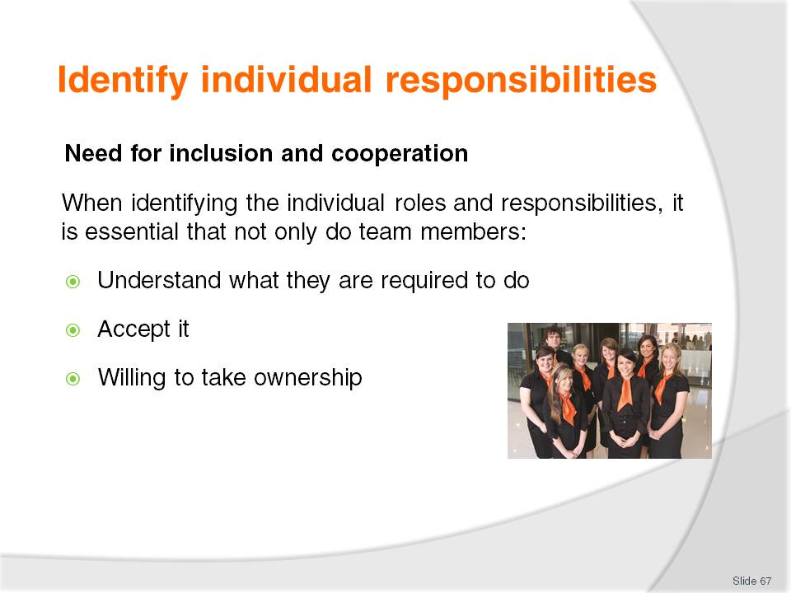
Slide No | Trainer Notes
Discussion
How can you make individuals more accepting and excited about their job and the roles and responsibilities they have?

Slide
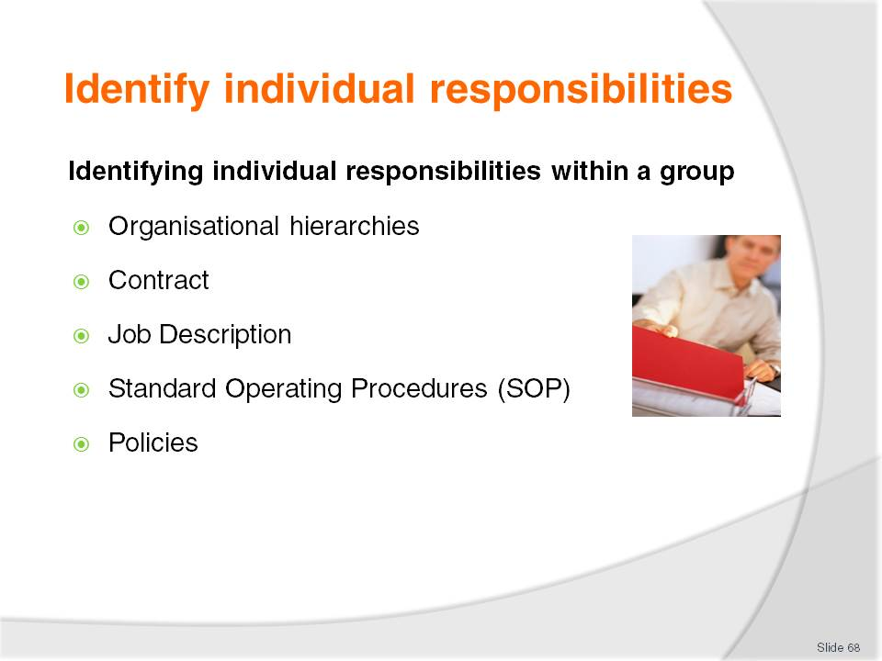
Slide No | Trainer Notes
Discussion about how to identify individual job roles and responsibilities
Trainer to provide examples of these documents for audience to review:
Organisational hierarchies – each organisation will have established work groups, each with their own positions
Contract – outlines your job including any responsibilities and conditions of employment
Job Description –most jobs will have a separate job description that will identify the activities that you need to perform as part of your role
Standard Operating Procedures (SOP) – standard instructions indicating how to perform specific tasks and the order of sequence
Policies – rules to follow in an organisation relating to difference circumstances.

Slide
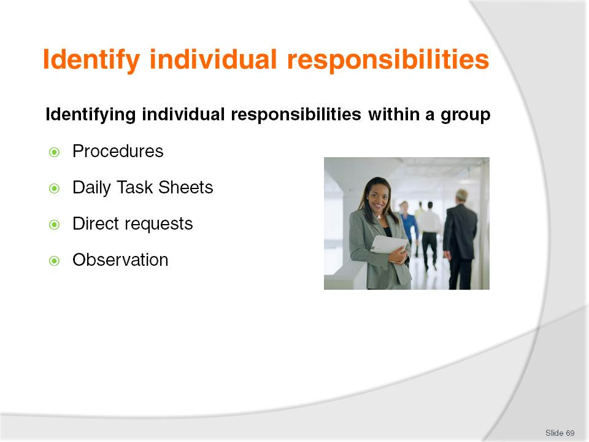
Slide No | Trainer Notes
Discussion about how to identify individual job roles and responsibilities
Trainer to provide examples of these documents for audience to review:
Procedures – step by step instruction detailing how to complete an activity
Daily Task Sheets – these may allocate specific tasks to perform that may relate to a specific activity or event
Direct requests – by management, colleagues or customers
Observation – quite often you will have feeling when a certain task will need to take precedence over others. This is intuition.

Slide
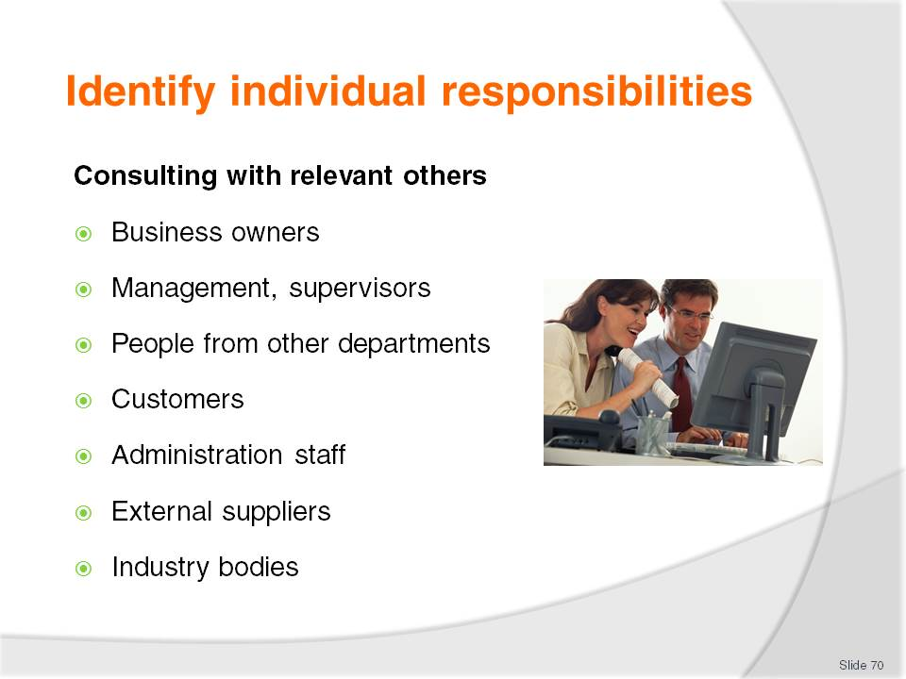
Slide No | Trainer Notes
Discussion the benefits and input others can provide when identifying roles and responsibilities
Management, supervisors or business owners – who can supply input regarding staffing levels, priorities, immediate workplace need etc
People from other departments with which you have contact – these people may be management level or they may be operational staff/workers
Customers – who may be in the workplace and who have made special requests etc for the upcoming work period
Administration staff – who may provide details regarding bookings/reservations or details of other work tasks from other areas that need to be integrated into the work of your team. Administration staff may also provide necessary resources or authorisations to enable the work to be done.

Slide
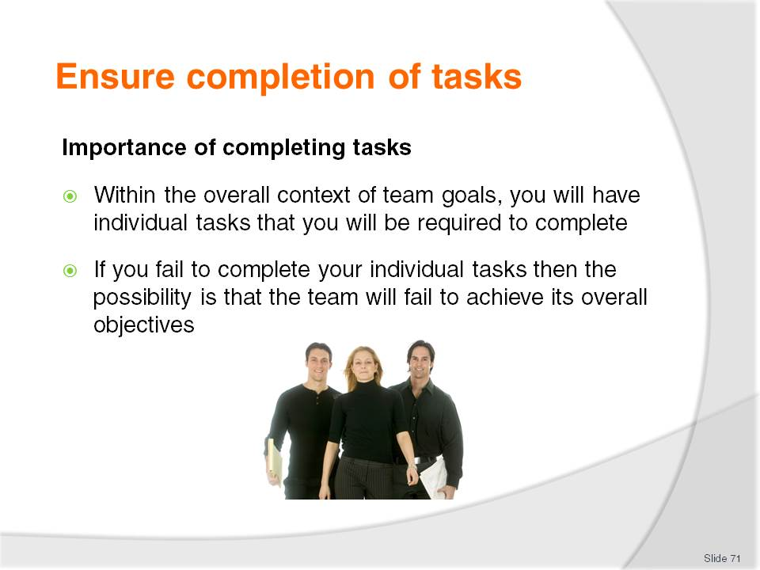
Slide No | Trainer Notes
Discussion
Why is it important to complete tasks?
How does it affect others if they are not done?
How can you ensure they are completed in a timely manner?

Slide
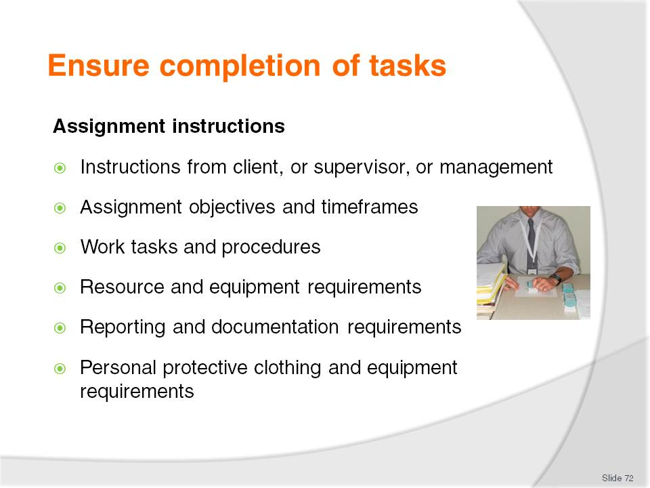
Slide No | Trainer Notes
Discussion
Discuss these assignment instructions?
What other ones are common?

Slide
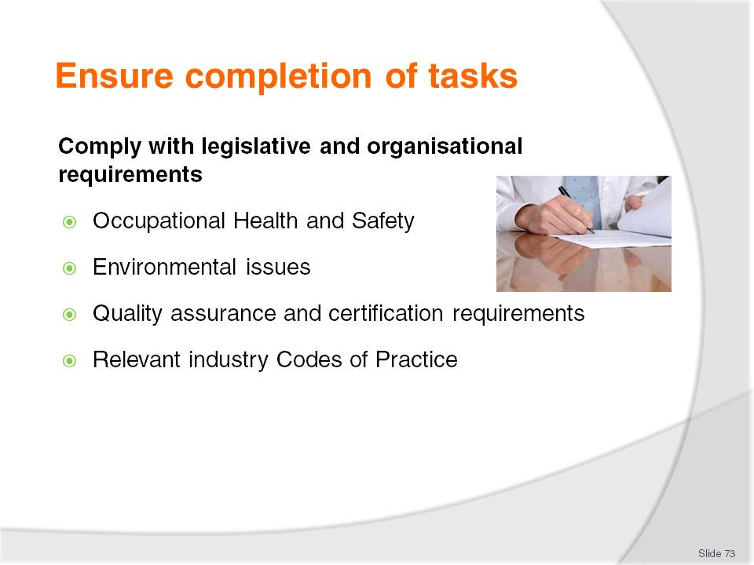
Slide No | Trainer Notes
Discussion about complying with legal requirements
Discuss the importance of these legal requirements
Why is it important that these are followed?
What are the consequences if they are not followed?
- Occupational Safety and Health
- Equal employment opportunity
- Industrial relations
- Anti-discrimination and diversity
- Licensing arrangements
- Trade practices
- Privacy requirements
- Confidentiality
- Environmental issues
- Quality assurance and certification requirements
- Relevant industry Codes of Practice
- Award and enterprise agreements.

Slide
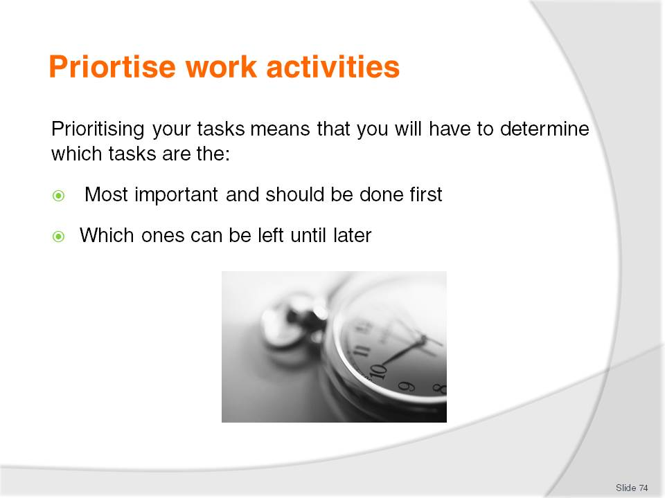
Slide No | Trainer Notes
Class Activity – General discussion
In your past experience:
What work activities to you need to do on a daily basis?
How do you prioritise your work activities?
Are you good at managing your time?
If so, how do you do it?
If not, why not and how could you be better at it?
Do you procrastinate? Why?

Slide
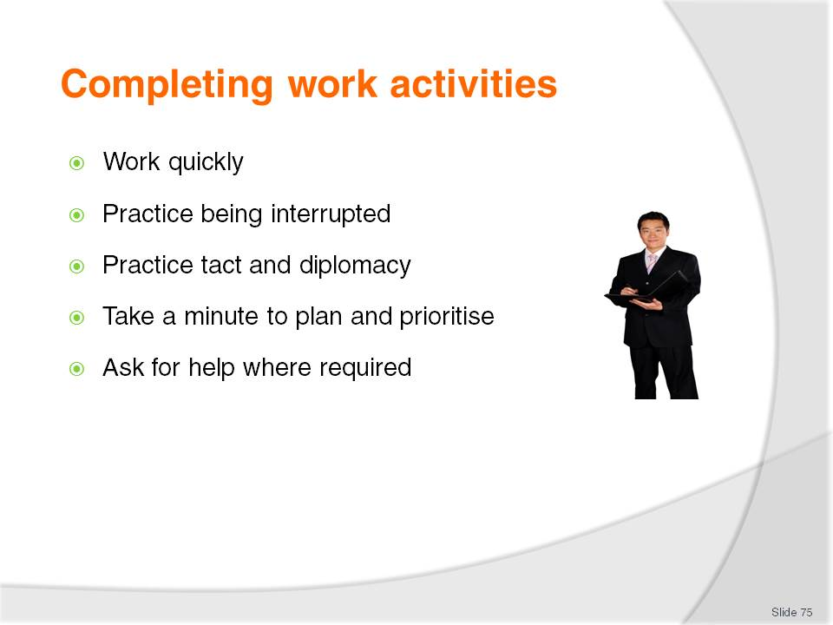
Slide No | Trainer Notes
Tips to make this happen are:
Work quickly – get as much done as fast as possible in keeping with quality, safety, house standards or noise. The point being that you can’t afford to dawdle or waste time
Practice being interrupted – accept that many of the things you start will not be able to be completed without interruption, so work with that understanding. The fact that you get interrupted demonstrates that there are people there for you to serve. The real worry would be if you had no-one to interrupt you!
Practice tact and diplomacy – there will be instances where you simply can’t stop what you are doing to do something else, so you must develop a set of responses that lets the customer know you are busy but you will be with them very shortly
Take a minute to plan and prioritise – too many people just jump in and start their work without planning and without giving their tasks a priority order. A minute spent working out what to do first, second or third, is time well spent as it forces you to identify why tasks have the urgency you allocate to them. It makes you justify to yourself why things should be done in a certain order
Ask for help where required.

Slide
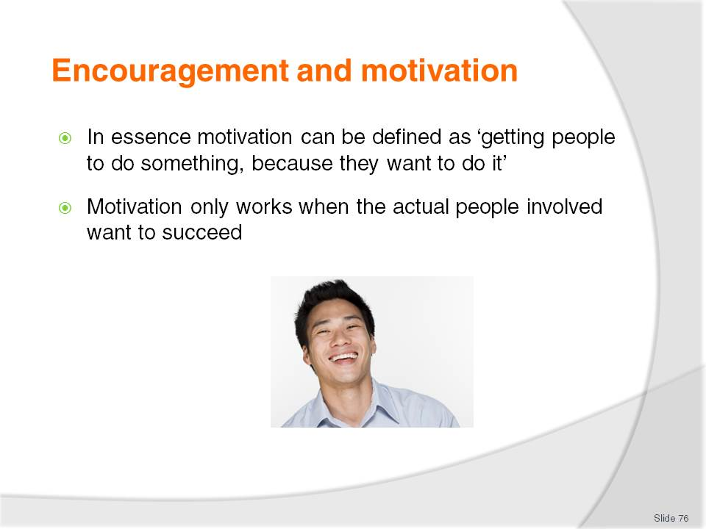
Slide No | Trainer Notes
Class Activity – Questions
What is the difference between encouragement and motivation?
How can you encourage someone? Who normally does this?
How can you motivate someone? Who normally does this?

Slide
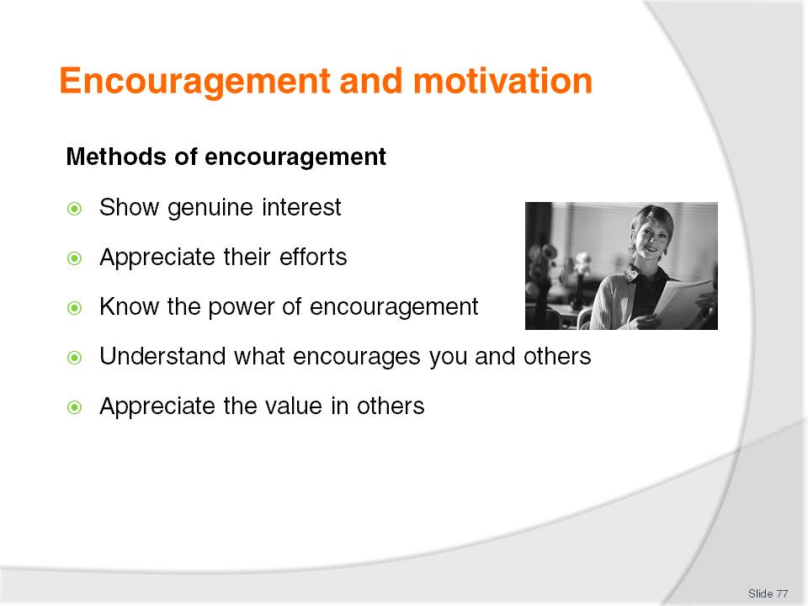
Slide No | Trainer Notes
Class Activity – Questions
How else can you encourage someone?
Show genuine interest – take the time to understand what others are doing. By understanding what they do, you can appreciate the effort they have put in
Appreciate their efforts – by knowing what people are actually doing, you can provide specific examples of great effort. This is more powerful than general appreciation
Know the power of encouragement – remember how you felt when someone encouraged you. Reciprocate this action
Understand what encourages you and others – by understanding what encourages you to perform, it can help gain an insight what might also encourage others
Appreciate the value in others – everyone has unique qualities. Remind them of their unique characteristics.

Slide
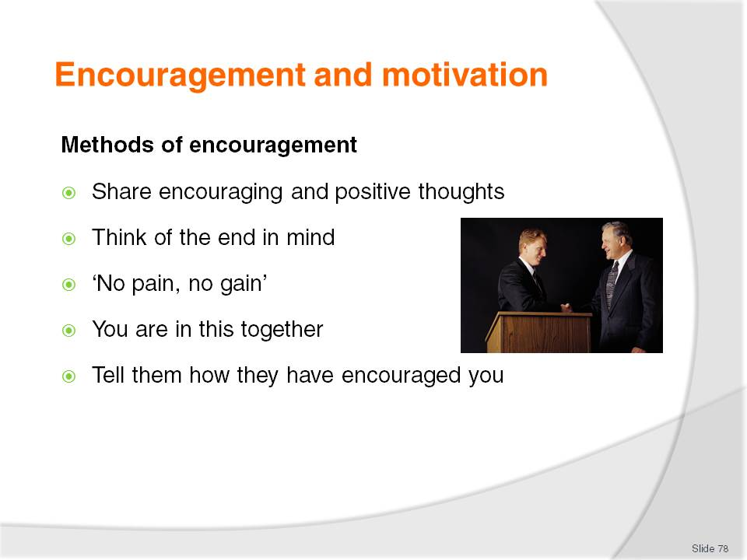
Slide No | Trainer Notes
Class Activity – Questions
How else can you encourage someone?
Share encouraging and positive thoughts – when you feel encouraged or have something positive to contribute, share it. Positivity is just as infectious and powerful as negativity
Think of the end in mind – keep reminding yourself and others, that ‘every cloud has a silver lining’. If things are tough, whether professionally or personally, keep the end in mind and keep reminding yourself and others the hard times will pass
‘No pain, no gain’ – like with all great rewards, you first have to go through an element of hardship
You are in this together – remember you are a team. What one person feels, others feel. What one person is doing, others are also doing. Help each other. No-one is alone
Tell them how they have encouraged you – if someone needs encouragement, you may like to remind them of a time when they encouraged you.

Slide
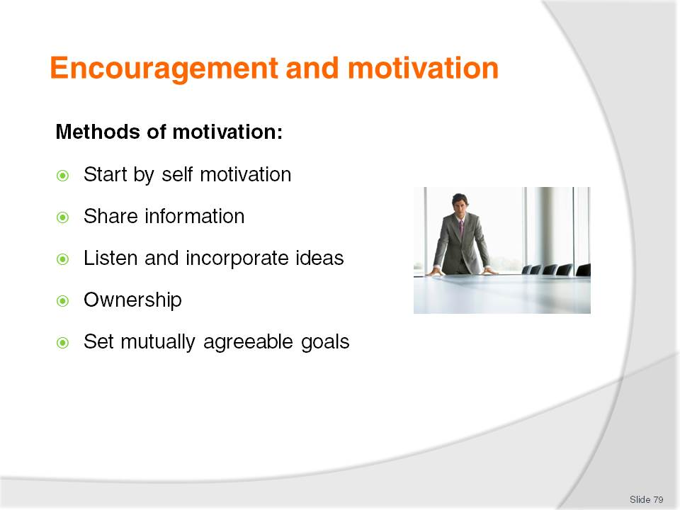
Slide No | Trainer Notes
Class Activity – Questions
How else can you motivate someone?
Start by self motivation – in order to motivate others, you firstly must be motivated yourself. Identify what motivates you and then start to consider what will motivate others
Share information - get people involved and give them all the facts
Listen and incorporate ideas – listen to what people have to say. The more ideas the better the chance to find the right one
Ownership – if people feel like they have some element of control and ownership over a situation, they are more likely to strive to complete a task
Set mutually agreeable goals – if everyone has a say in what is to be achieved they are more likely to strive towards the accomplishment of it.

Slide
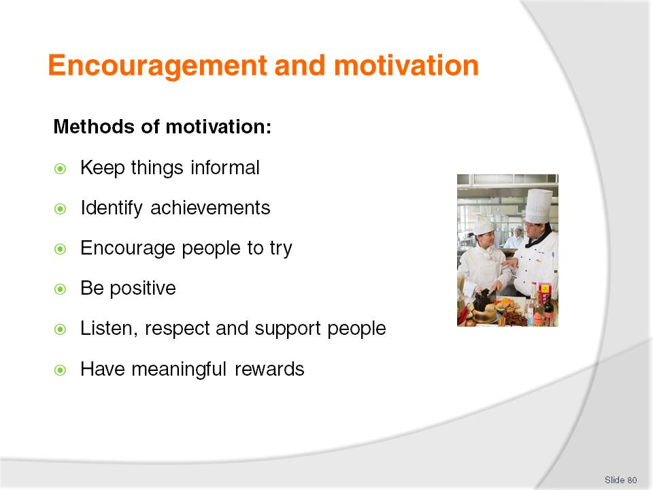
Slide No | Trainer Notes
Class Activity – Questions
How else can you motivate someone?
Keep things informal – whilst it is important to retain structure and formality, the more you can give the appearance of informality, the more comfortable people will feel
Identify achievements – whenever achievements or milestones have been reached, let people know and celebrate success
Encourage people to try – mistakes will happen. Don’t blame people for mistakes or failures that take place if they have truly tried. You must give people the ability to try new things without fear of punishment if it doesn’t work out
Be positive – as mentioned before, the more positive you can be, with a focus on successes of individuals or groups, the more positive others will be
Listen, respect and support people – this manual is focused on the concept and importance of support. It is a truly powerful tool. If people can work together, great things are possible
Have meaningful rewards – it is important that people have something to strive for, some carrot at the end of the stick. Remember people are motivated by different things so it is important to recognise individual and groups needs.

Slide
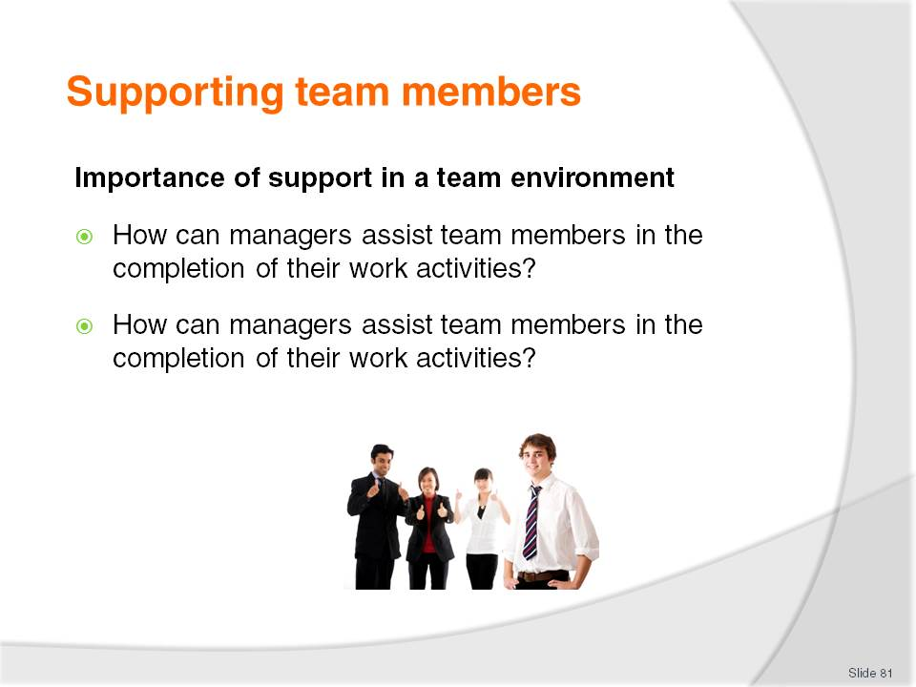
Slide No | Trainer Notes
Class Activity – Questions
Discuss the questions in the slide to generate discussion.
In Section 2.4 of this manual, different ways assistance and support can be offered or received will be discussed in detail.

Slide
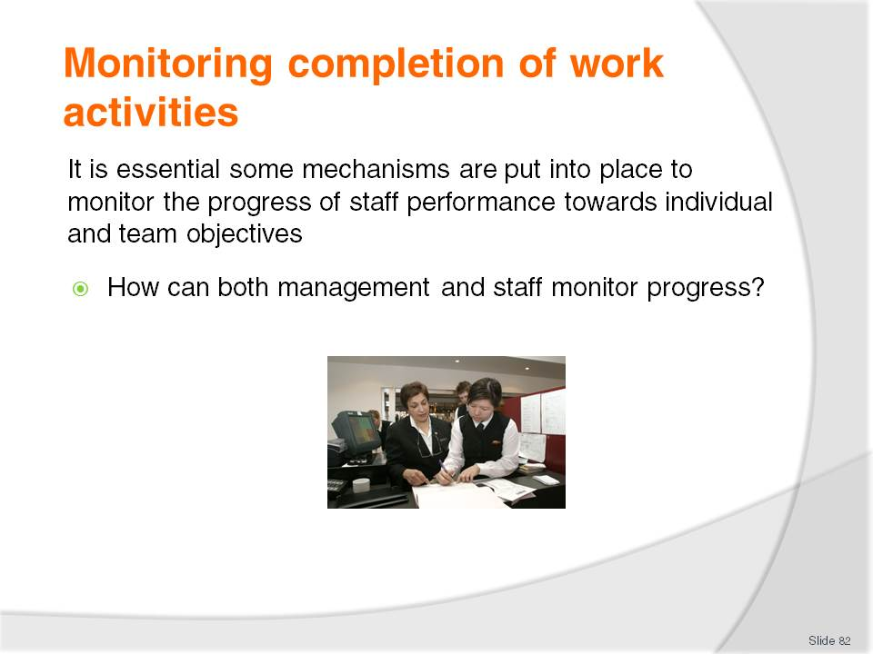
Slide No | Trainer Notes
Class Activity – Questions
Discuss the questions in the slide.

Slide
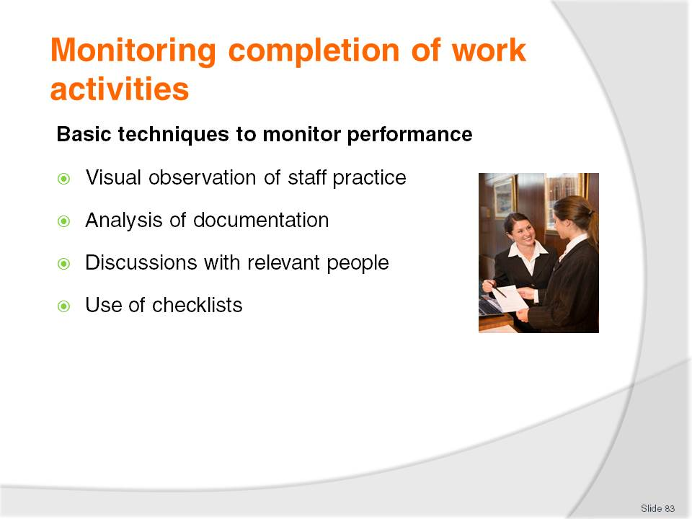
Slide No | Trainer Notes
Class Activity – Discuss basic techniques to monitor performance
Visual observation of staff practice – to see if their performance matches the required standards and, if not, to what degree there is a variance
Analysis of documentation – such as calculating the extent to which targets (materials cost, waste, profit, rooms serviced, labour cost etc.) have been achieved for the period in question
Discussions with relevant people – these could be other staff members, other supervisors, customers, trainers, and suppliers. Anyone impacted by the employee whose performance is being monitored are possible ‘relevant people’.

Slide
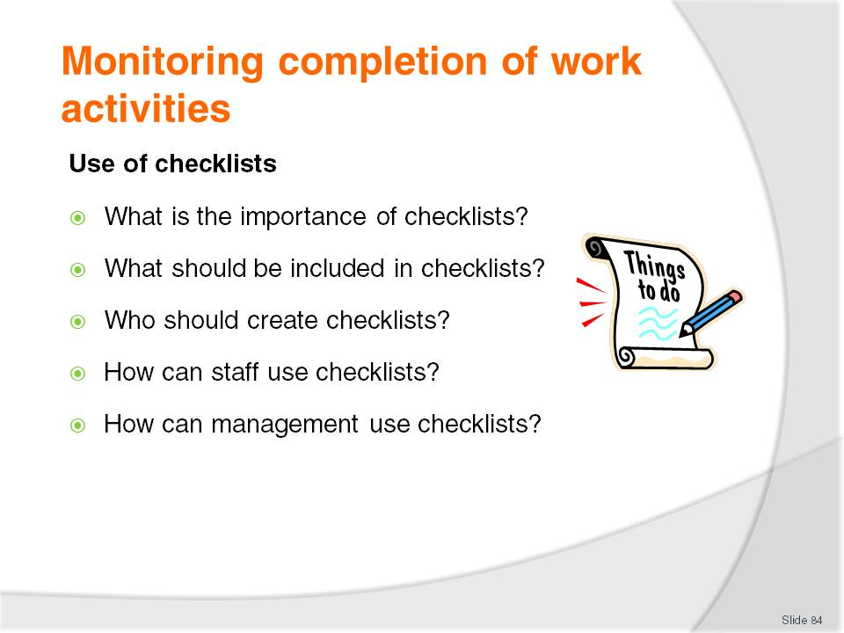
Slide No | Trainer Notes
Class Activity – Discussion
Discuss the questions in the slide.

Slide
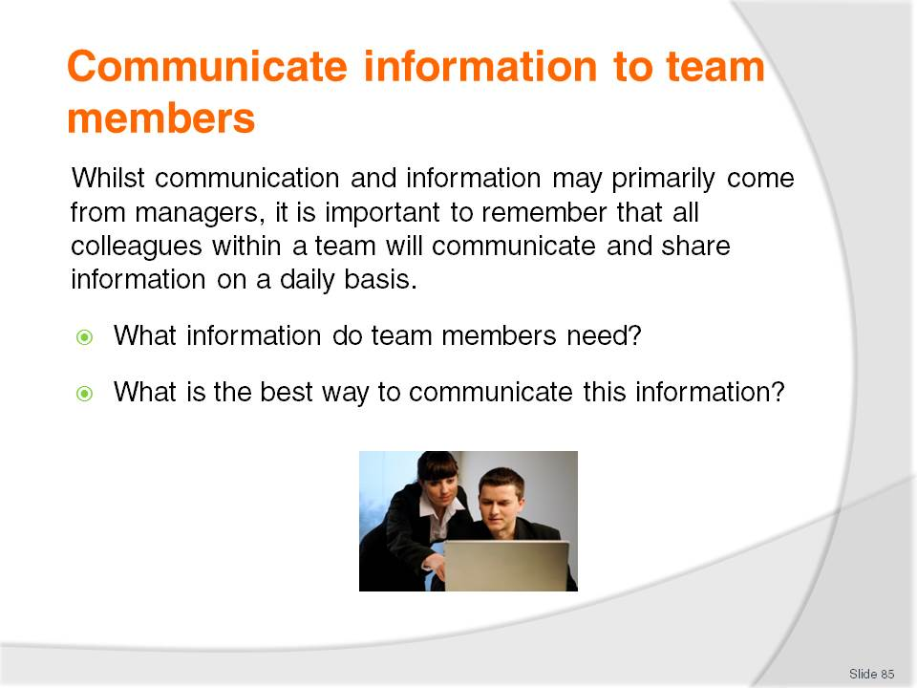
Slide No | Trainer Notes
Class Activity – Discussion
Discuss the questions in the slide.

Slide
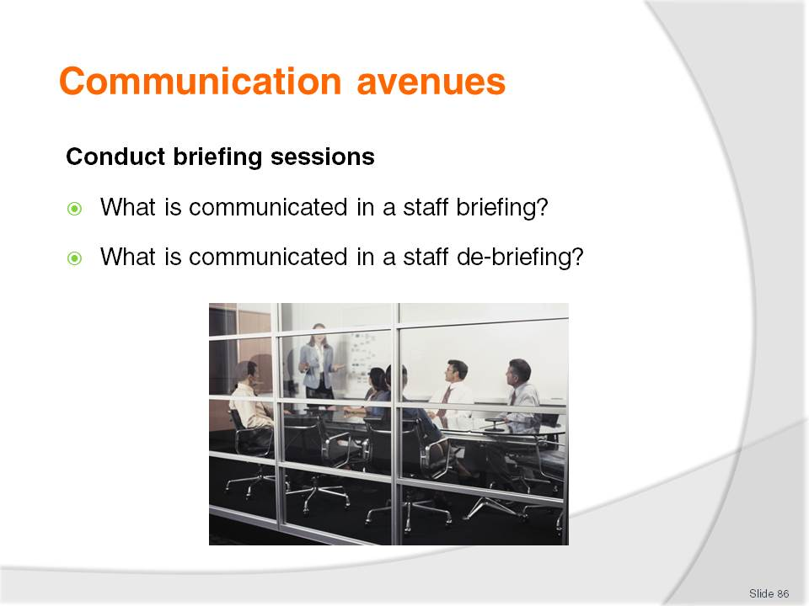
Slide No | Trainer Notes
Class Activity – Discussion
What are the activities that are undertaken during a staff briefing / debriefing?
What information is discussed, shared or issued?

Slide
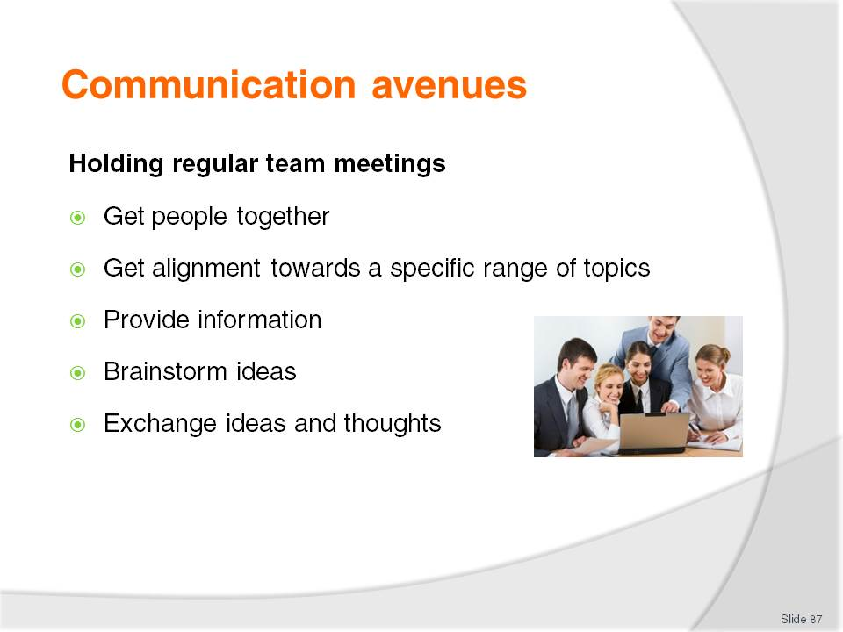
Slide No | Trainer Notes
Class Activity – Discussion
Discuss the importance of these meeting topics
How often should meetings take place?
When are they normally held?

Slide
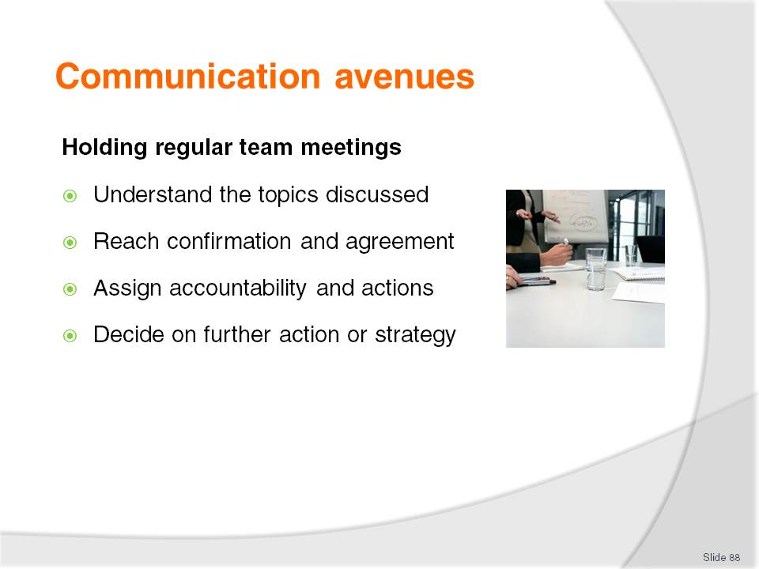
Slide No | Trainer Notes
Class Activity – Discussion
Discuss the importance of these meeting topics.

Slide
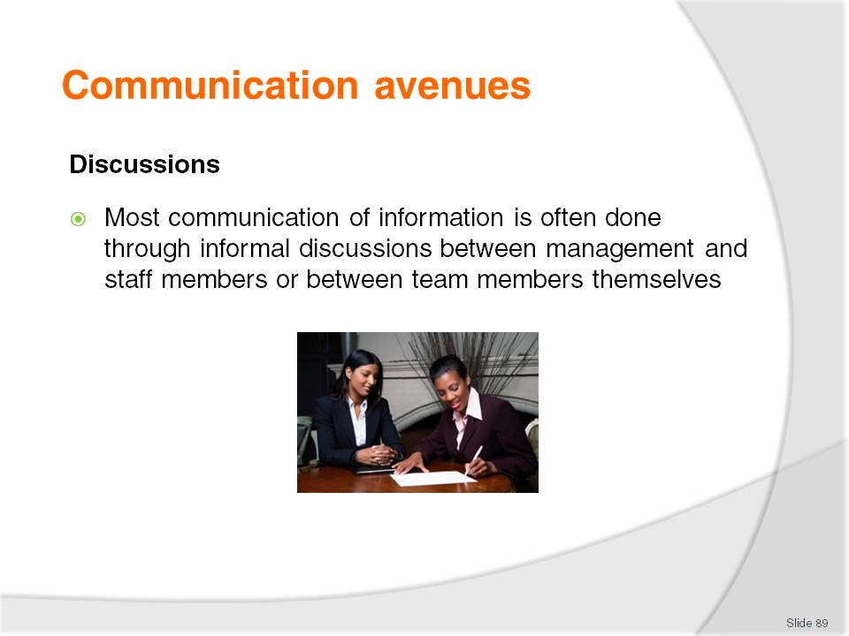
Slide No | Trainer Notes
Class Activity – Discussion
Discuss the importance of small discussions.

Slide
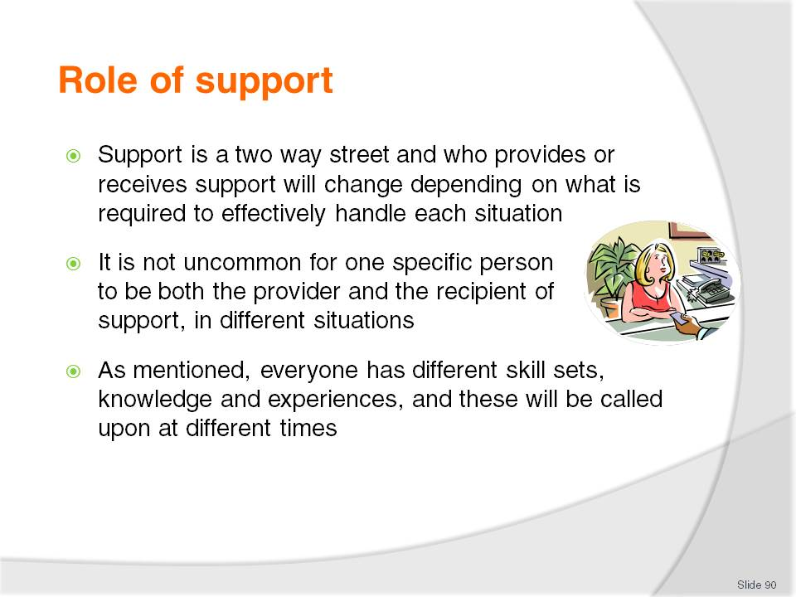
Slide No | Trainer Notes
Class Activity – Questions
When was a time when you provided and received support?

Slide
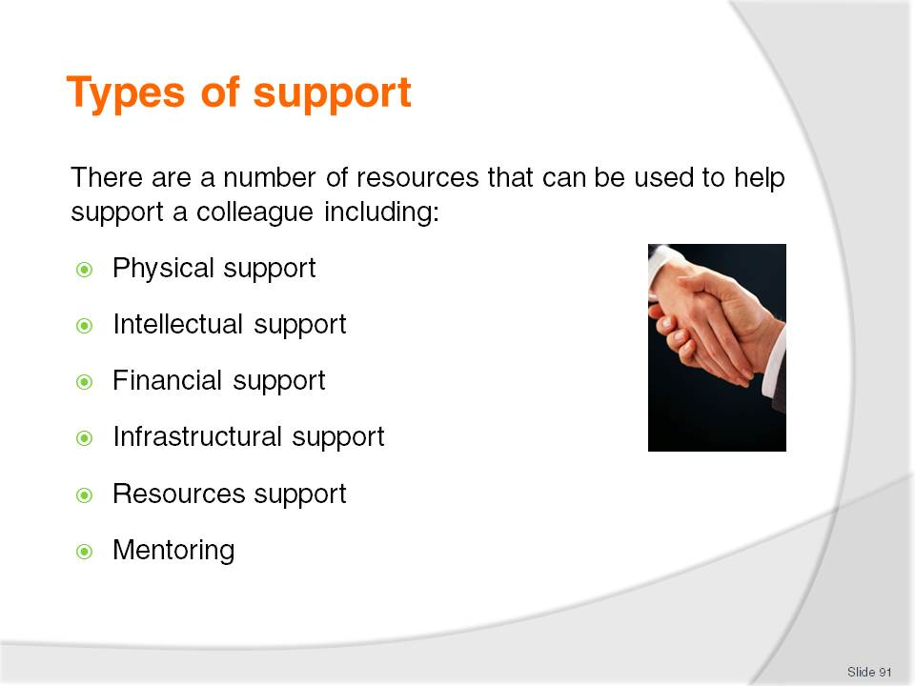
Slide No | Trainer Notes
Class Activity – Questions
Which type of support is most common and why?
Physical support – skill sets and actual physical help whether it be lifting, carrying, pushing or pulling
Intellectual support – frameworks, documents, files, knowledge and advice
Financial support – money needed to be able to undertake an activity
Infrastructural support – physical items including buildings, equipment, furnishing, fittings and fixtures
Resources support – food, beverages, uniforms, stationary and other supplies
Mentoring – advice and guidance.

Slide
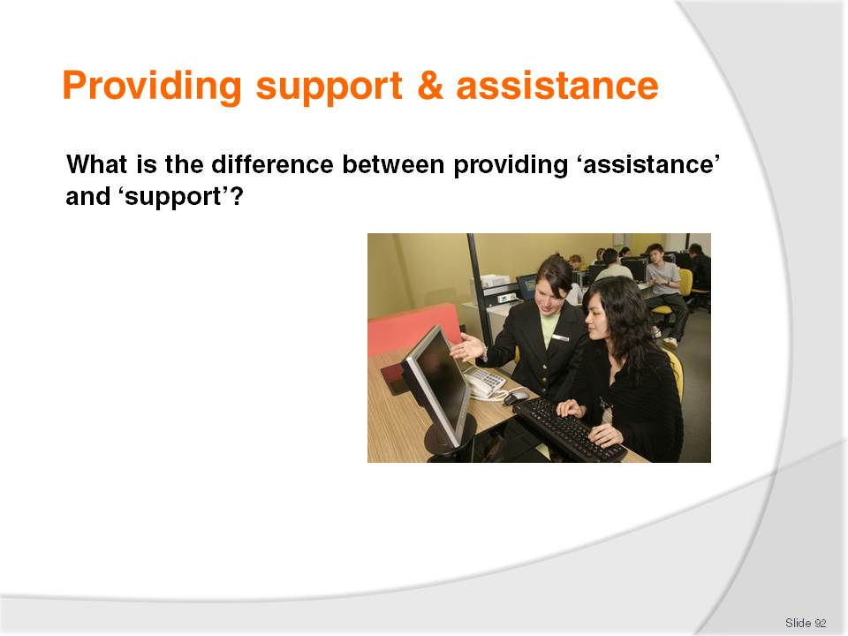
Slide No | Trainer Notes
 | There is no set answer here but is a great discussion point to get the audience thinking about the concept.

Slide
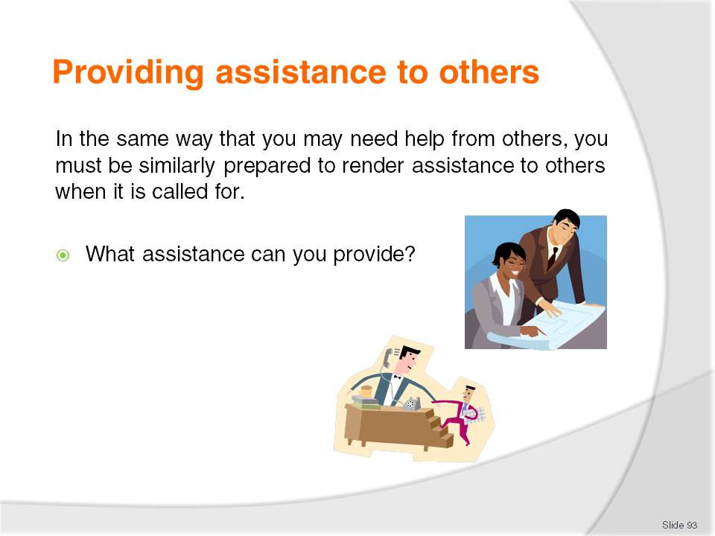
Slide No | Trainer Notes
Class Activity – General discussion
In your past experience:
When have you given assistance to someone else before?
Why did they need it?
How did you feel when you were asked?

Slide
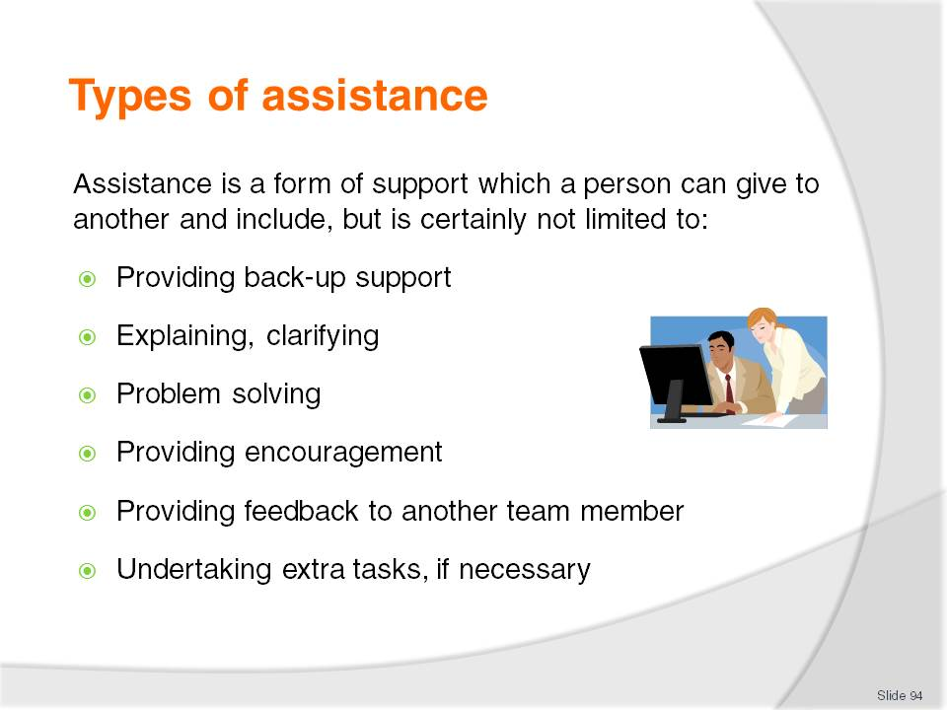
Slide No | Trainer Notes
Class Activity – Questions
What is the difference between support and assistance?

Slide
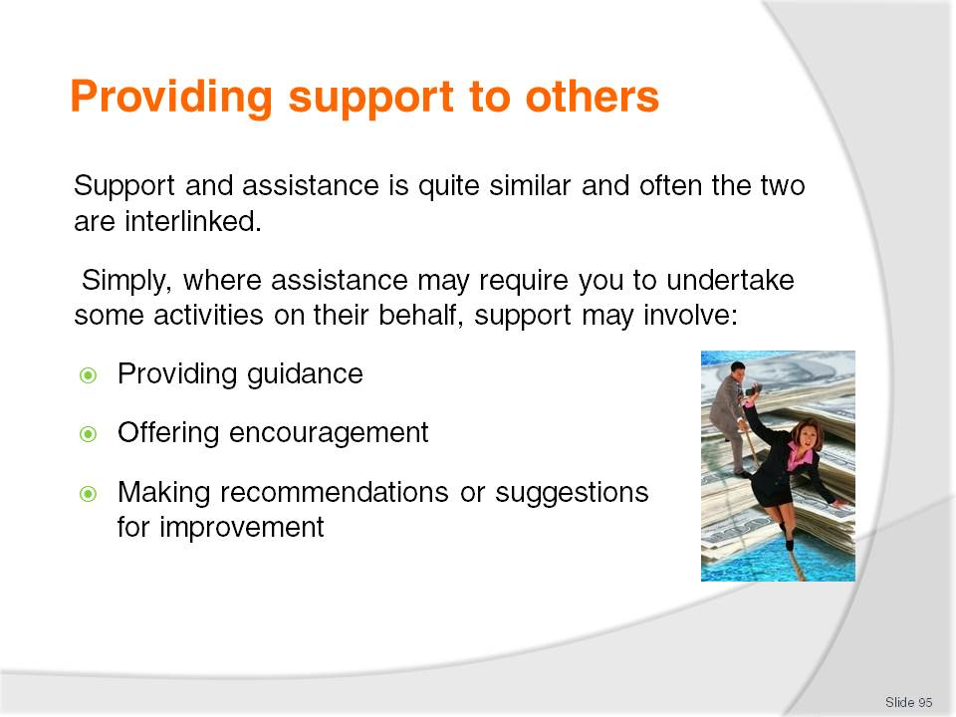
Slide No | Trainer Notes
 | Provide examples for each of the points.

Slide
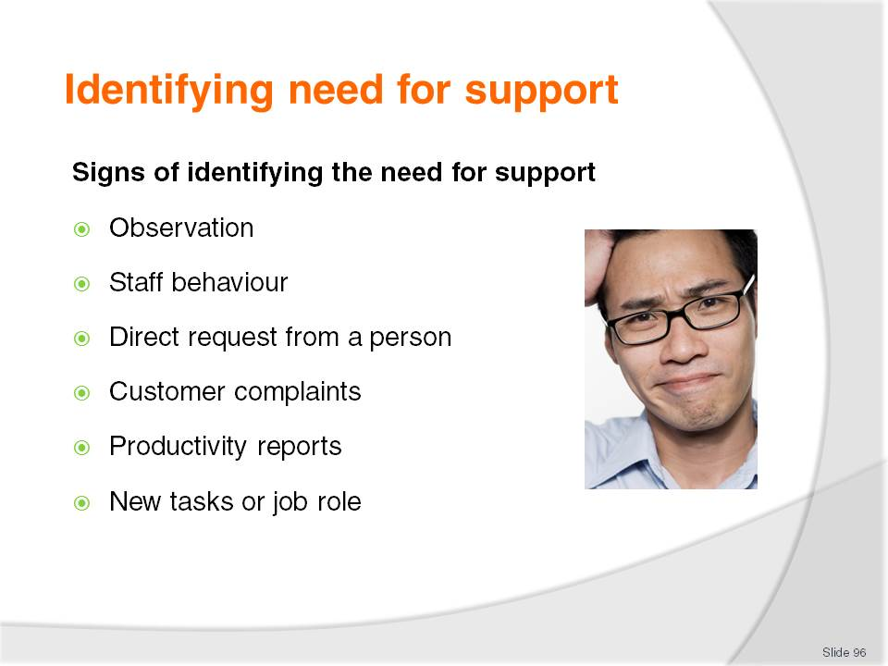
Slide No | Trainer Notes
Class Activity – Questions
How else can you identify when someone needs support?
Observation – viewing an inability of a person to undertake job tasks or constantly making mistakes
Staff behaviour – they may be reluctant, frustrated, stressed or not motivated in starting or completing a task
Direct request from a person – whether a direct request or repeating asking for help
Customer complaints – customers may have complained about a person’s behaviour or performance
Productivity reports – reports may show that a person is unable to perform tasks to a set quality or quantity standard
New tasks or job role – new tasks and responsibilities may require staff to receive additional resources or training.

Slide
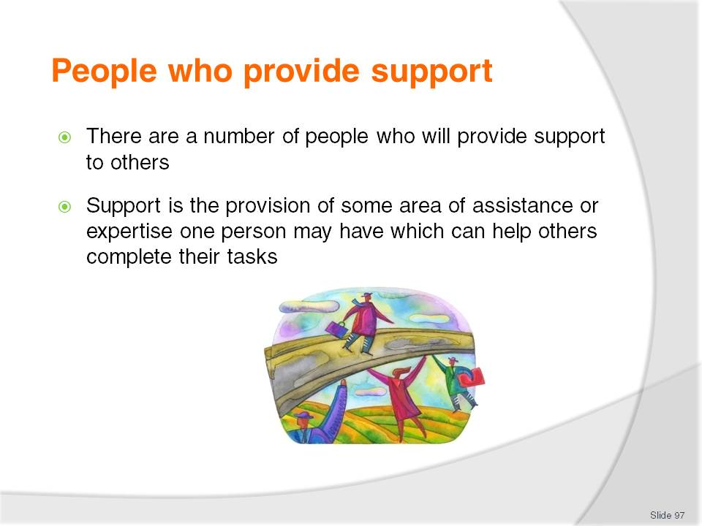
Slide No | Trainer Notes
Class Activity – Questions
Who provides support?
What types of support can they provide?

Slide
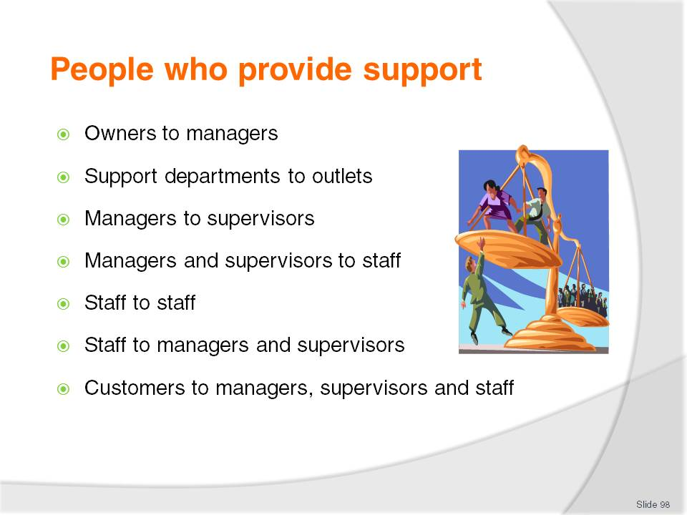
Slide No | Trainer Notes
Class Activity – Questions
What are different types of support provided in each of these scenarios?

Slide
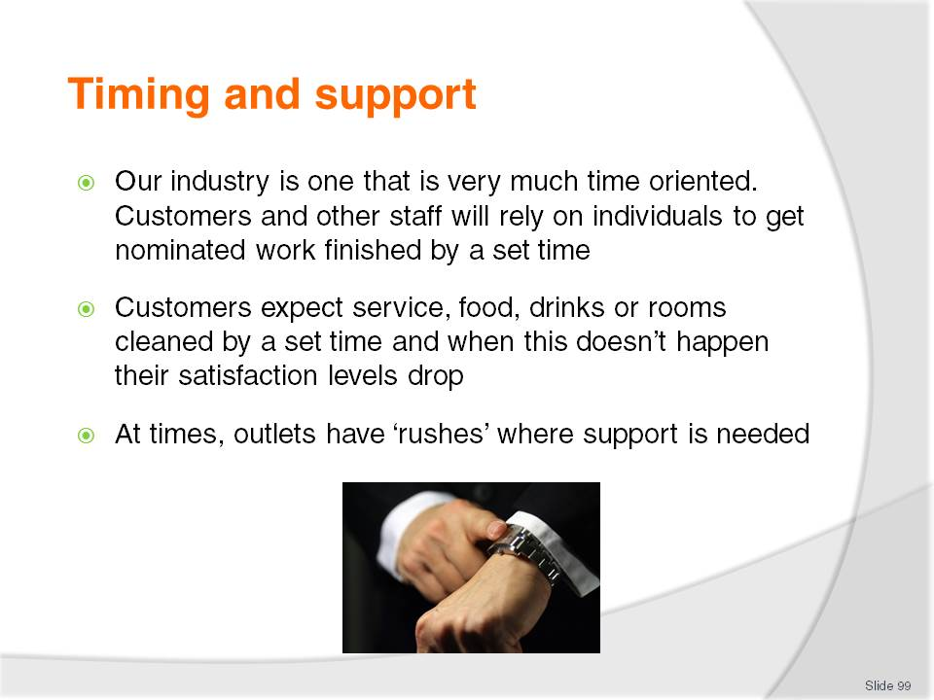
Slide No | Trainer Notes
Class Activity – Questions
What ‘rushes’ occur in different departments?
What times do they normally occur?
Why do they normally occur?
What support it required?
Where can it come from?

Slide
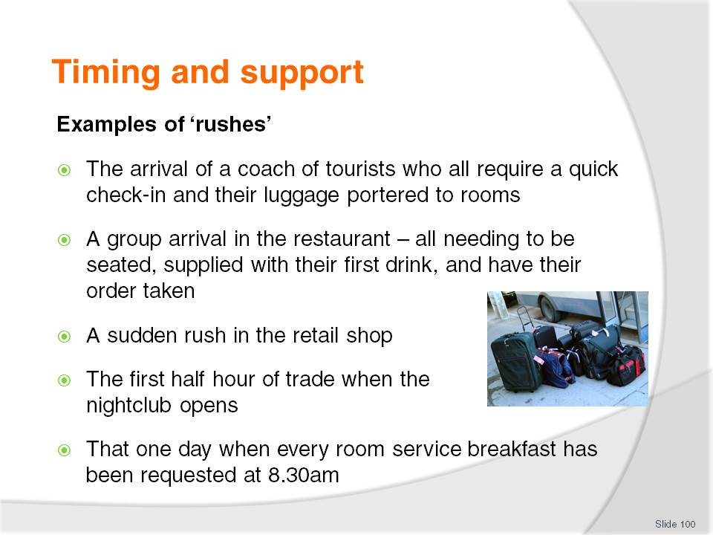
Slide No | Trainer Notes
Class Activity – Questions
For each of the examples in this slide:
What times do they normally occur?
Why do they normally occur?
What support it required?
Where can it come from?

Slide
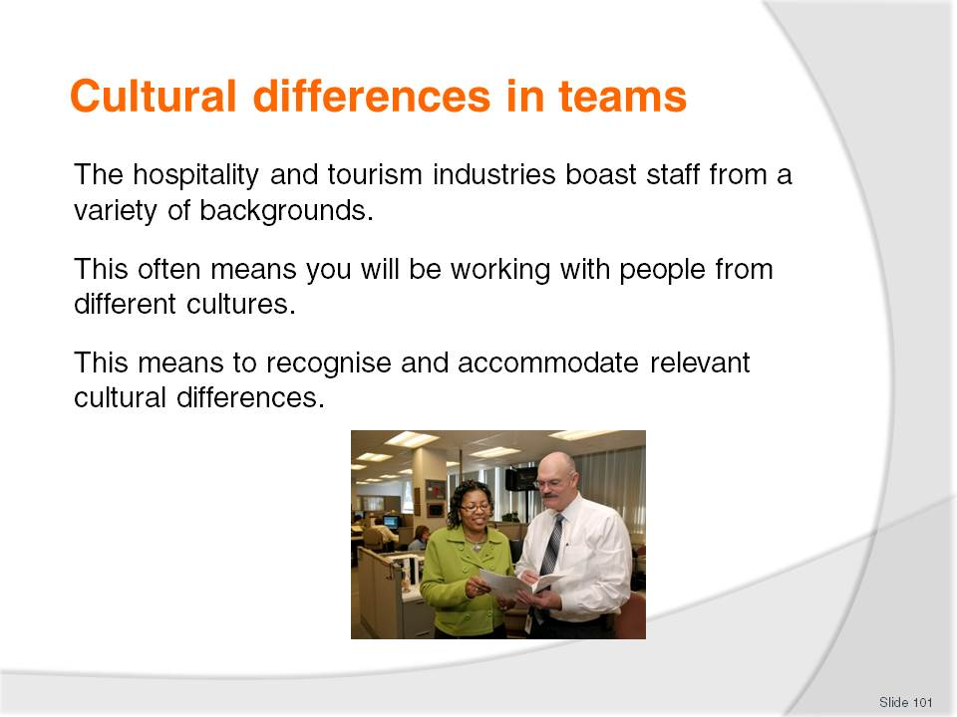
Slide No | Trainer Notes
Class Activity – General discussion
What is a ‘cultural difference’?
What cultural differences exist in your team (or a team in which you have been a part of)?
What problems or differences did they cause?
How were they overcome?

Slide
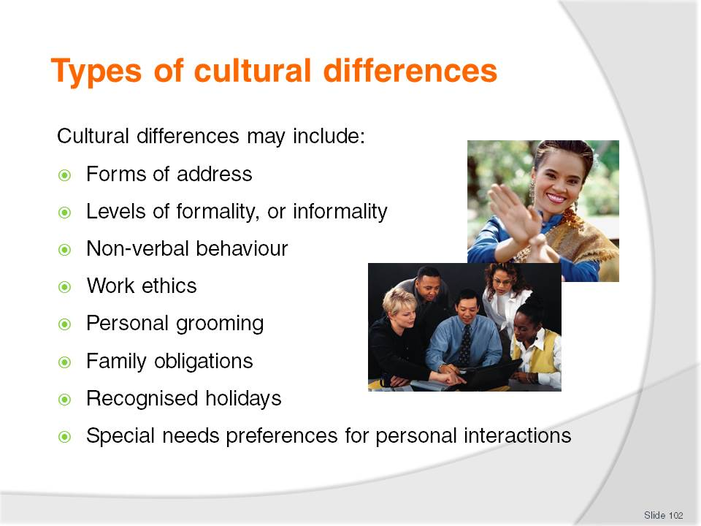
Slide No | Trainer Notes
Class Activity – General discussion
What considerations need to be recognised in relation to these cultural differences?
Provide examples of each of these cultural differences and how they can impact on a team?

Slide
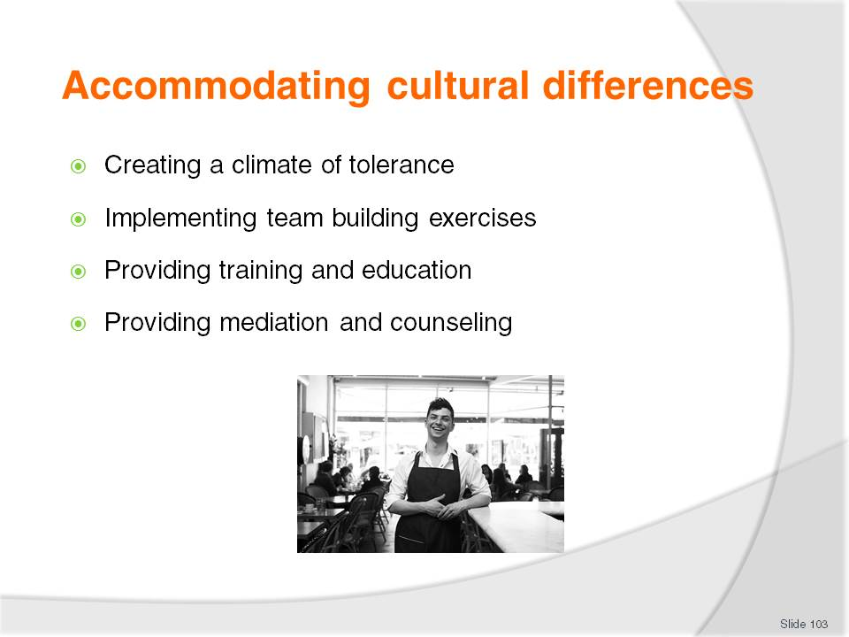
Slide No | Trainer Notes
Explain how to accommodate cultural differences:
Creating a climate of tolerance within the department – that will help cushion any misunderstandings that may actually occur
Implementing team building exercises – to foster and extend trust and understanding
Providing training and education – to help make all staff more culturally aware. Cultural awareness training is a common topic in many businesses that employ people from a diversity of cultures, or where the enterprise deals with customers from a variety of cultures
Providing mediation and counselling – to assist in retrieving situations where misunderstanding occurs or conflict already exists.

Slide
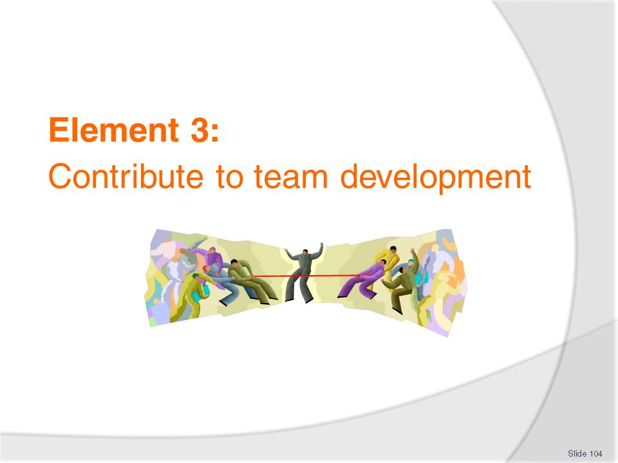
Slide No | Trainer Notes
Introduce topic.
Class Activity – General Discussion
Ask general questions:
How can you contribute to the success of a team?
What makes some teams successful and more productive than others?

Slide
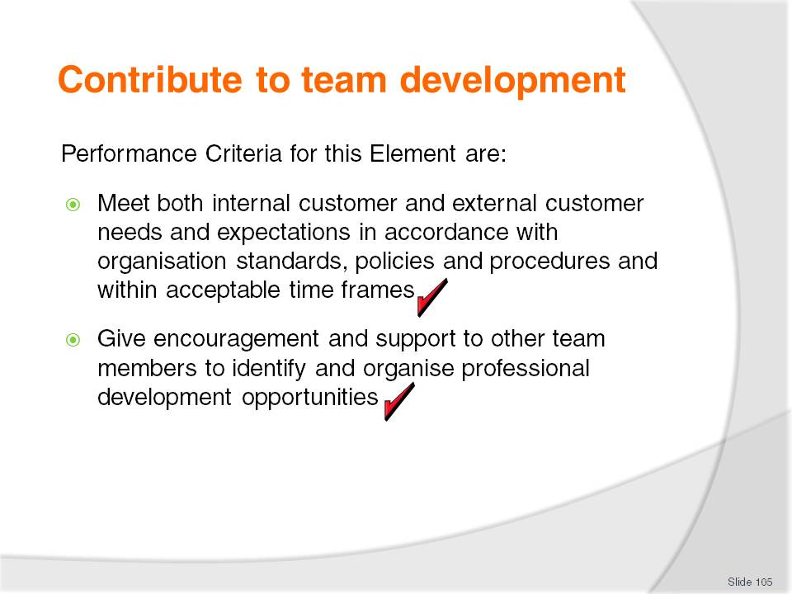
Slide No | Trainer Notes
 | Trainer identifies the Performance Criteria for this Element, as listed on the slide.

Slide
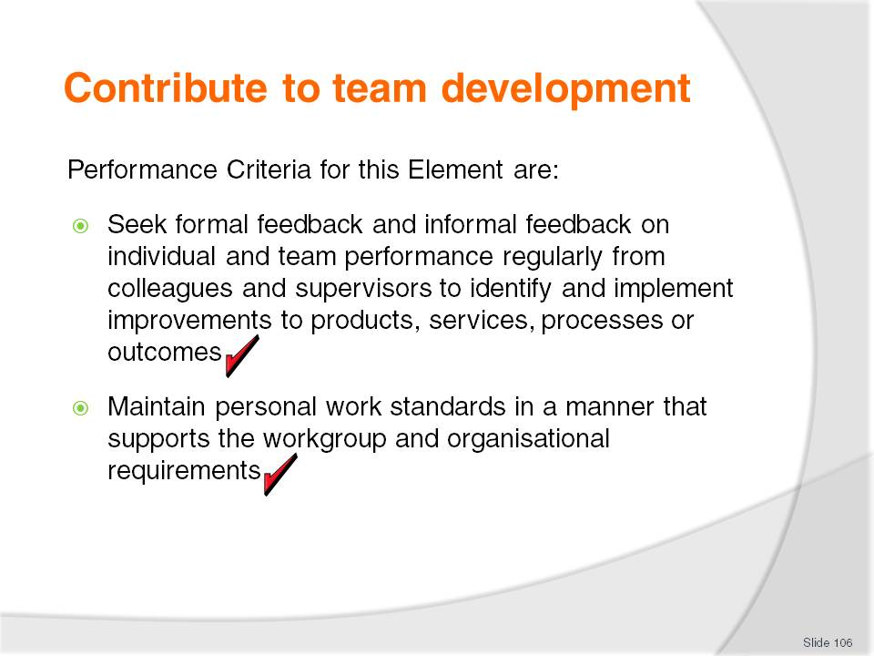
Slide No | Trainer Notes
 | Trainer identifies the Performance Criteria for this Element, as listed on the slide.

Slide
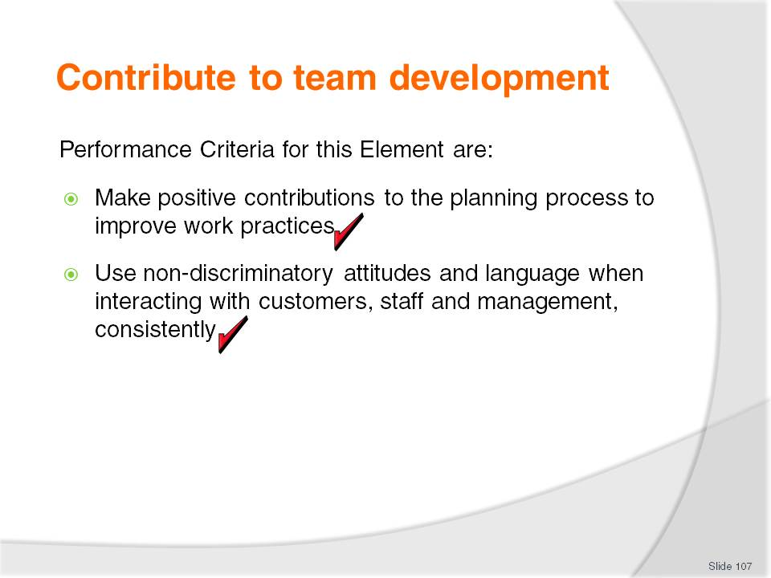
Slide No | Trainer Notes
 | Trainer identifies the Performance Criteria for this Element, as listed on the slide.

Slide
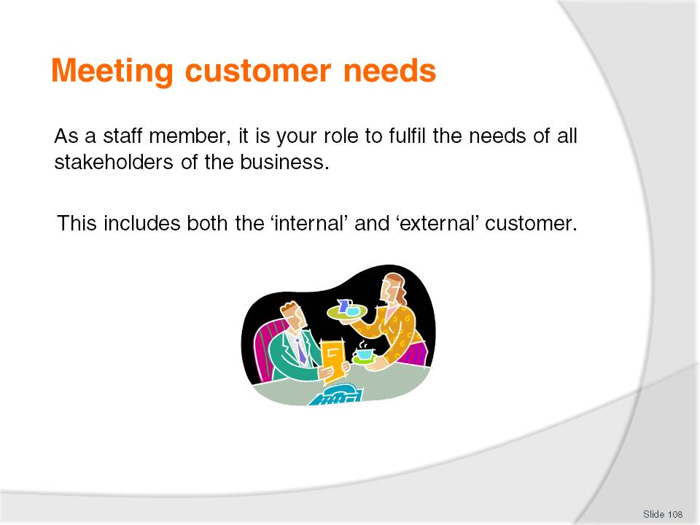
Slide No | Trainer Notes
Class Activity – Questions
Picture yourself as a customer. If you were to visit a restaurant or hotel:
What needs would you have?
How can a business satisfy your needs?
Use examples from personal experience where businesses have successfully met your needs in the past. Get the audience to share their stories with each other.

Slide
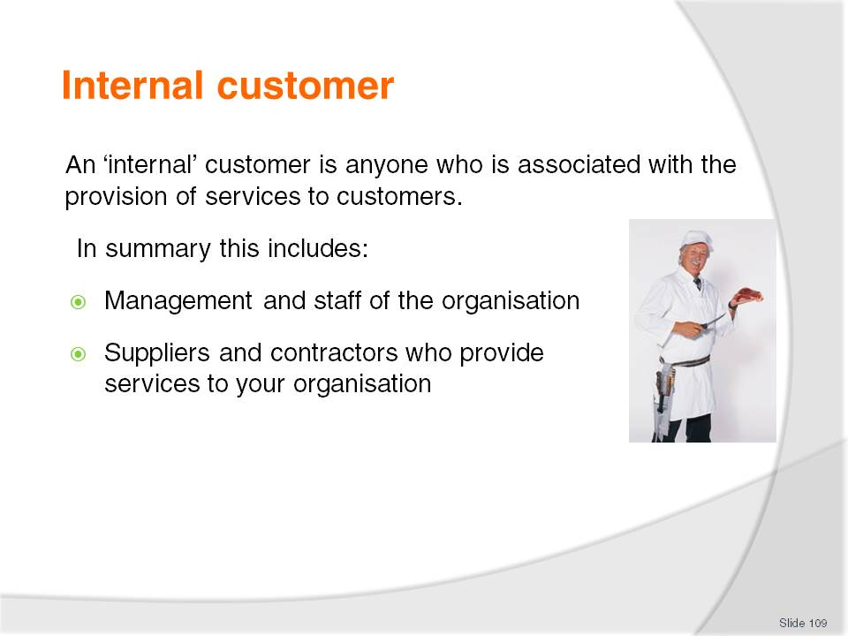
Slide No | Trainer Notes
Class Activity – General discussion
For each of the points in this slide, identify needs each may have and how you, as a hospitality business, can meet these needs.

Slide
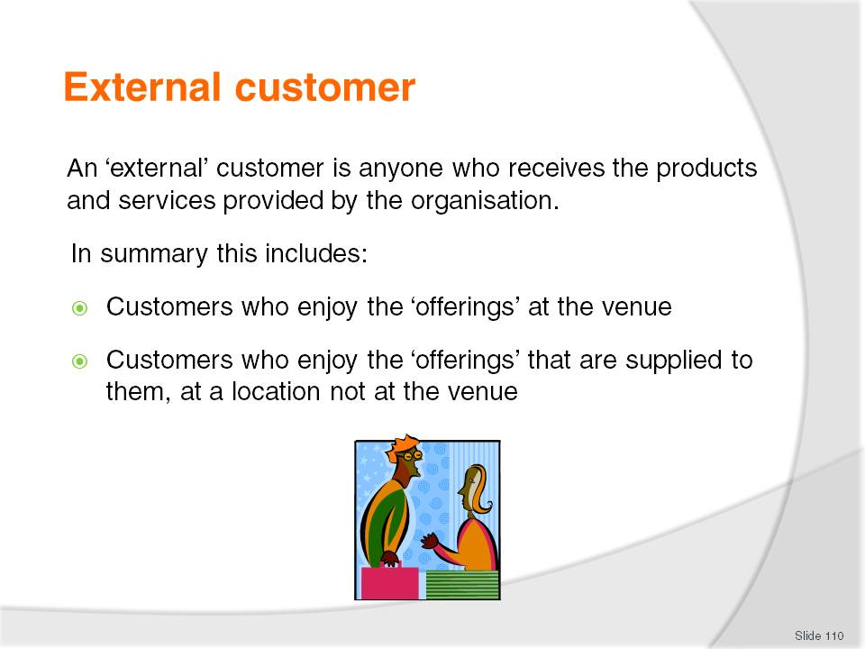
Slide No | Trainer Notes
Class Activity – General discussion
For each of the points in this slide, identify needs each may have and how you, as a hospitality business, can meet these needs.

Slide
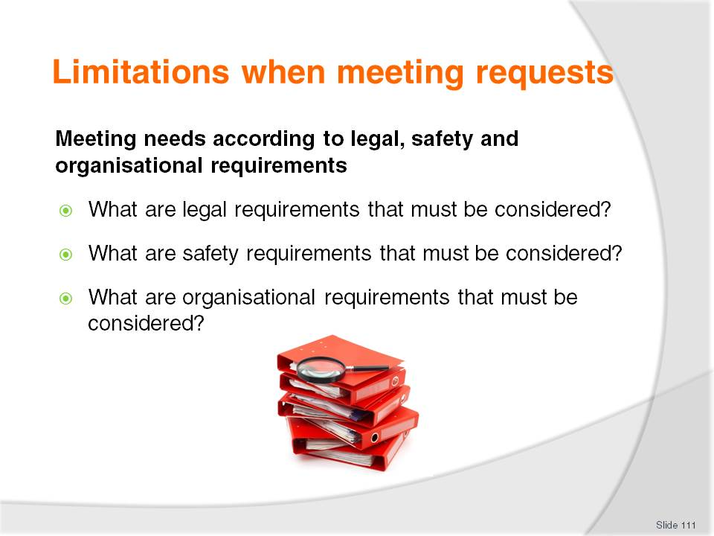
Slide No | Trainer Notes
Class Activity – General discussion
Discuss the questions in the slide.

Slide
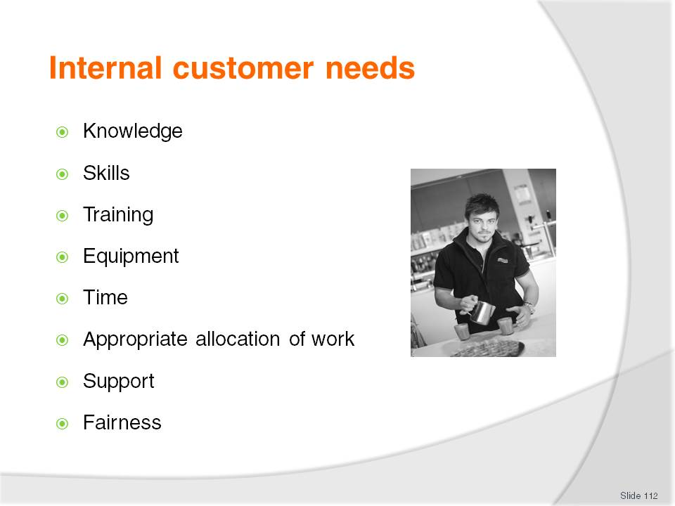
Slide No | Trainer Notes
These needs include:
Knowledge –understand and perform their job role, product knowledge, menu knowledge, external customer preferences, upcoming events, policies and procedures and schedule of events for particular shifts
Skills – the ability to practically perform selected tasks including making beds, cooking meals and checking in guests
Training – both practical and theoretical training to ensure staff skills sets are appropriate to provide quality customer service
Equipment – this can include mechanical equipment (computers, ovens, blenders) and associated tools of the trade (plates, glassware, pens, cleaning cloths)
Time – staff need adequate time to perform their tasks in the correct manner
Appropriate allocation of work – appropriate allocation of customers per staff member to be able to deliver quality service. Management must ensure adequate levels of staff are on duty to perform the necessary
Support – staff must receive support and guidance from management
Fairness – equality in areas of pay, work rate, scheduling of activities.

Slide
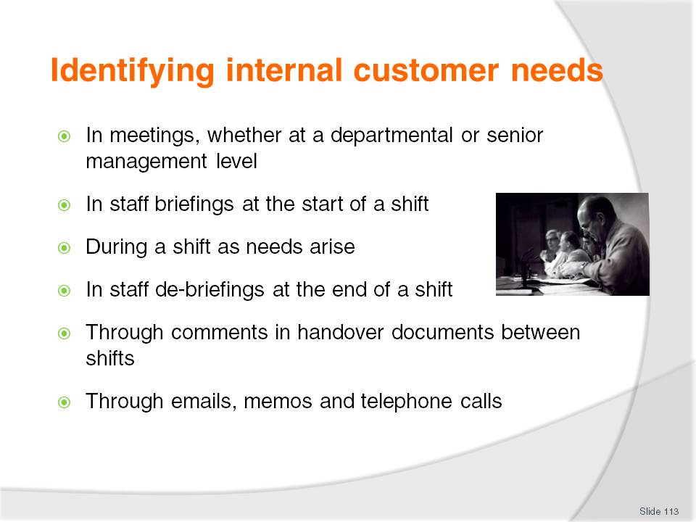
Slide No | Trainer Notes
 | Discuss points.

Slide
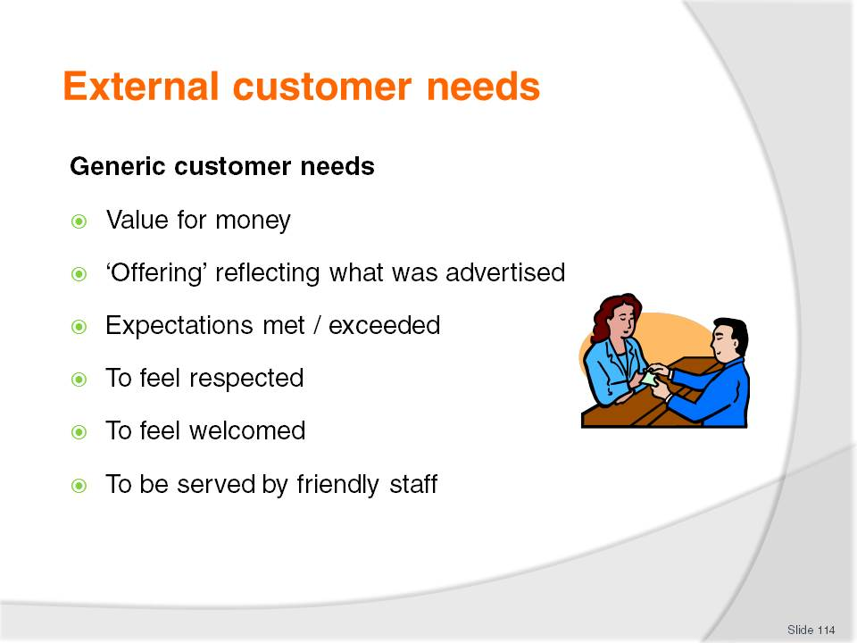
Slide No | Trainer Notes
Value for money
‘Offering’ reflecting what was advertised
Expectations met / exceeded
To feel respected – which is why we use “Sir” and “Madam”
To feel welcomed – which is why we give all our customers a warm, genuine and sincere smile and welcome. We really are pleased to see them
To be served by friendly staff – which is again why we smile and why we spend that extra few seconds with them, talking about how their day went and so on.

Slide
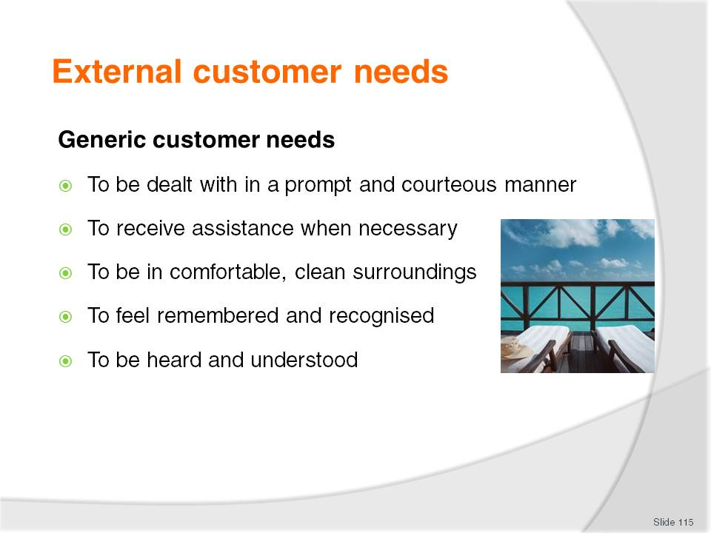
Slide No | Trainer Notes
To be dealt with in a prompt and courteous manner – which is why we don’t keep them waiting at reception, the bar, for room service, meals etc
To receive assistance when necessary – which is why we have excellent product and local knowledge and why we look for opportunities to pass this on to them whenever we can, even without their having to ask
To be in comfortable, clean surroundings – which is why we make sure the facilities, rooms, grounds and equipment are spotless
To feel remembered and recognised – which is why we use the customer’s name as often as we can
To be heard and understood – which is why we listen to complaints and adopt the role of their advocate whenever there is a complaint, problem or dispute. We want to fix their problems, not create new ones.

Slide
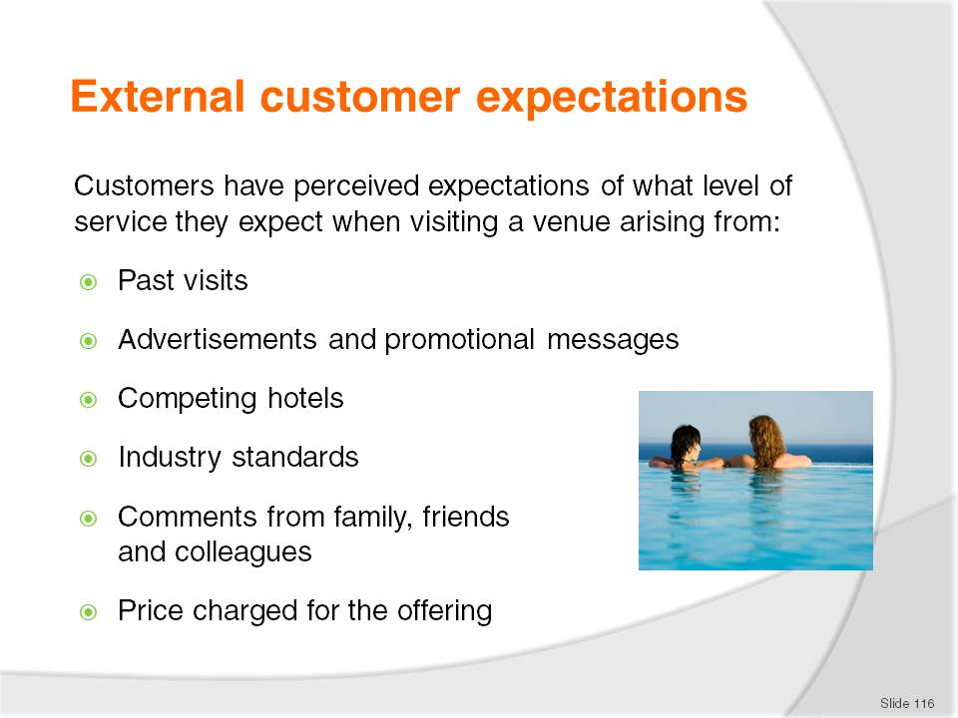
Slide No | Trainer Notes
 | Discuss points.

Slide

Slide No | Trainer Notes
Business – computer and internet access, newspapers, executive lounges, laundry services, business or executive centre, business and news channels. Business men are more likely to frequent a hotel bar and eat in the restaurant
Women – hairdryers, larger mirrors, healthier food options, specific bathroom amenities, fashion magazines, bath. Business women are more likely to use the gym and eat room service
Family – interconnecting rooms, costs, entertainment options, child care facilities, children’s television programs, package deals and safety
Leisure – cheaper rates, local attractions, concierge services
Elderly – single beds, medical facilities, suitable food options and cheaper rates
Groups – need for large allocation of rooms, cheap rates, meeting rooms, specialised menus, bus access and parking.
Class Activity – General discussion
Are there any other major market segments that exist?
What needs do they have?

Slide
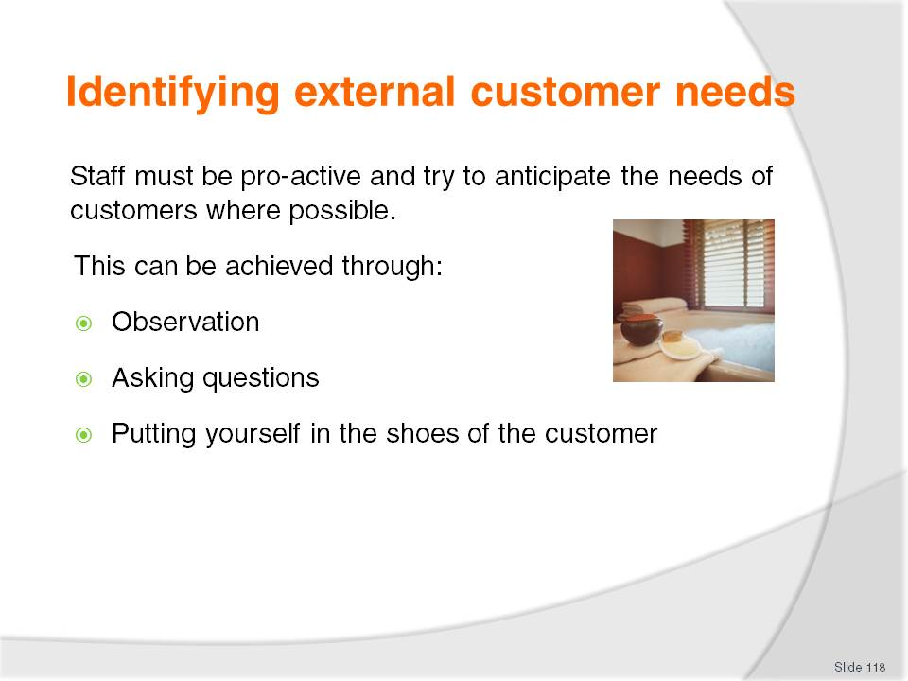
Slide No | Trainer Notes
Class Activity – General discussion
For each of the points in this slide, identify using examples how needs can be identified.

Slide
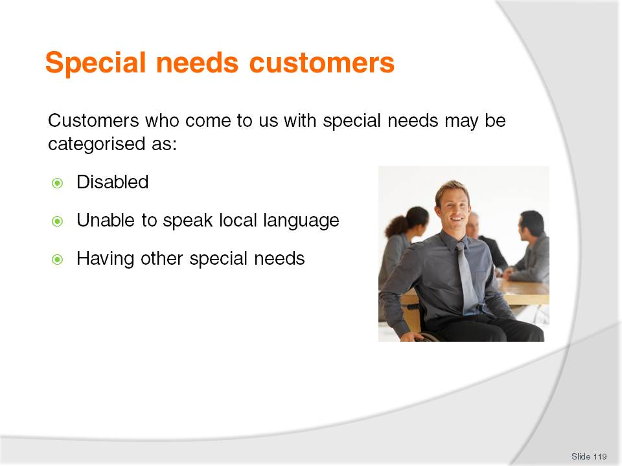
Slide No | Trainer Notes
Class Activity – General discussion
What are common ways a hotel can meet the needs of ‘special needs customers’?

Slide
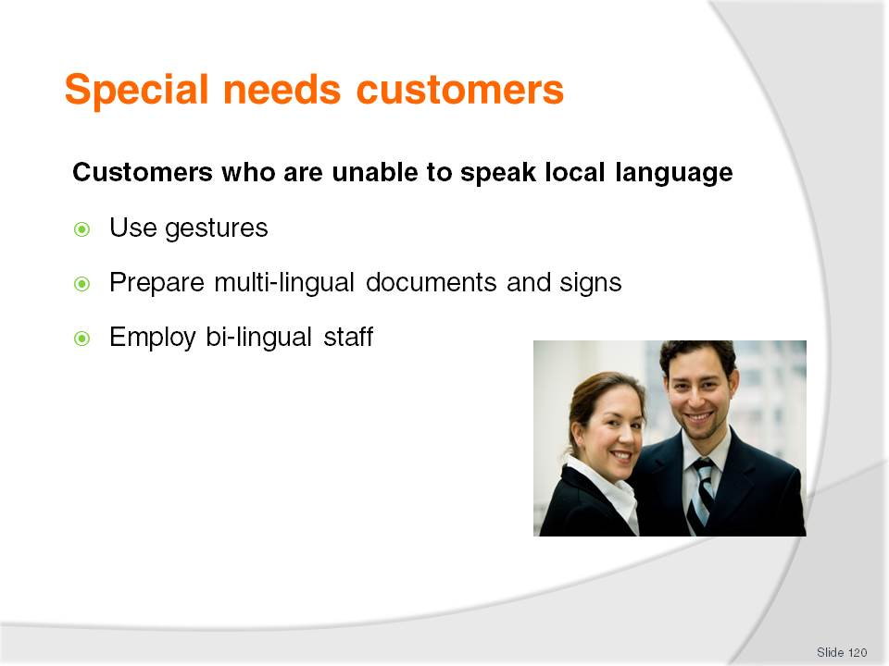
Slide No | Trainer Notes
Attempts at gestures may include:
Pointing to indicate a location
Holding fingers up to establish quantities
Rubbing your hands to indicate temperature
Nodding your head in agreement
Shaking your head in disagreement
Using facial expressions to relay your feelings
Removing adjectives (descriptive words) from your speech
Slowing your speech down and speaking clearly and concisely
Avoiding using local idiom or slang.
Where possible documents should be printed in a variety of languages to enable customers to understand information relating to the property and the surrounding region. The printing of a selection of documentation in various languages should include, but not be limited to:
Information compendium
Emergency procedures
Menus.

Slide
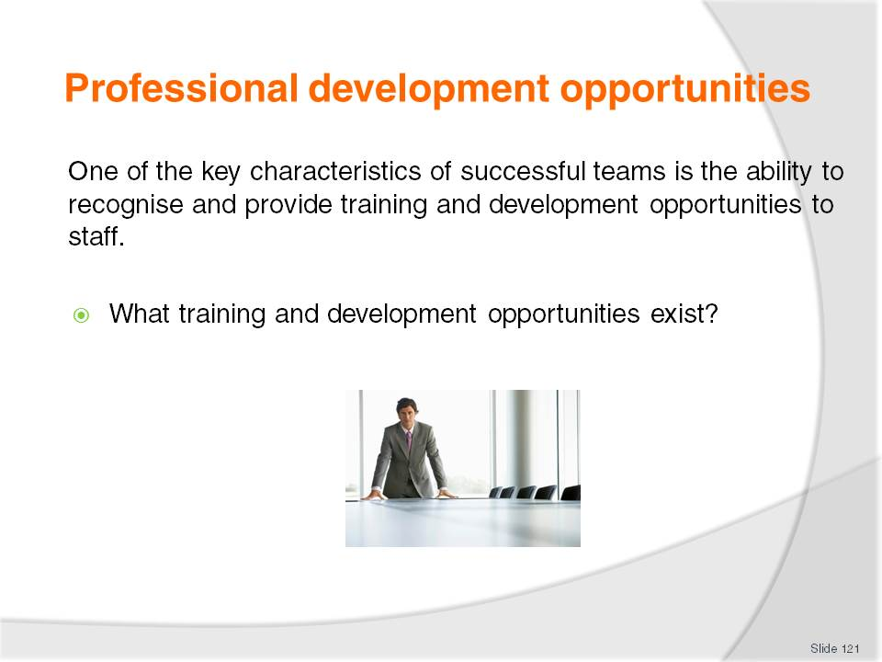
Slide No | Trainer Notes
Discussion
What are the benefits of providing these for:
- Owners
- Managers
- Staff members themselves
- Customers.

Slide
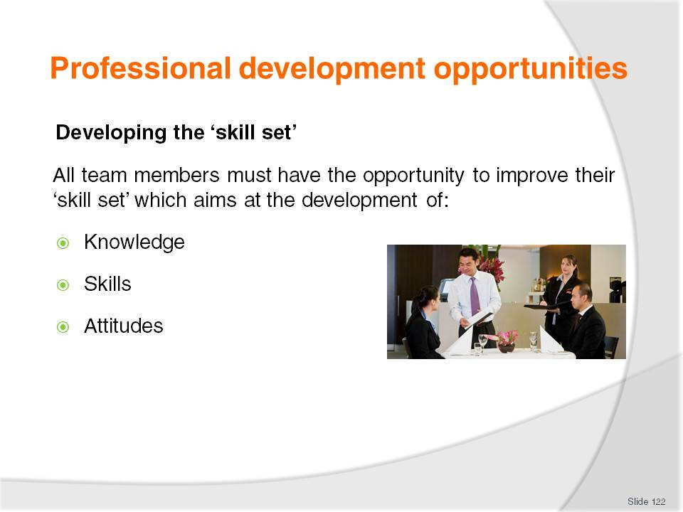
Slide No | Trainer Notes
Discussion
Trainer to discuss the difference between these:
Identify examples of different training sessions and how each of these points are developed
What is the best way to ‘develop’ each of these points?

Slide
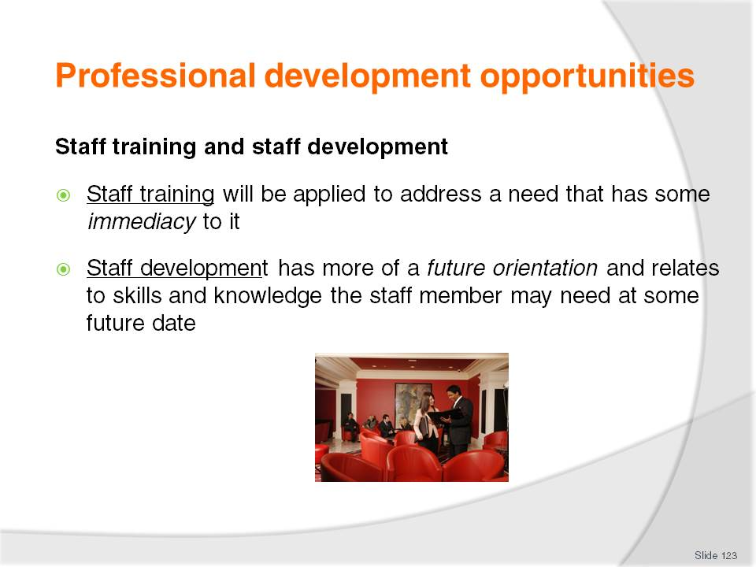
Slide No | Trainer Notes
Discussion
What are the benefits of each of these approaches?
What are examples of development programs for each of these?

Slide
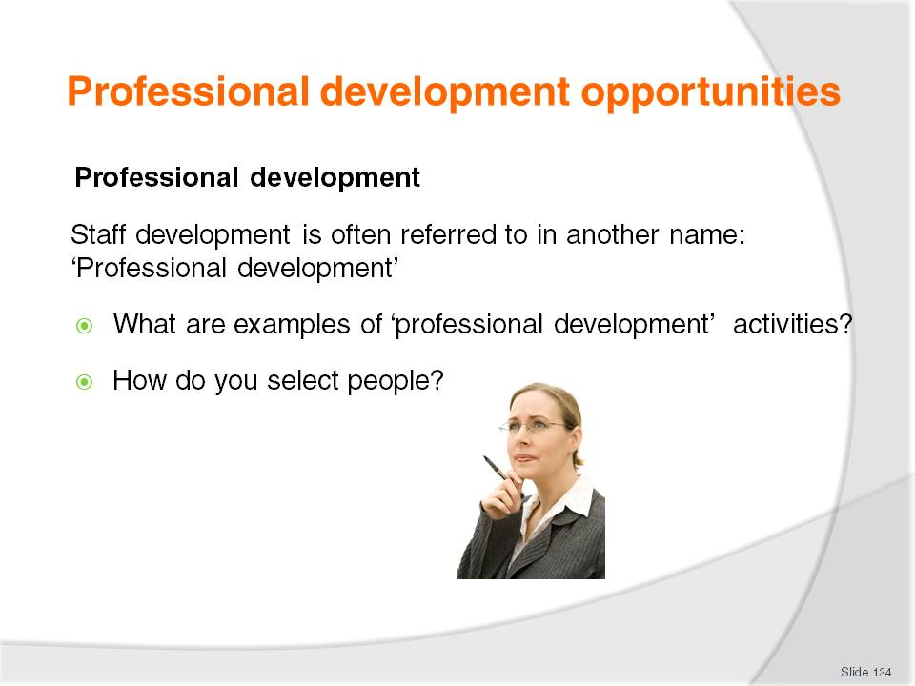
Slide No | Trainer Notes
Discussion
Discuss the questions in the slide.

Slide
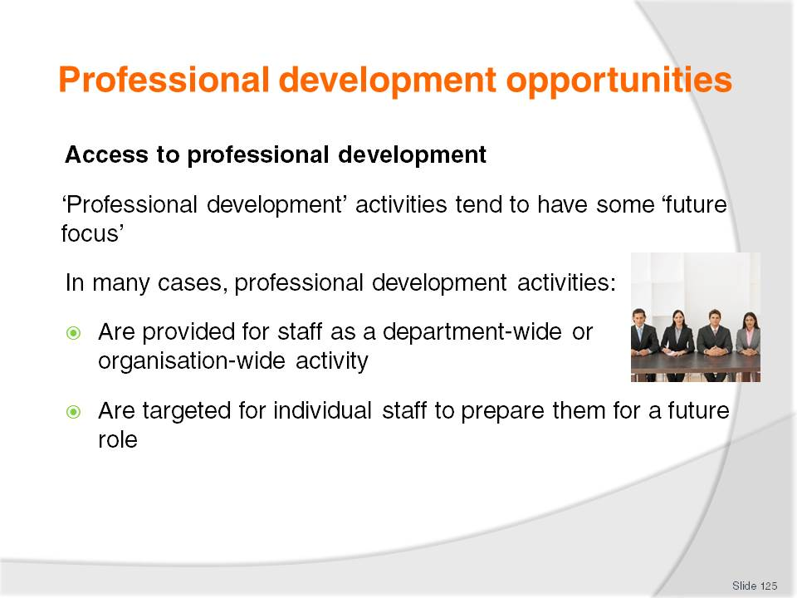
Slide No | Trainer Notes
Discussion
What are examples of programs suited to:
- Whole organisation or department?
- Individuals or small groups?
Are provided for staff as a department-wide or organisation-wide activity– for example, all staff may be required to participate in a professional development activity on ‘time management’
Are targeted at one (or more) individual staff to prepare them for a future role – such as promotion, to replace another staff member who is taking leave, to learn how to undertake new tasks associated with the introduction of a new product/service to the venue.

Slide
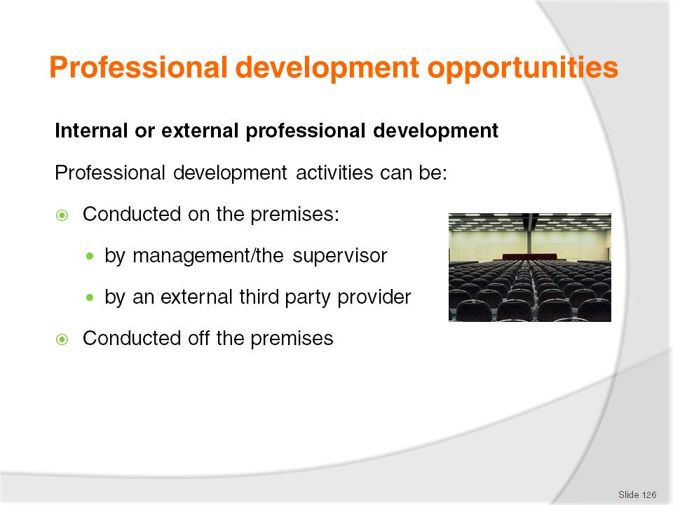
Slide No | Trainer Notes
Discussion
What are the benefits of each?
What are examples of each?

Slide
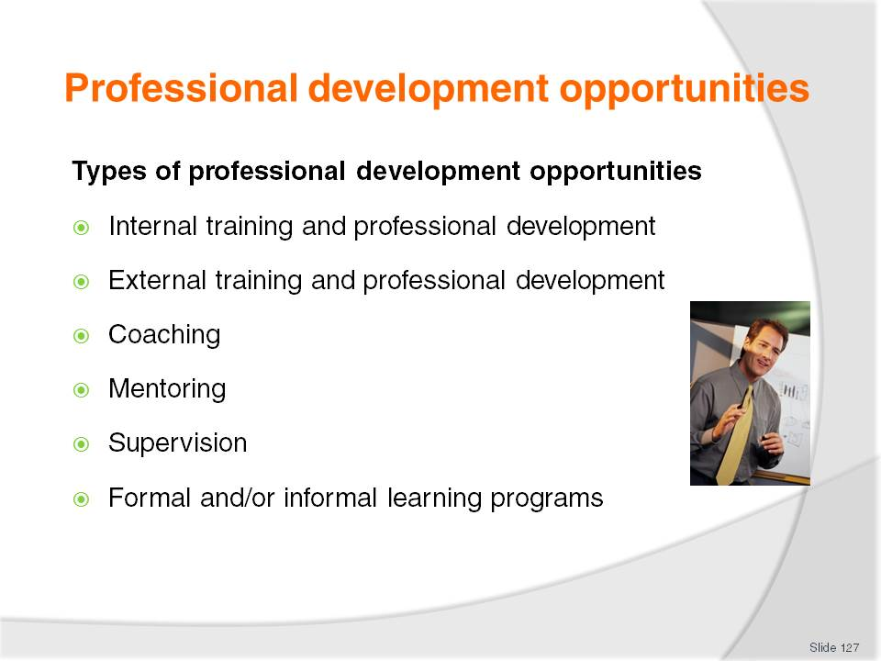
Slide No | Trainer Notes
Discussion
Identify each type of professional development opportunity
When would it be beneficial?

Slide
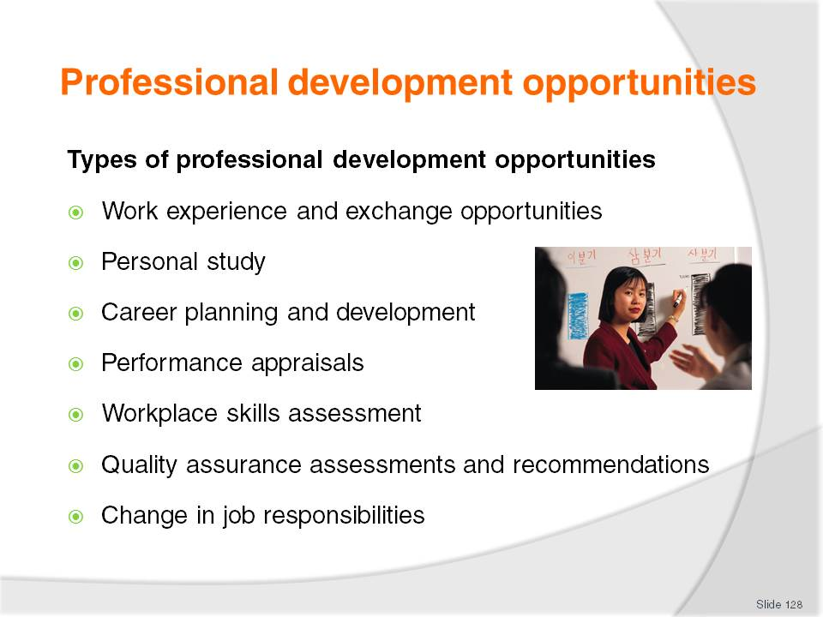
Slide No | Trainer Notes
Discussion
Identify each type of professional development opportunity
When would it be beneficial?

Slide
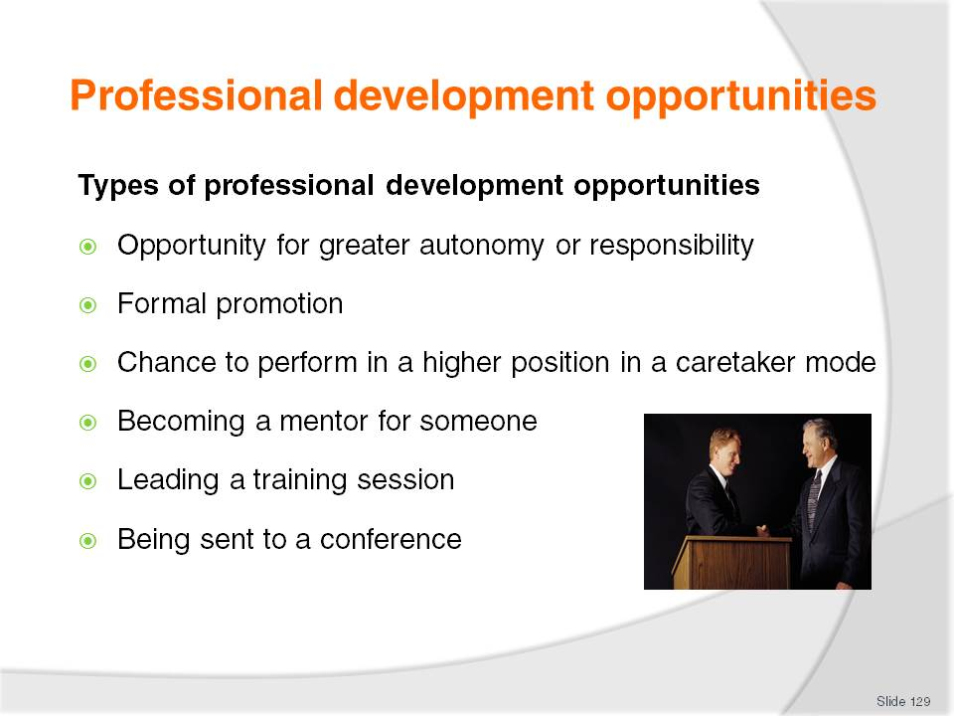
Slide No | Trainer Notes
Discussion
Identify each type of professional development opportunity
When would it be beneficial?

Slide
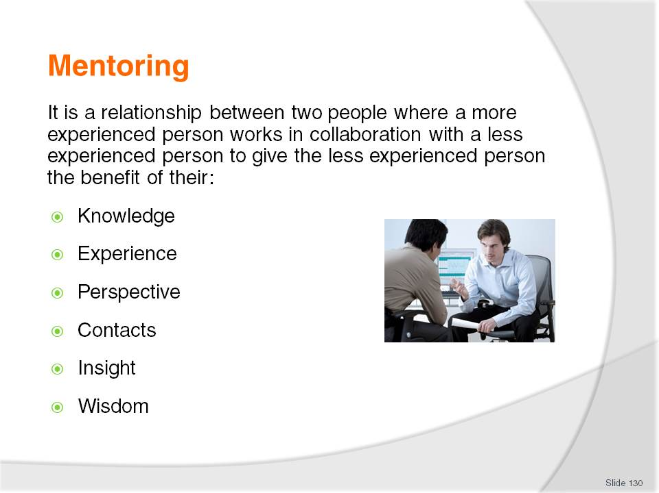
Slide No | Trainer Notes
Discussion
Why is mentoring such a popular professional development activity?
What is the purpose of mentoring?
What are the benefits?
How long should the mentoring process last?

Slide
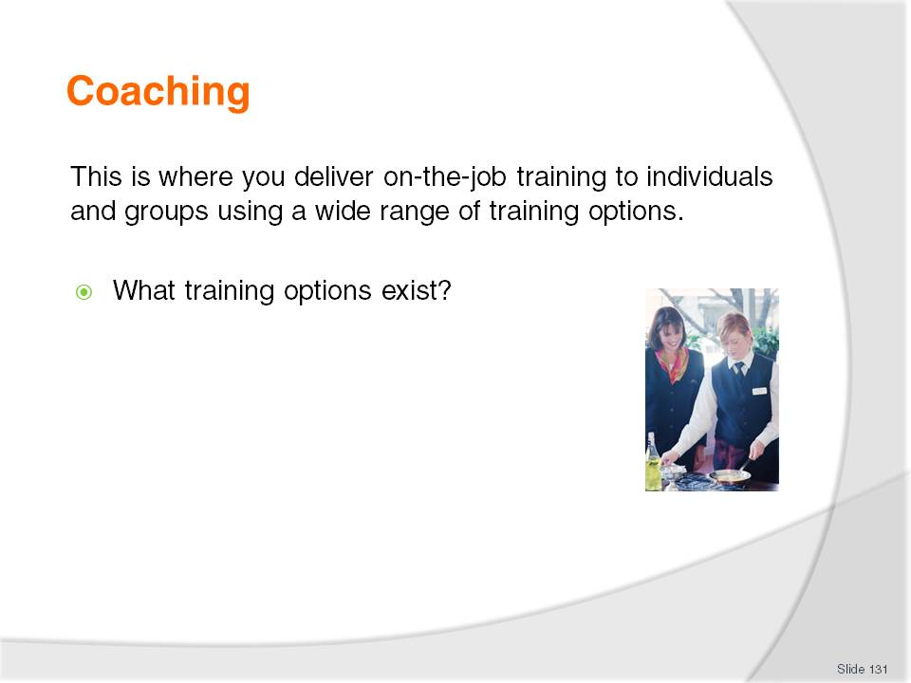
Slide No | Trainer Notes
Discussion
Discuss the question in the slide.

Slide
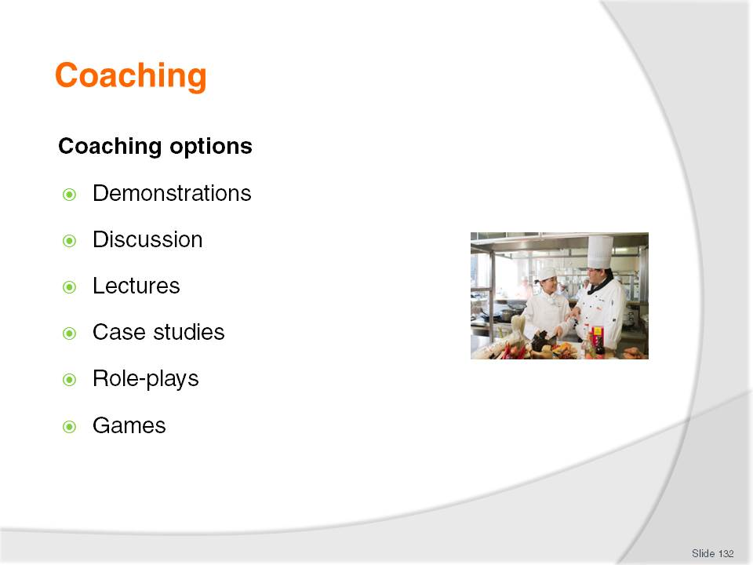
Slide No | Trainer Notes
Discussion
Discuss the different coaching options as identified in this slide.

Slide
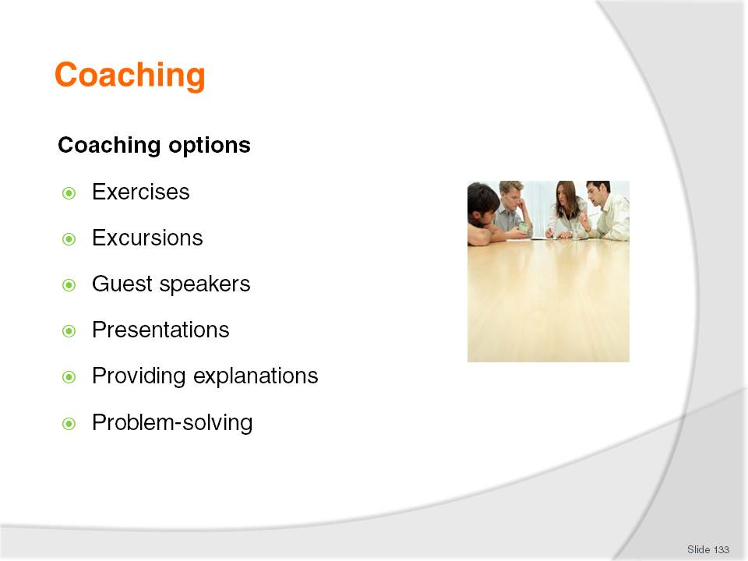
Slide No | Trainer Notes
Discussion
Discuss the different coaching options as identified in this slide.

Slide
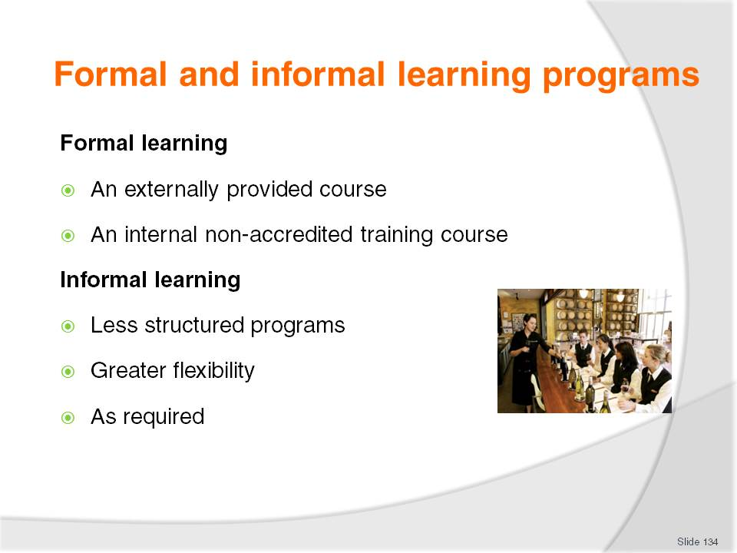
Slide No | Trainer Notes
Discussion
What is the different between these two approaches?
What are the benefits of each?
What are examples of formal and informal learning programs?

Slide
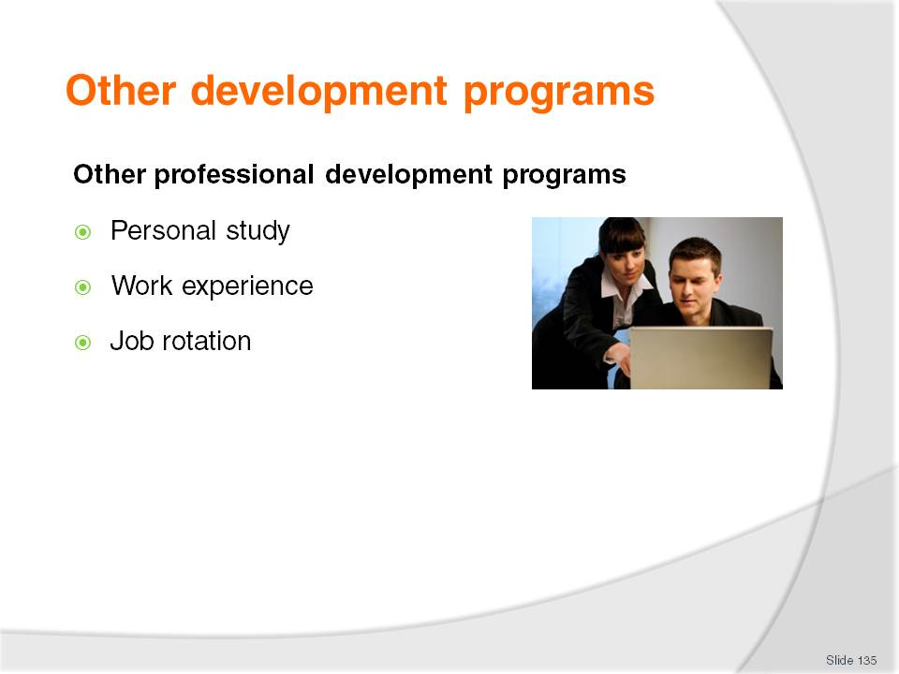
Slide No | Trainer Notes
Discussion
What are these approaches?
What are the benefits of each?

Slide
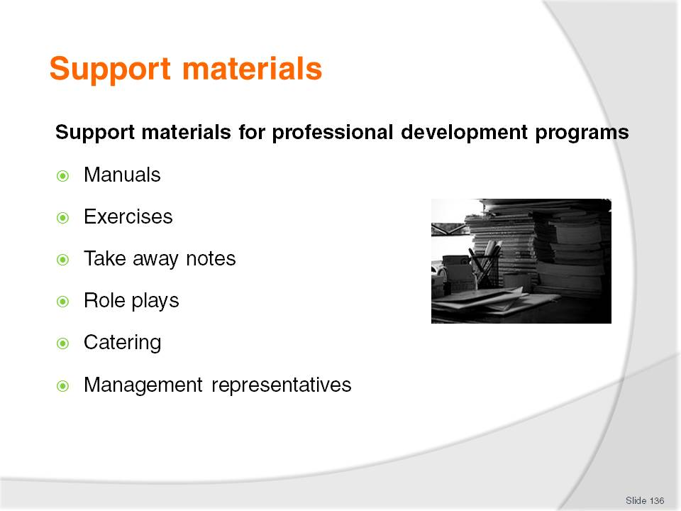
Slide No | Trainer Notes
Discussion
When are these support materials best utilised?

Slide
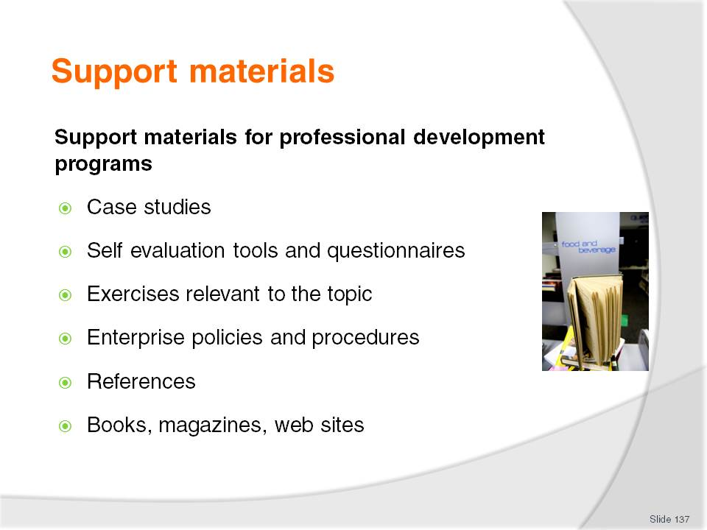
Slide No | Trainer Notes
Discussion
When are these support materials best utilised?

Slide
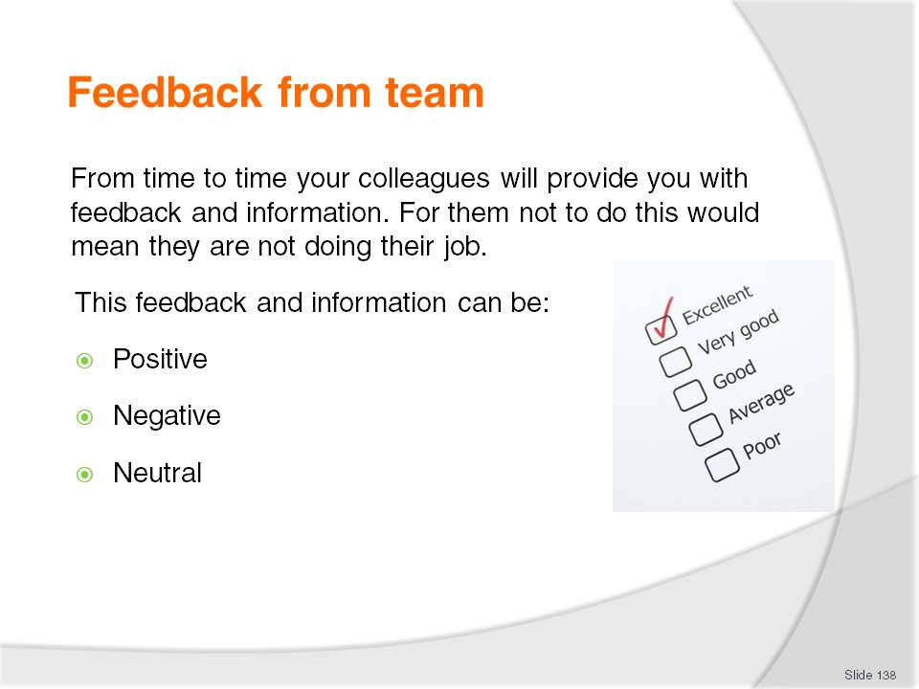
Slide No | Trainer Notes
Class Activity – General discussion
In your past experience:
What type of feedback is the most common? Why?
What are some examples of each type of feedback you have received?

Slide
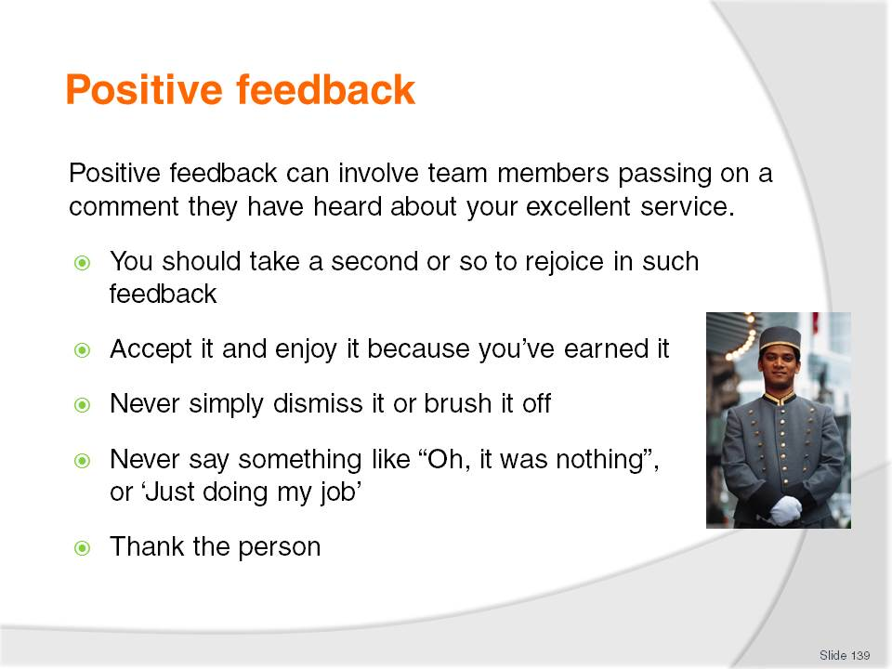
Slide No | Trainer Notes
Class Activity – General discussion
In the past, describe times when you have received positive feedback.
How did it feel to receive it?

Slide
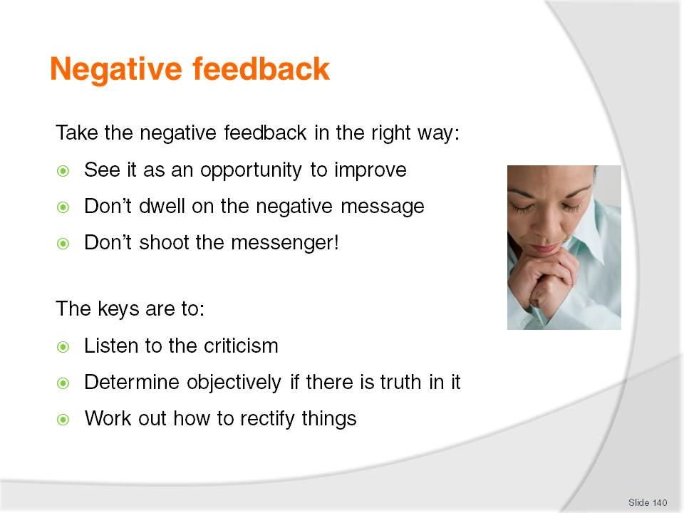
Slide No | Trainer Notes
Class Activity – General discussion
In the past, describe times when you have received negative feedback.
How did it feel to receive it?

Slide
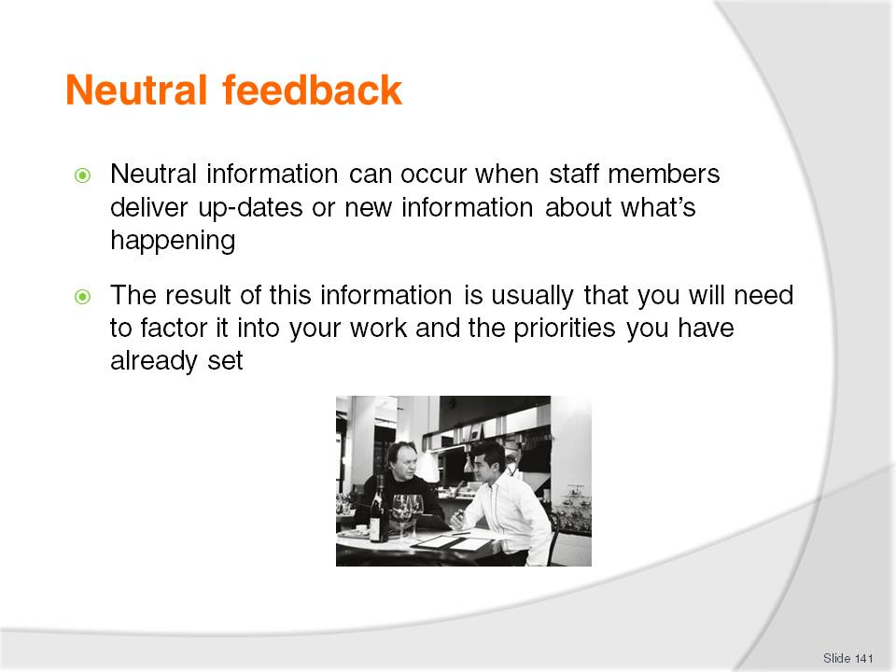
Slide No | Trainer Notes
Class Activity – General discussion
In the past, describe times when you have received neutral feedback.
How did it feel to receive it?

Slide
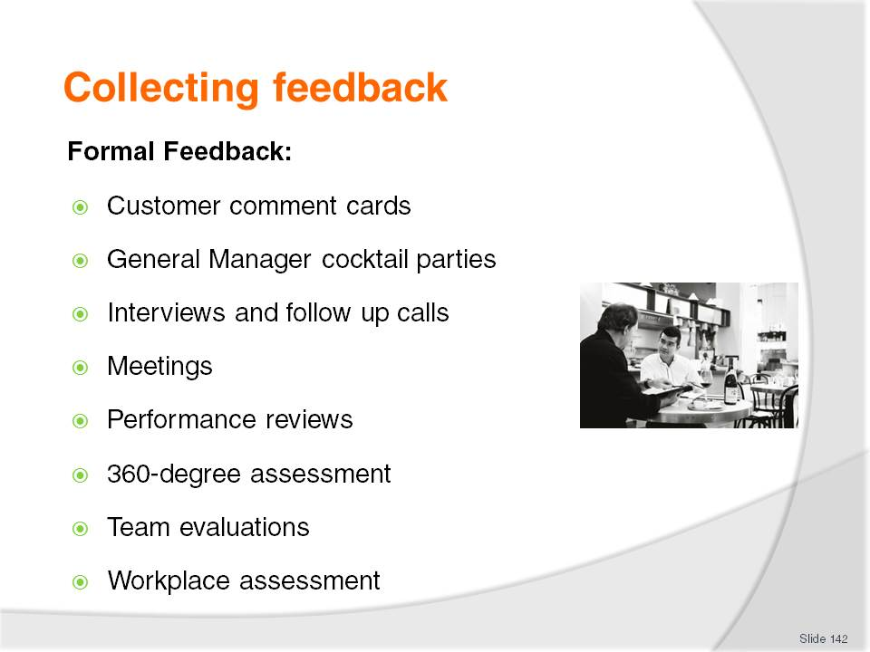
Slide No | Trainer Notes
Customer comment cards – these are established documents aimed at getting responses to a wide range of questions covering all facets of an operation
General Manager cocktail parties – this approach involves selected guests enjoying refreshments with senior management. It is common for management to ask questions about their stay and suggestions for improvement. This approach is also beneficial in finding out more about the customer, which can be used to provide more personalised service
Interviews and follow up calls – at times management may contact customers to find out about their experiences or visits
Meetings – staff meetings are held on a regular basis and normally will explore the performance of operations. At these meeting, comment cards from customers are discussed with strategies for improvement implemented
Performance reviews – this approach is used by management when providing feedback to staff regarding their performance. During these reviews, management will also ask staff for their suggestions or recommendations for improvement. At times, causes of poor staff performance will identify faults in the operation (lack of training, understaffing, limited or faulty equipment) which can be improved.

Slide
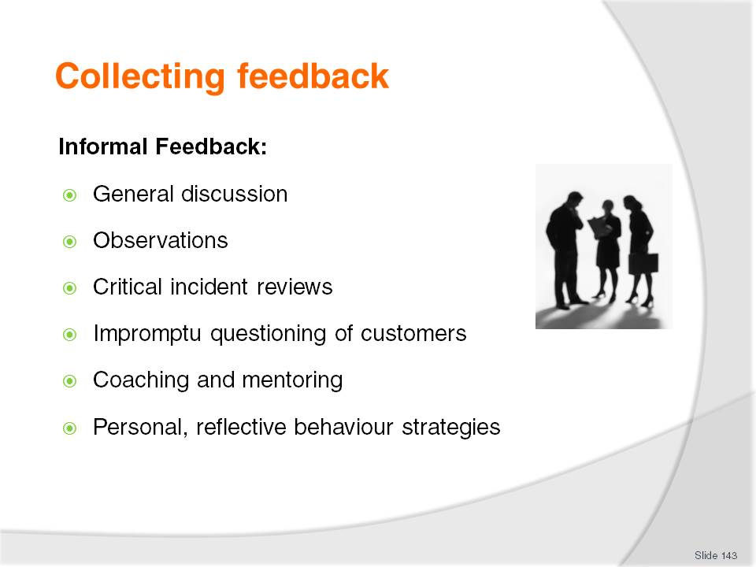
Slide No | Trainer Notes
This approach is a very effective way to get feedback. This information may come in the form of ‘gossip’ or ‘through the grapevine’, however is the provider of the largest amount of feedback.
Informal feedback involves collecting information and feedback outside the above mentioned formal avenues. This includes:
General discussion – whether with fellow staff or with customers, by interacting with people, you can get a good feel of what people are thinking
Observations – this is a great form of feedback. It is encouraged that staff observe the actions and reactions of customers and fellow staff. Most people are often uneasy about truthfully giving negative feedback, so this approach is useful in getting an accurate reading of what people are thinking in different situations.

Slide
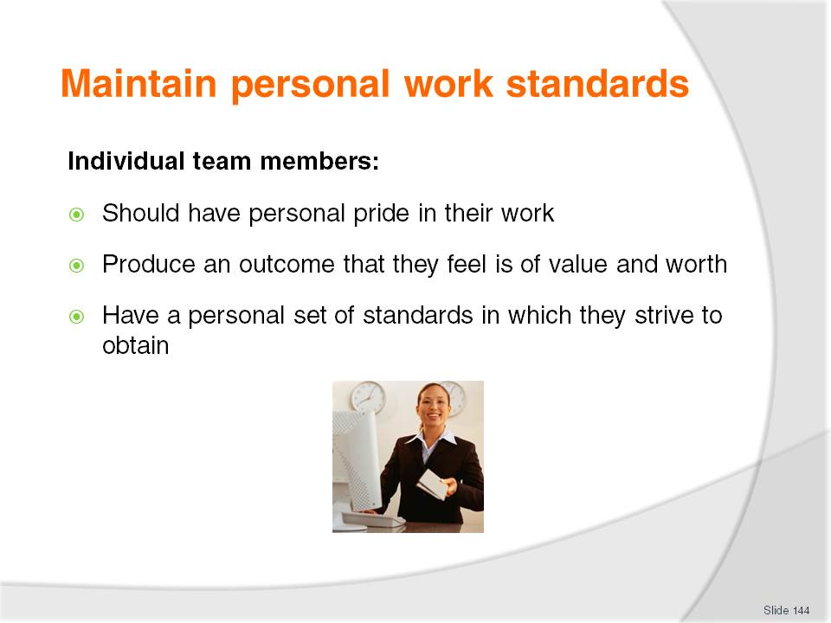
Slide No | Trainer Notes
Questions
Why is it important to have personal work standards?
What are examples of work standards you would have?

Slide
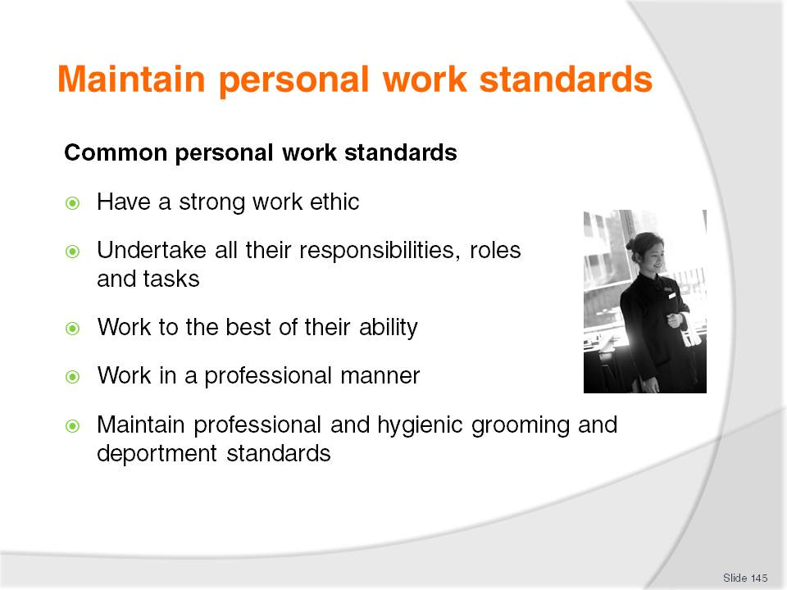
Slide No | Trainer Notes
Discussion
Discuss these personal work standards.

Slide
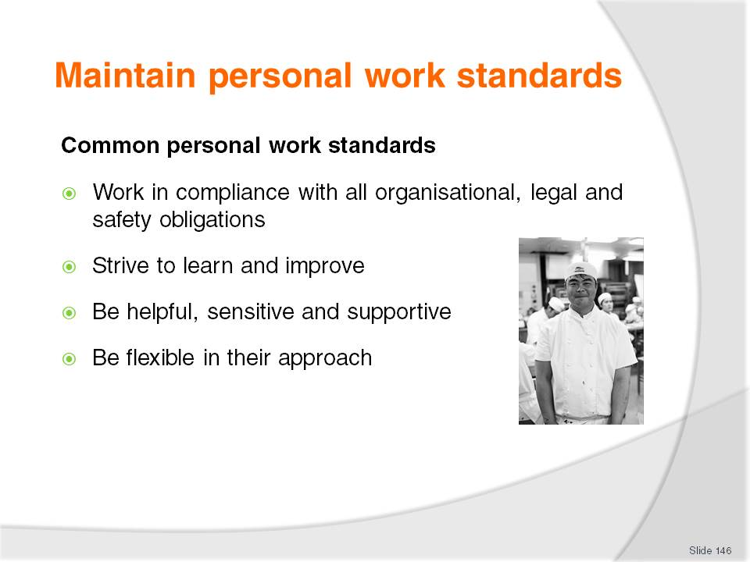
Slide No | Trainer Notes
Discussion
Discuss these personal work standards.

Slide
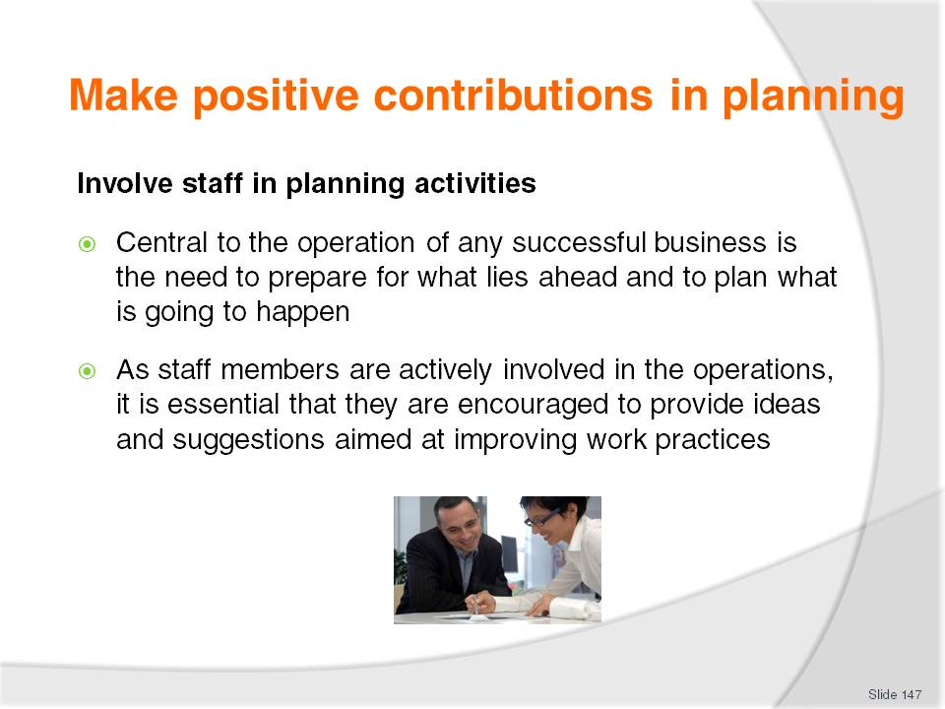
Slide No | Trainer Notes
Discussion
Why is it important to involve staff in the planning process?
How can you involve them?

Slide
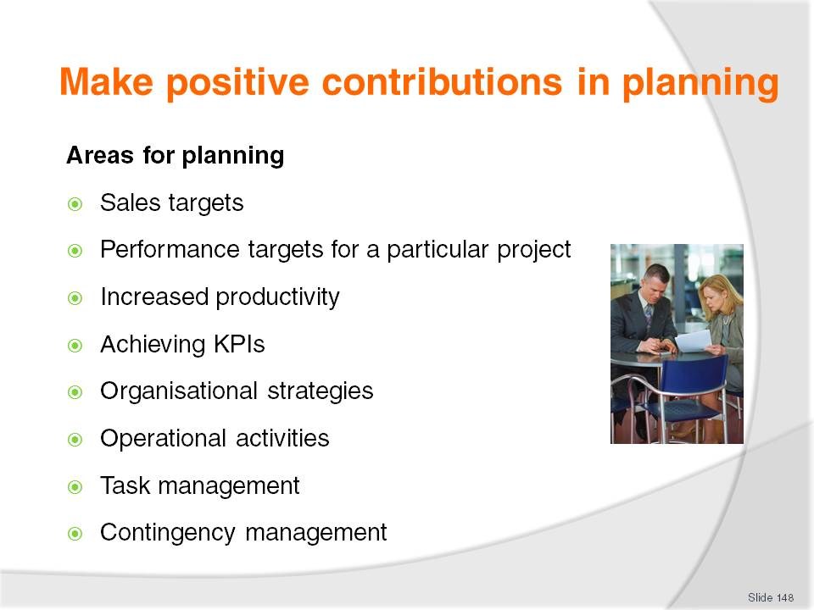
Slide No | Trainer Notes
Discussion
Discuss the points in the slide.

Slide
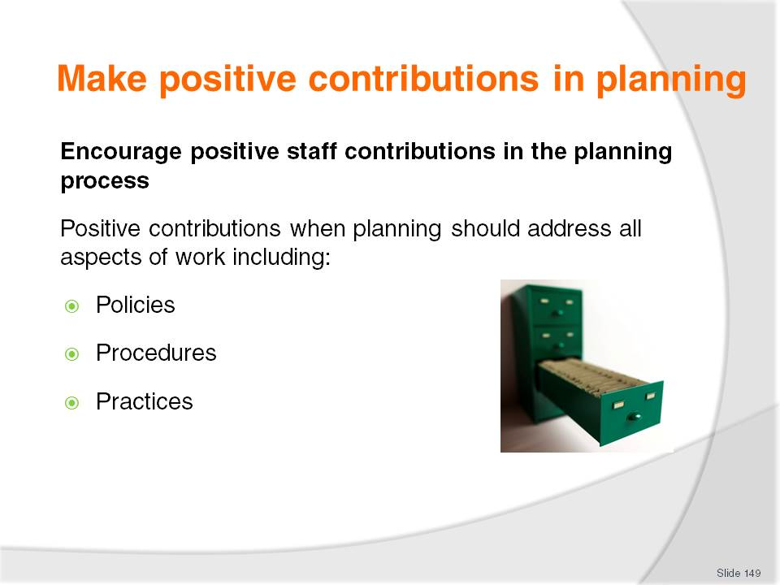
Slide No | Trainer Notes
Discussion
What input would you want staff to contribute?

Slide
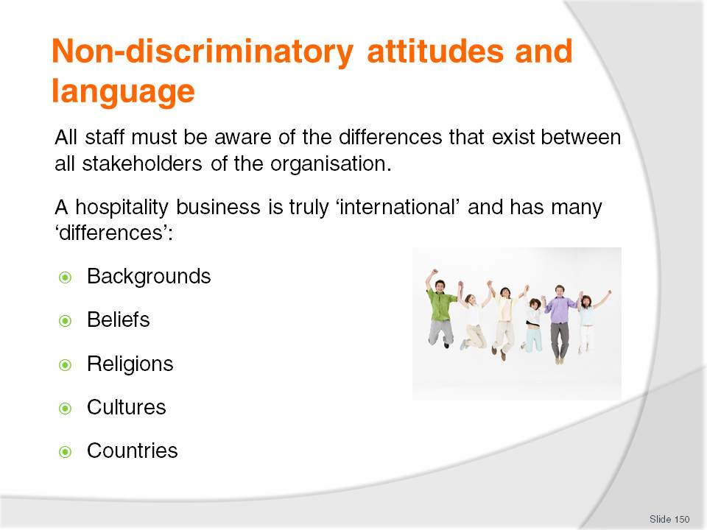
Slide No | Trainer Notes
Things that one person may regard as ‘normal’, ‘acceptable’, ‘likeable’ or even ‘preferable’ can be, and frequently are, very different to what customers from different countries expect.
Class Activity – General discussion
Get audience members to discuss differences that exist when dealing with people from different countries, using the points in this slide as a guide.

Slide
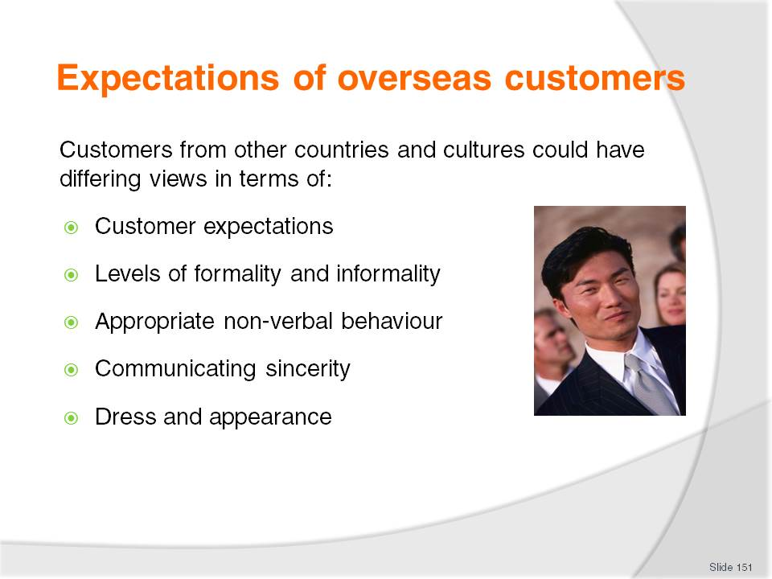
Slide No | Trainer Notes
 | Discuss points based on self experience.

Slide
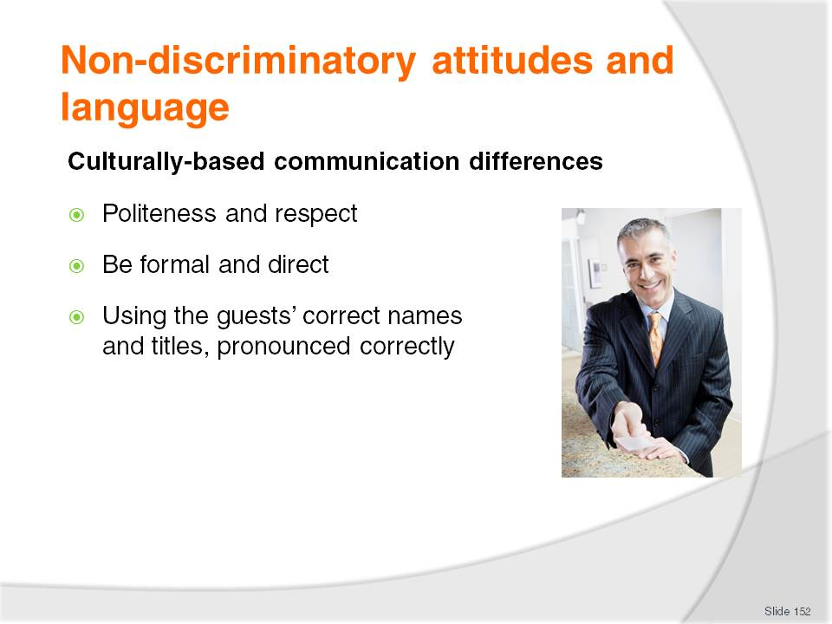
Slide No | Trainer Notes
 | Discuss points.

Slide
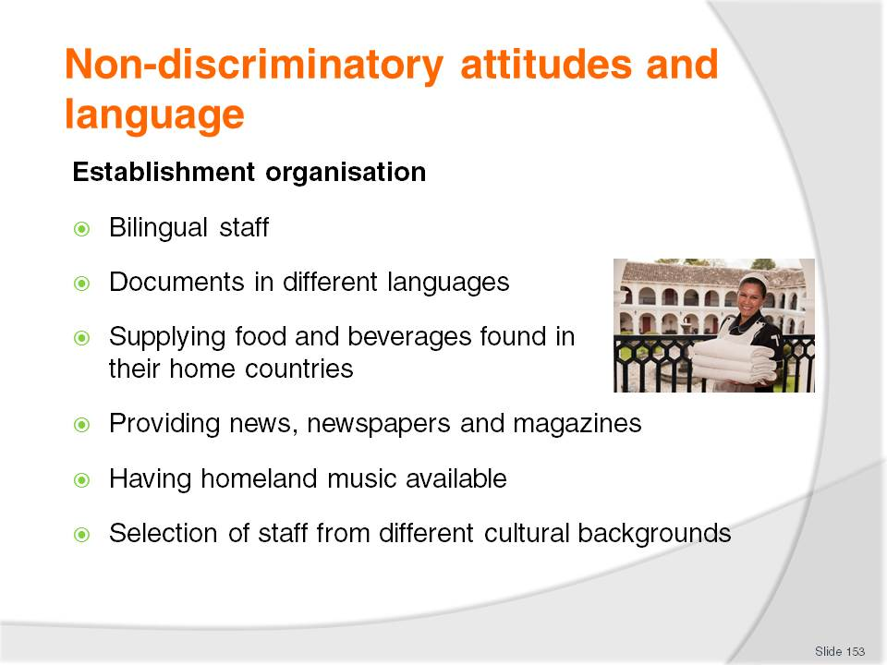
Slide No | Trainer Notes
Class Activity – General discussion
What can a hotel do to cater for its international market? Use this question as the basis of a group activity.
Break the group into pairs and get each pair to identify 5-10 things they can do to cater to an international market.
As a trainer, to make the activity more challenging, you may allocate each group a country or market segment.

Slide
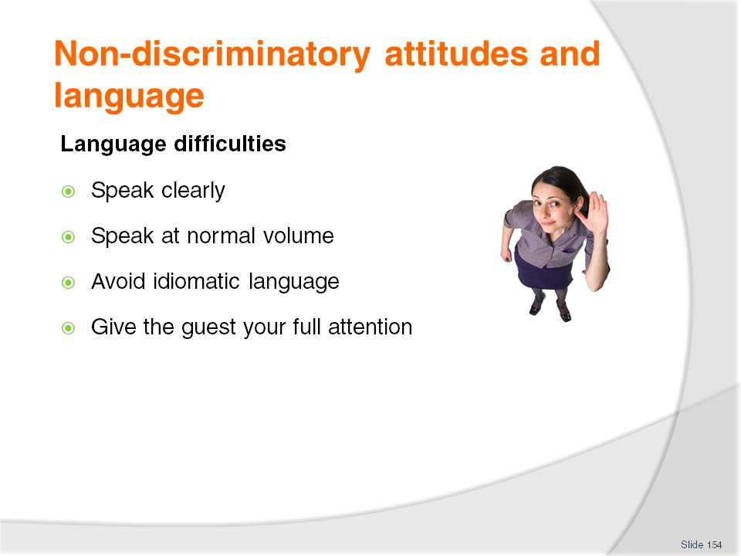
Slide No | Trainer Notes
Class Activity – General discussion
How do you communicate with someone who doesn’t speak the same language as you?

Slide
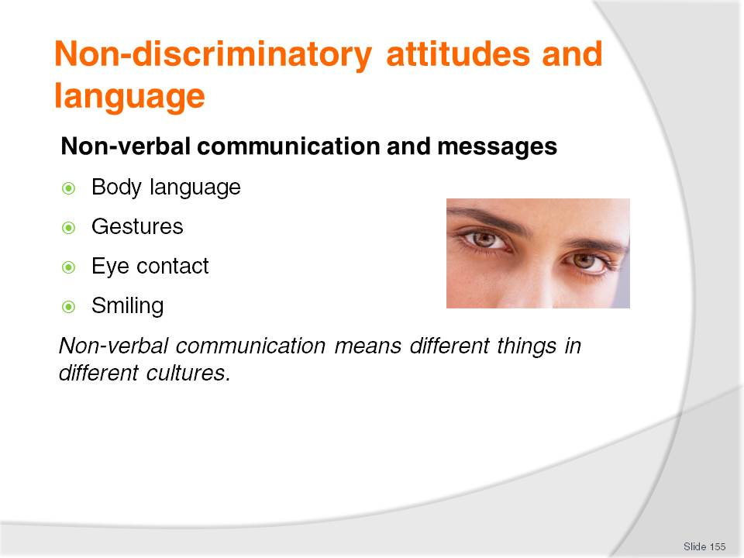
Slide No | Trainer Notes
Class Activity – General discussion
What are points to consider when using each of the points mentioned in this slide when working in an ‘international’ environment?

Slide
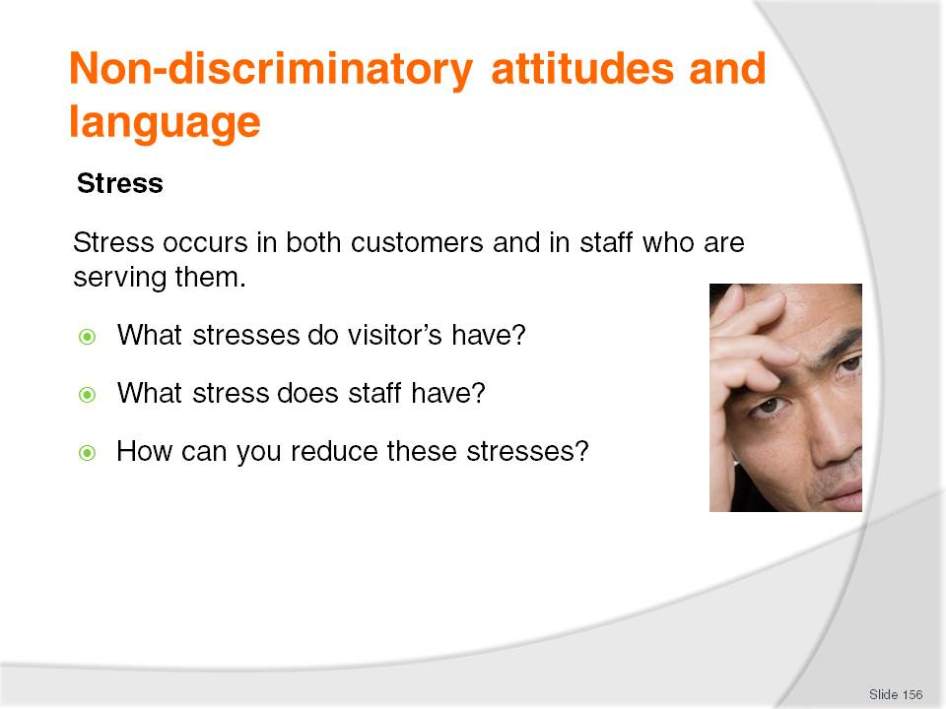
Slide No | Trainer Notes
Visitors are often under a great deal of stress. They are in a foreign land, confronted with an alien language and not having even the basic day-to-day working knowledge that everyone simply takes for granted.
And the staff who deal with them are also usually a bit stressed by the normal work routine, plus the challenge of having to cope with a difficult situation.

Slide
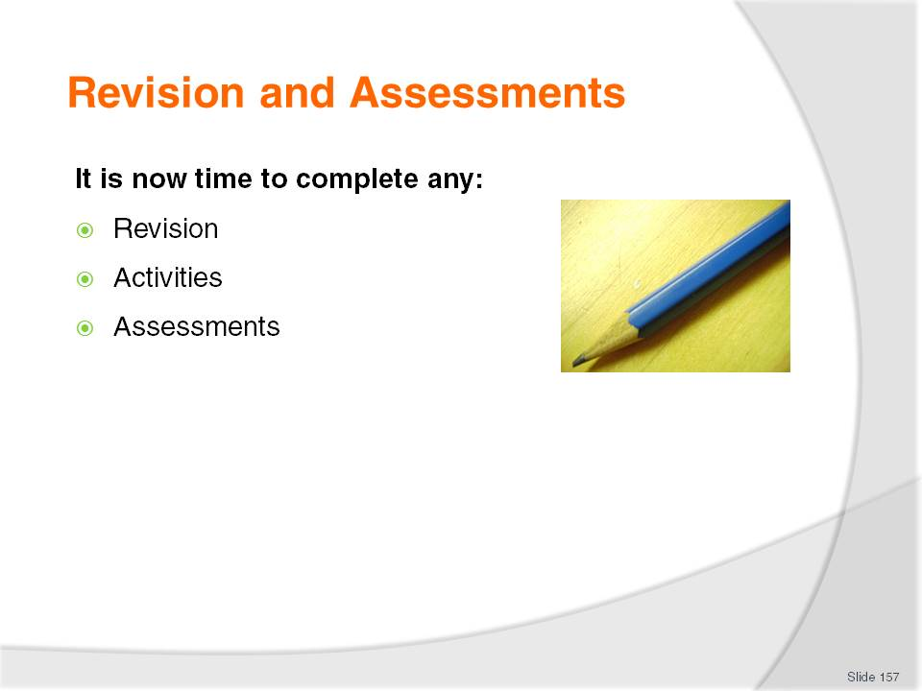
Slide No | Trainer Notes
Class Activity – Revision and Assessments
Explain Revision and Assessments.
Trainer to give audience time to undertake Revision and Assessments.

Recommended training equipment
Brochures
Communication documents used in workplace, including menus, compendiums, brochures and other materials for use by guest (in different languages)
Computer with internet and email access
DVD’s and written documents relating to cross cultural communications
Embassy and Consulate information regarding different countries
Emergency procedures
Equal Employment legislation
Information on different countries
OSH documents
Organisational Chart
Note pads and pens
Posters (in different languages)
Safety Signs (in different languages)
Scope of Authority examples for staff at all levels dealing with complaints
Standard Operating Procedures (SOP’s)
Telephone system

Instructions for Trainers for using
PowerPoint – Presenter View
Connect your laptop or computer to your projector equipment as per manufacturers’ instructions.
In PowerPoint, on the Slide Show menu, click Set up Show.
Under Multiple monitors, select the Show Presenter View check box.
In the Display slide show on list, click the monitor you want the slide show presentation to appear on.
Source: http://office.microsoft.com
Note:
In Presenter View:
You see your notes and have full control of the presentation
Your trainees only see the slide projected on to the screen
More Information
You can obtain more information on how to use PowerPoint from the Microsoft Online Help Centre, available at: http://office.microsoft.com/training/training.aspx?AssetID=RC011298761033
Note Regarding Currency of URLs
Please note that where references have been made to URLs in these training resources trainers will need to verify that the resource or document referred to is still current on the internet. Trainers should endeavour, where possible, to source similar alternative examples of material where it is found that either the website or the document in question is no longer available online.

Appendix – ASEAN acronyms
AADCP | ASEAN – Australia Development Cooperation Program.
ACCSTP | ASEAN Common Competency Standards for Tourism Professionals.
AEC | ASEAN Economic Community.
AMS | ASEAN Member States.
ASEAN | Association of Southeast Asian Nations.
ASEC | ASEAN Secretariat.
ATM | ASEAN Tourism Ministers.
ATPMC | ASEAN Tourism Professionals Monitoring Committee.
ATPRS | ASEAN Tourism Professional Registration System.
ATFTMD | ASEAN Task Force on Tourism Manpower Development.
CATC | Common ASEAN Tourism Curriculum.
MRA | Mutual Recognition Arrangement.
MTCO | Mekong Tourism Coordinating office.
NTO | National Tourism Organisation.
NTPB | National Tourism Professional Board.
RQFSRS | Regional Qualifications Framework and Skills Recognition System.
TPCB | Tourism Professional Certification Board.







